**Hettich redefines 'Make in India' with global standards and BIS-certified excellence**

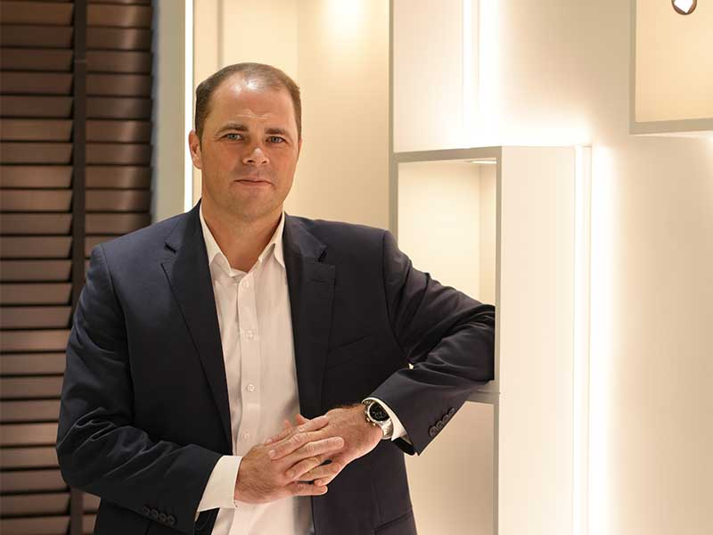

India's journey toward self-reliance and global manufacturing leadership is being powered by initiatives like 'Make in India' and 'Atmanirbhar Bharat'. At the forefront of this national movement stands Hettich, one of the world's leading manufacturers of furniture fittings and hardware solutions, actively driving the shift from being a participant to becoming a catalyst for systemic change.

For Hettich, local manufacturing is more than a cost efficiency and ready availability- it is about nurturing innovation, creating employment, and building future-ready capabilities. With manufacturing plants in Indore and Vadodara, powered by German-engineered automation, the brand has established itself as a benchmark for precision, quality, and sustainability in the Indian manufacturing landscape. These facilities are not just production hubs but symbols of India's growing ability to deliver world-class solutions at home for domestic and global markets.

A key milestone in this journey is Hettich's achievement of BIS (Bureau of Indian Standards) for all its Hinges, including slide-on, clip-on, and soft-close hinges. Widely used in diverse furniture applications, these products are celebrated for their precision, durability and, superior performance.

BIS certification is regarded as India's standard for reliability, signifying compliance with the country's most stringent quality, safety, and performance norms, assuring customers of unmatched trust and excellence.

Commenting on this significant achievement, Mr. Andre Eckholt, Managing Director, Hettich India, SAARC, Middle East and Africa, said: It is a matter of great pride to have received BIS Certifications as it validates our commitment to quality and compliance. This is also in alignment with the Honble. Prime Minister's vision of Viksit Bharat and our commitment to "Make in India, Make for the world", which aims at making India a global manufacturing hub. We have embraced this by investing in state-of-the-art manufacturing facilities, local talent, and sustainable processes."

This recognition aligns perfectly with Hettich's philosophy of "Make in India. Make for the World." By strengthening supply chains, investing in Indian talent, and building eco-conscious manufacturing ecosystems, the company is not only driving self-reliance but also enhancing India's standing in the global arena.

Hettich's commitment extends beyond manufacturing. By championing sustainability, digitalisation, and continuous innovation, the company is shaping the future of the Indian industry. Its efforts showcase a robust business model that inspires others to follow the same path and enhance India's stature on the global stage.

With more products lined up for BIS certification, Hettich is proving that excellence isn't optional; it is the standard. Together, its investments in infrastructure, certification milestones, and unwavering focus on quality demonstrate how global companies can play a transformative role in India's march toward self-reliance.

In redefining what `Made in India' means, Hettich is not just building fittings for furniture-it is building trust, confidence, and a stronger future for Indian manufacturing.

[Click to read the original feature!](https://timesofindia.indiatimes.com/hettich-redefines-make-in-india-with-global-standards-and-bis-certified-excellence/articleshow/124464674.cms)