Design meets efficiency: pronorm and Hettich develop new drawer system
A joint response to market demands

How do you turn two well-functioning drawer systems into one? Pronorm and Hettich have jointly addressed this and other questions and developed proTech X, a drawer system that fulfils the German kitchen manufacturer’s high design standards while making the production process significantly more efficient. At the in-house exhibition at pronorm in Vlotho from 20–26 September 2025, the new proTech X drawer system will premiere.

Pronorm's reasons for switching to a different drawer system were varied - and correspondingly demanding. Daniel Schwarz, Head of Product Development at pronorm, explains the reasons: "The zeitgeist and market requirements have changed. We were therefore looking for a drawer system with a particularly slim, linear design that was also suitable for industrial production. It should also offer us the possibility to map all our product lines with different design variants in one single system." The requirements came at exactly the right time, because Hettich has developed a drawer system specifically for automated production processes, which can be integrated into almost any setup, regardless of the machinery used.

Successful development partnership
pronorm and Hettich have a long and successful partnership. "We quickly realised that the ExeoTech drawer system from Hettich offered the perfect basis for an exclusive adaptation to our needs," says Daniel Schwarz. "Firstly, we were impressed by the platform concept, which allows the Actro YOU runner, which we already use, to be combined with different ExeoTech drawers. Secondly, the well thought-out assembly of the drawer and the excellent storage options it enables. Despite the slim design, the stability is extremely high," he continues. After around 1.5 years of joint development, the market launch of proTech X is imminent. All kitchens in pronorm's showroom at the Vlotho site have already been reset for the new drawer system for the premiere at the Küchenmeile.

Design variants installed as a special show
pronorm presents the only drawer system with a side profile as slim as 11 mm in the colours anthracite and titanium, as well as in the variants proTech X pure as standard with closed drawer sides, proTech X glassCase with glass drawer side and proTech X pureMaxi with a drawer side height of 251 mm. For the special show in the pronorm in-house exhibition, Hettich designed an exhibit with specially manufactured cabinet bodies in the form of a carousel, presenting retailers with the full range of drawer design options and easy assembly.

Efficiency gains in production
Tests during the introductory phase have already shown that series production will run more efficiently later on. The practical experience gained from resetting the kitchens in the in-house exhibition for the trade fair is also very positive for pronorm. An additional efficiency gain for pronorm will be the elimination of duplicate stock control for two drawer systems. The great strengths of ExeoTech from Hettich are the drawer systems' high level of automation capability combined with sophisticated design and ease of assembly. This is currently unique on the market. pronorm has recognised this and secured the lead for itself.

The following picture material is available for downloading from the "Press" menu at
www.hettich.com:

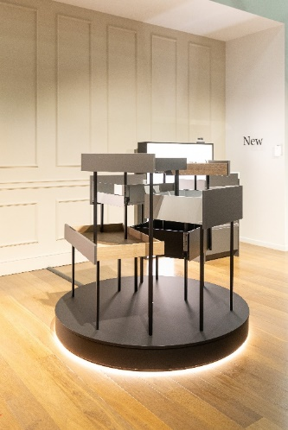
422025_a
Pronorm will be presenting its new proTech X drawer system at the Küchenmeile 2025 in-house exhibition. All possible design variants can be discovered by the retail trade on the exhibit designed by Hettich. Photo: Hettich

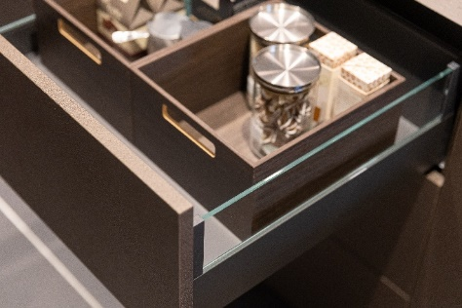
422025_b
Pure design is at the centre of pronorm's new proTech X drawer system, which impresses with its drawer side profiles that are just 11 mm narrow. Shown here in the elegant proTech X glassCase version with glass frame. Photo: Hettich

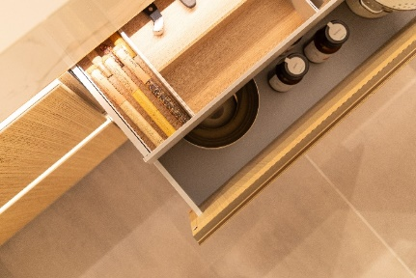
422025_c
pronorm offers its proTech X drawer system in the colours anthracite and titanium. This makes it possible to fulfil the wishes of kitchen buyers in every design direction. The standard proTech X pure version in titanium harmonises perfectly with bright wood tones. Photo: Hettich

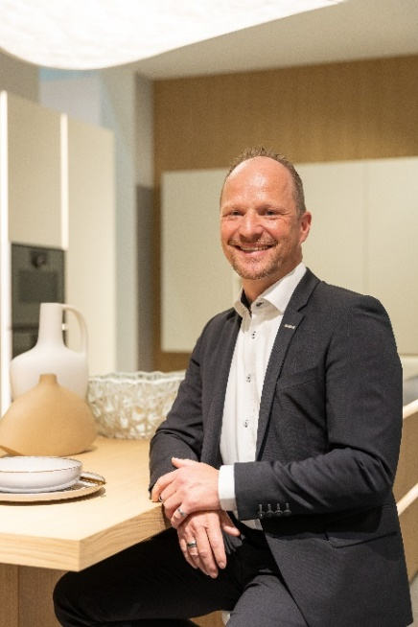
422025_d
Daniel Schwarz, Head of Product Development at pronorm, accompanied the development process of the proTech X drawer system together with Hettich and is looking forward to the market launch. Photo: Hettich

About Hettich
Founded in 1888, Hettich is one of today's largest and most successful manufacturers of furniture fittings on the international stage. The family-owned company is based at Kirchlengern in the furniture-making cluster of Germany's East Westphalia region. Some 8,400 members of staff work together to provide our future-proof solutions in over 100 countries. Promising "It's all in Hettich", the Hettich brand provides a comprehensive portfolio of services that is consistently and resolutely geared to the needs of customers across the globe. By tradition, top priority has always been at the focus of everything we do to ensure social, societal and ecological sustainability. www.hettich.com

