ZB Holzsysteme lives craft 4.0
AvanTech YOU fits perfectly with processes

For the technology-driven trade company ZB Holzsysteme from Rastede in northern Germany, only one thing counts: data conformity. The 4.0 workshop with state-of-the-art machinery is exemplary. All work processes, products and services are efficiently networked. Consequently, only products with a clean database are processed to ensure first-class processing quality. This means that the AvanTech YOU drawer system from Hettich fits perfectly into the company's process-orientated value chain.

"Never change a running system". For the Managing Director of ZB Holzsysteme, Manuel zum Buttel, this guiding principle only applies to a limited extent. What counts for him is progress and further development. If there is an opportunity for improvement, such as when switching to the design-orientated drawer system AvanTech YOU, he seizes it. With his passion and know-how for CAD, he has successfully positioned ZB Holzsysteme on the market as a supplier for the trade and furniture industry. His customers buy furniture parts and ready-to-assemble furniture from him and often have the goods delivered directly to them on site. The high quality standard, functionally reliable long-lasting durability and customisability of the production orders also impress architects, planning offices and private customers.

Switched to AvanTech YOU drawer system
"Our value chain lies in the processes. The drilling patterns are crucial and processable data is essential for this," explains Manuel zum Buttel. Hettich has been cooperating with imos for a long time and makes all product data available in the library. It was there that Manuel zum Buttel came across the data sets for the InnoTech drawer systems back in 2006 and successfully tested them for his automated production.
Later, he was one of the first companies to switch to the ArciTech drawer system from Hettich and was already using the data sets before they were available from imos. "Thanks to the close contact with Hettich's sales team, I am very well informed about everything new. If the quality is right, I'm in immediately," emphasises the CAD-savvy managing director. This means he takes a lot off his customers' hands: he tests and selects fittings that are technically sophisticated and match the timeless furniture design.
He immediately liked the AvanTech YOU drawer side profile, which is only 13 mm slim. Especially for living room furniture if no decorative drawer is to be used. After a series of tests on various projects and a comparison with other drawer systems, Manuel zum Buttel decided to switch to the more flexible AvanTech YOU system.
To differentiate himself, he chose an anthracite-coloured drawer side profile with a design profile in Brushed stainless steel, which he also branded with his ZB logo.
As the company is very keen to avoid packaging waste, the fact that Hettich can supply the complete system in bulk packaging was very positively received. The modern machinery at ZB Holzsysteme has also grown to include the pneumatic AvanFit assembly press.

Own brand: ZB-Kitchens
ZB Holzsysteme has achieved something that not many craft businesses manage: the establishment of its own kitchen brand. Manuel zum Buttel loves Kitchens because many technical refinements can be installed there. Many years ago, he started making Kitchens on the side to load his first new CNC machine. Word of mouth in the neighbourhood increased the demand for ZB Kitchens, of which the company now produces around 100 each per year. We are even planning our own outdoor kitchen programme. "Everything has to work for us, after all, we want people to have fun with the furniture. That's why we put the fitting technology through its paces," summarises Manuel zum Buttel. In any case, he is completely convinced by the AvanTech YOU drawer system from Hettich.

The following image material is available for download in the menu "Press" at www.hettich.com:

Images
Captions

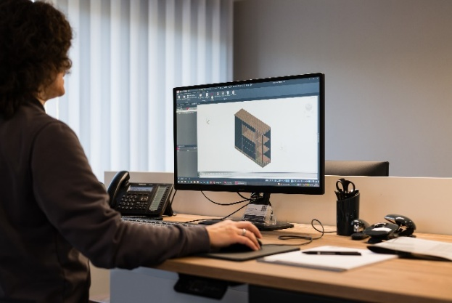
142026_a
For ZB Holzsysteme, a highly technology-driven craft business, high CAD data quality, such as that supplied by Hettich, is a prerequisite for smooth production processes. Picture: Thomas Weber

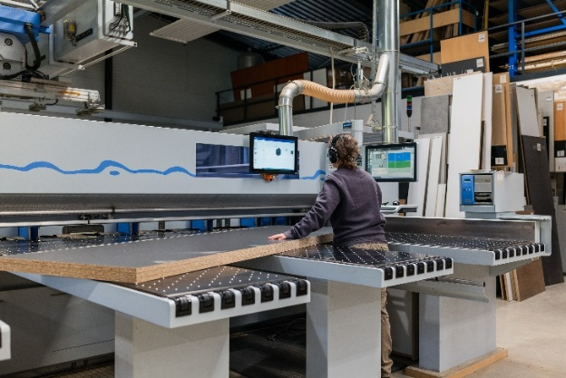
142026_b
At ZB Holzsysteme, all production steps, such as cutting, are completely digitalised. Photo: Thomas Weber

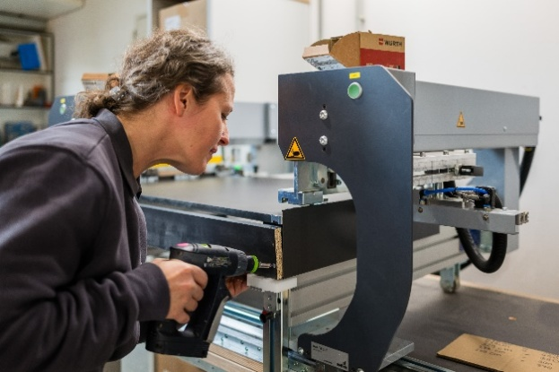
142026_c
The assembly of AvanTech YOU drawers is efficient: with the AvanFit assembly aids, many drawers can be precisely assembled in a short time. Photo: Thomas Weber

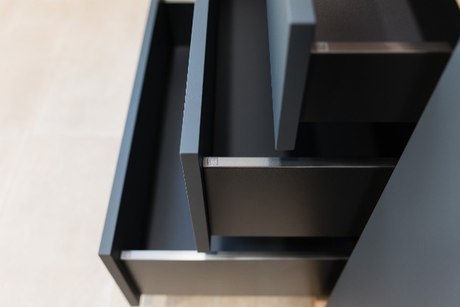
142026_d
ZB Holzsysteme uses the AvanTech YOU drawer system to differentiate itself: anthracite-coloured drawer side profile with a design profile made of Brushed stainless steel and its own ZB logo. Photo: Thomas Weber

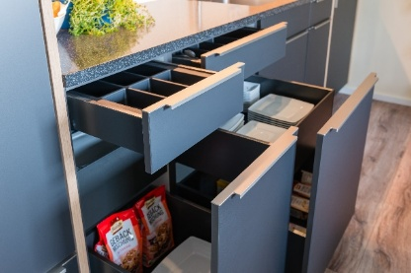
142026_e
AvanTech YOU is used by ZB Holzsysteme both in customer projects and in its own ZB Kitchens programme. Photo: Thomas Weber

About Hettich
Founded in 1888, Hettich is one of the world’s largest and most successful manufacturers of furniture fittings. The family-owned company is based in Kirchlengern, in Germany’s East Westphalia furniture production region. Around 8,200 colleagues work together to deliver future ready solutions in more than 100 countries. Under the brand promise “It’s all in Hettich”, the company provides a comprehensive portfolio of products and services consistently aligned with customer needs worldwide. Responsible, sustainable action — socially, societally and environmentally — has always been a top priority for Hettich. www.hettich.com

