**Trends are taking the outdoor kitchen by storm**

**Hettich trend report from spoga+gafa 2023**

**At the leading garden lifestyle trade fair, the outdoor kitchen was one of this year's major trending topics. "Social Gardens", a name given to these booming green urban spaces, are not only a place for bringing people together and social interaction, they also provide extended living and working areas. Core component of "Social Gardens" is the outdoor kitchen. In the garden at home too, cooking and enjoyment in the open are being celebrated ever more professionally – and stylishly. Hettich's trend report gives an overall picture.**

As the popularity of outdoor kitchens grows, so too are the demands on equipment, convenience and creative diversity. This is where Hettich's trend scouts have put together the key directions from spoga+gafa 2023.

**Dark or natural looks with peaks of colour**

What continues to enjoy popularity in indoor kitchens leaves a very classy and high quality look outdoors as well: dark to black surfaces, smooth or textured. Black is and remains the favourite with kitchen designers. Combining it with high quality BBQ equipment and accessories made of stainless steel, or with chrome plated details, looks particularly stylish and professional. But it's not about external appearance alone. Elegant dark design continues through on the inside too thanks to the weatherproof InnoTech Atira drawer system. In keeping with the outdoor look, these drawers score with their characteristic angular design for a consistent visual impression while still providing broad design diversity. The drawers move in and out on the Quadro Compact runner: it is strong and robust, making it exactly the right system for the heavy gas bottle pull-out, say.  
  
Anyone preferring contrasts are spoilt for choice with the coloured barbecuing elements. This is where the options range from bright red to restrained creamy white. Natural tones also create a homely contrast among the designs available for the outdoor kitchen: various timbers are featured in just the same way as understated plain coloured fronts.

**Creative material variety**

There's one thing all materials must be: weatherproof. Concrete is a robust material that can cope well with frost, heat and UV radiation, making it a highly suitable cabinet body material for outdoor kitchens. Real wood creates a completely different look. Exuding warmth and homeliness, these kitchens integrate into the natural backdrop of gardens and patios. Drawers with wooden fronts as well as solid wooden doors that conveniently open and close on Hettich's weatherproof Veosys stainless steel hinge with integrated soft closing are complemented by many other creative details to provide an overall appearance of perfected harmony.

Particularly when it comes to the choice of outdoor materials, the proximity to furniture trends is unmistakable. Surfaces in deceptively real and exquisite looking reproduction marble are just as much part of the options as unpolished looking rust effect finishes in industrial chic. Sustainable extravagance comes from glass ceramics made of recycled bottles: each top is one of a kind and a luxurious eye catcher. Enamelled surfaces tend to be used in a more jazzy and creative way. The magnetic surfaces become centre stage for kitchen herbs and truly fascinate as a splash of colour.

**The outdoor kitchen is growing**

Demand is spurring on designers and manufacturers. Going perfectly with the outdoor kitchen, the range of standalone storage units is growing, making it even more convenient and pleasurable to cook outdoors and enjoy time spent in the open. For instance, bar cabinets are available that provide ample space for wines and spirits, glasses of all types and a wide range of accessories. Also on offer are more and more practical ideas for space management in the outdoor kitchen, such as pull-out worktops or outdoor tables with space for storing utensils and seat cushions.

Hettich's trend scouts have come back from spoga+gafa 2023 with a fascinating video that summarises all the key trends: [spoga+gafa2023 trendvideo hettich](https://www.hettich.com/short/umwmrzd)



The following picture material is available for downloading from the **"Press" menu** at **www.hettich.com**:

**Images**

**Captions**

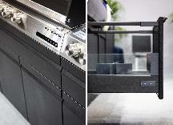

**232023_a**

Expectations on outdoor kitchen design are growing: dark fronts in combination with stainless steel being right on trend. The high quality of design can also be continued through on the inside with the versatile InnoTech Atira drawer system from Hettich. Photo: Hettich

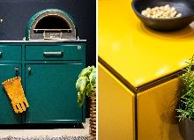

**232023_b**

Colourful highlights in the outdoor kitchen are provided above all by BBQ equipment and standalone kitchen modules or jazzy enamelled surfaces. Photo: Hettich

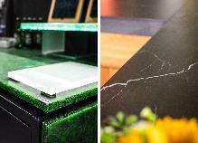

**232023_c**

Extravagant materials such as glass ceramics made from recycled bottles or classy looking reproduction marble underscore the growing status of outdoor kitchens. Photo: Hettich

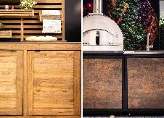

**232023_d**

Wood effect and real wood finishes give outdoor kitchens a very homely look and come in all colour options. Industrial chic, shown here in rust effect, has also arrived in the outdoor kitchen. Photo: Hettich

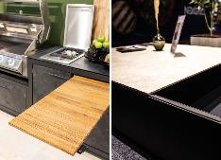

**232023_e**

Creative practical ideas for extra space and storage can be found in the outdoor kitchen too. Photo: Hettich



**232023_f**

[spoga+gafa2023 trendvideo hettich](https://www.hettich.com/short/umwmrzd)   
Hettich's trend scouts have come back from spoga+gafa 2023 with a fascinating video that summarises all the key trends.

About Hettich

Founded in 1888, Hettich is one of today's largest and most successful manufacturers of furniture fittings on the international stage. The family owned company is based at Kirchlengern in the furniture making cluster of Germany's East Westphalia region. Some 8,000 members of staff in almost 80 countries work together to give the industry future proof solutions. Promising "It's all in Hettich", the Hettich brand provides a comprehensive portfolio of services that is consistently and resolutely geared to the needs of customers across the globe. By tradition, top priority has always been at the focus of everything we do to ensure sustainability at social, societal and ecological level. [www.hettich.com](http://www.hettich.com)