**Tiny Home from Hettich sparks excitement in China**

**18m2 home living concept wins award and now features in acclaimed permanent exhibition**

**The 34th International Furniture Exhibition in Shenzhen/China saw Hettich's 18m2 sized Tiny Home win the "Best Whole House Solutions Award", securing it a permanent place in one of the country's largest trade shows for architecture.**

Cities in China are rapidly growing. In the most populous country on Earth, this means that technological and design focused innovations in furniture and interior design are among the keys in developing tomorrows urban environments. In particular, turnkey solutions that make the most compact of homes an attractive option are right on trend. Having already presented its Tiny Home at Interzum 2019, Hettich demonstrates how versatile storage solutions can turn an apartment on a mere 18 m2 of floor space into a fully adequate home that leaves you wanting for nothing: a conveniently equipped kitchen and bathroom as well as a living area that doubles up as a bedroom. For instance, the kitchen island becomes a table, the sofa a bed, the floor step a storage unit, with the bar also providing an occasional table. From floor to ceiling, every last inch of storage space is brimming with intelligent ideas.

Hettich is particularly delighted with the Chinese "Best Whole House Solutions Award" because China has a long tradition of home living in very small spaces, and this is reflected in the expectations being placed on new solutions. Demonstrating the accomplished integration of design, furniture and architecture, Hettich's Tiny Home now features in the permanent exhibition on display at the ALPUP Architects Research and Development Centre – one of the largest purchasing platforms for the furniture making and housing construction industry in China. Firm evidence that Hettich has made its mark in China with its contemporary, all embracing solutions.

The following picture material is available for downloading from **www.hettich.com, menu: Press**:

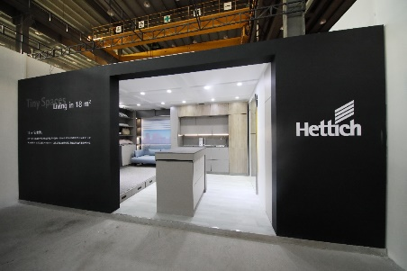

012021_a

The 18m2 Tiny Home from Hettich has made it into the permanent exhibition on display at the ALPUP Architecture Research and Development Centre in China. Photo: Hettich

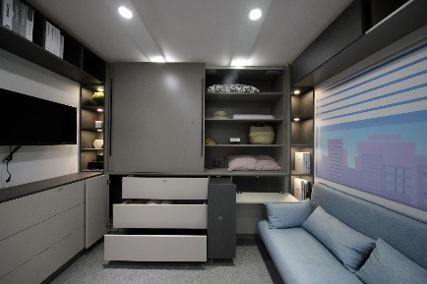

012021_b

Has it all: the Tiny Home from Hettich brings together a stylish feel, practical furniture and clever interior design to create a comfortable apartment in a minimum of space. Photo: Hettich

About Hettich

Hettich was founded in 1888 and is today one of the world's largest and most successful manufacturers of furniture fittings. Over 6,700 members of staff in almost 80 countries work together towards the objective: developing intelligent technology for furniture. Hettich thus inspires people all over the world and is a valuable partner for the furniture industry, trade and craft. The Hettich brand stands for consistent values: for quality and innovation. For reliability and customer proximity. Despite its size and international significance, Hettich has remained a family business. Being independent of investors means that the company has a free hand in shaping its future with a focus on the human element and sustainability.