“Holz Weiß”: From a joinery workshop to a full-service provider of interior design solutions
Establishing the furniture-making industry in partnership with Hettich

Holz Weiß has set a course for growth. In 2025, the construction and joinery firm, with its adjoining specialist timber shop, not only celebrated its 30th anniversary, but will also officially open its new workshop – equipped with state-of-the-art machinery – and its showroom, which has been expanded to 800 square metres, in June 2026. The fact that furniture manufacturing has developed into the third major column of the Geiselhöring-based company in Bavaria is also down to its long-standing and fruitful partnership with the fittings specialist Hettich.

Hettich fittings have been a constant feature at Holz Weiß since the company was founded in 1995. When Alexander Weiß attended the master craftsman’s school around 12 years ago, the focus was still on the timber trade and joinery, including the assembly of doors, windows and floors. Even back then, he had a clear vision of how the company should develop. “In the past, far more customers used to lay their own wooden floorboards or install wooden ceilings themselves. Over time, this has become less and less common, and as a result, the timber trade has also declined steadily. We took this as an opportunity to focus more closely on our skills as joiners. Today, we are a one-stop shop for furniture, interior designers and building components, offering a wide range of related services," explains Alexander Weiß. “What has remained unchanged over the years, however, is the Bavarian mentality. Long-standing relationships, getting to know one another personally and mutual trust continue to play a major role for us. The same applies to our suppliers."

If we’re going to make a splash in the furniture industry, it’ll be with Hettich
When Hettich’s field sales team gave a presentation at Alexander Weiß ’s master carpentry school, showcasing their practical range of fittings, it became clear to the aspiring master carpenter that he had found the right partner to help his joinery business focus on the production of high-quality furniture. It was not only Hettich’s innovative fittings that impressed him, but also, in particular, the sales team’s high level of motivation. This became abundantly clear when Alexander Weiß was looking for a suitable fitting solution for his masterpiece – a drinks cabinet in the shape of the Empire State Building. Thanks to the personal commitment of the Hettich sales representative, a bespoke solution was found. This led to a close, long-standing partnership, which continues to be characterised by effective and prompt collaboration with the Hettich team.

Exhibitions as a driver of turnover
It was clear to the young master joiner that the only way to establish the furniture division would be through an exhibition. “It is extremely important for customers to be able to see and touch the things they want to buy,” he says. His success proved him right. When the first exhibition of kitchens, bathrooms and living room furniture opened, the joinery had eight staff; today there are around 40. Customers are advised personally by the owners, Robert and Alexander Weiß. The two of them attend between 10 and 20 consultation appointments each week. Customers really appreciate this, as it’s something the big furniture stores and building materials suppliers don’t offer. In Geiselhöring, everyone knows one another, and family-run businesses are held in particularly high regard. In the extended exhibition, Holz White showcases not only furniture across 800 square metres, but also everything else that defines a room, such as windows, flooring, sun protection, front doors and much more – all crafted by a single artisan.

AvanTech YOU in all its forms
The AvanTech YOU drawer system from Hettich has been particularly well received at the exhibition. The modern look, with its narrow, straight drawer side profiles, is very appealing. During consultations, the Weiß family like to use the sample display featuring the various colours and finishes available in the drawer system. The various operating mechanisms include the synchronised opening of two adjacent drawers and the opening of handleless drawers using the ‘push-to-open’ mechanism. At the exhibition, customers can see for themselves the high level of comfort and added value offered by Hettich fittings. These include a wide variety of sliding door fittings as well as concealed hinges, in particular the Sensys range with integrated damping and in the colour Obsidian Black. Hettich’s modern Cadro aluminium frame system is also included. This makes it easy to have modern shelving systems made to measure.

Thanks to the new building, Holz Weiß has quadrupled its workshop and production space and created a ‘Carpentry 4.0’ facility. This means that all the conditions are in place for further growth, which the managing directors, Robert and Alexander Weiß, intend to continue designing in partnership with Hettich.

The following picture material is available for download under the "Press" menu at www.hettich.com:

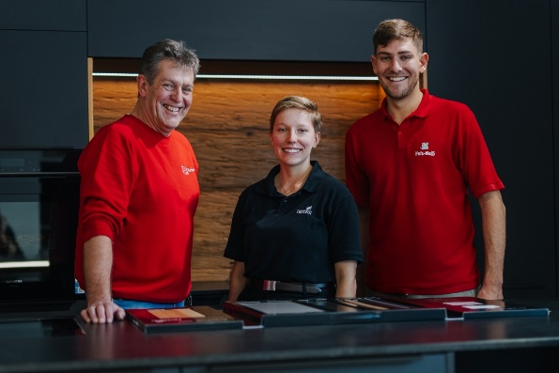
262026_a
A great team: Managing Directors Robert Weiß (left) and Alexander Weiß (right) with Lena Bruggesser from Hettich in a kitchen in the new, expanded showroom. Here, customers can experience the AvanTech YOU drawer system for themselves. Photo: Hendrik Steffens

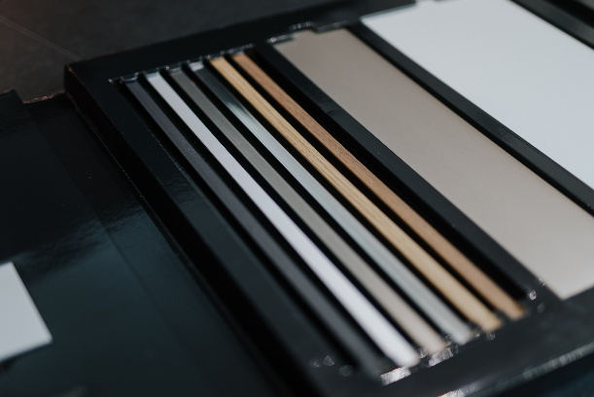
262026_b
The AvanTech YOU sample fan is ideal for showing customers the various colours and finishes in which the drawers can be manufactured to match the front panel or to contrast with it. Photo: Hendrik Steffens

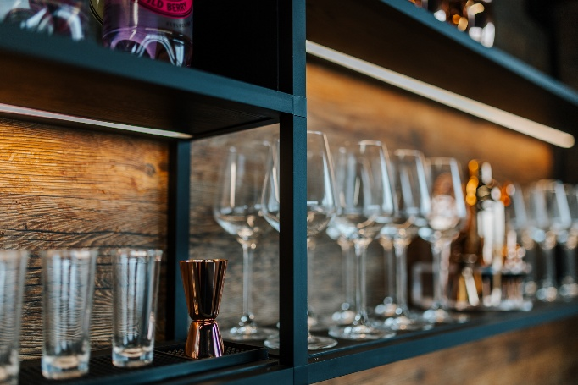
262026_c
Individual variety is at the heart of Holz Weiß’s new exhibition: using Hettich’s Cadro frame system, Holz Weiß has created modern shelving solutions, complete with lighting. Photo: Hendrik Steffens

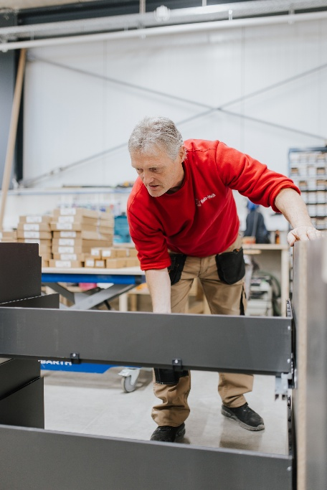
262026_d
The Holz Weiß team also values Hettich’s AvanTech YOU drawer system because it is easy to assemble. Photo: Hendrik Steffens

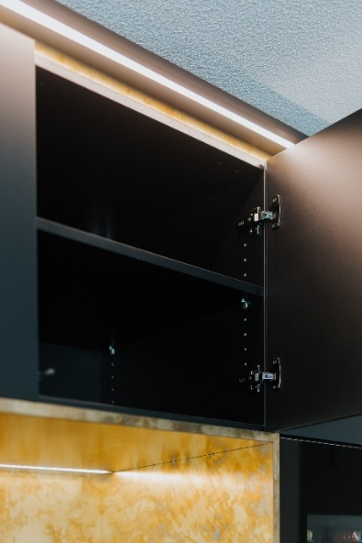
262026_e
It doesn’t get much more elegant than this: the Sensys hinge in obsidian black blends seamlessly with the dark finishes of the kitchen wall units. Photo: Hendrik Steffens

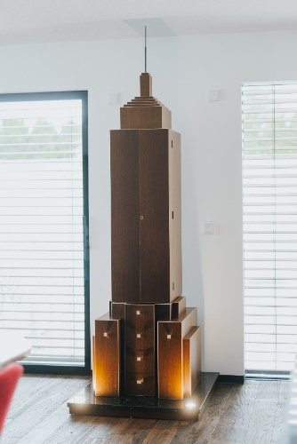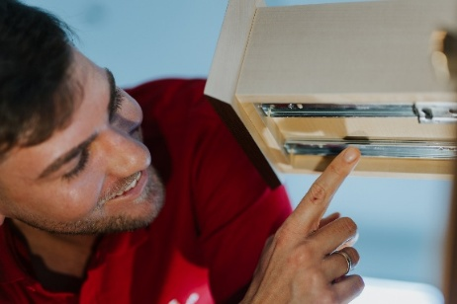
262026_f+g
A true masterpiece: a drinks cabinet in the shape of the Empire State Building – built by Alexander Weiß. When looking for the right drawer runners for the narrow, inset drawers, Hettich proved to be the right partner to provide a solution.
Photo: Hendrik Steffens

About Hettich
Founded in 1888, Hettich is one of the world’s largest and most successful manufacturers of furniture fittings. The family-owned company is based in Kirchlengern, in Germany’s East Westphalia furniture production region. Around 8,200 colleagues work together to deliver future ready solutions in more than 100 countries. Under the brand promise “It’s all in Hettich”, the company provides a comprehensive portfolio of products and services consistently aligned with customer needs worldwide. Responsible, sustainable action — socially, societally and environmentally — has always been a top priority for Hettich. www.hettich.com

