Rethinking interior fittings:
More space, more order, more flexibility

Hettich is consolidating its strengths to offer carefully considered solutions for interior fittings. Neat organisation, convenience, individualisation – the wish for easy to use storage space is growing. The family owned company is responding to this trend by presenting a newly defined product segment for storing provisions, cookware, clothing and other items for multifunctional applications – inspired by real life, perfected in every last detail.

Offering this newly positioned lineup, Hettich is underscoring its expertise as a system provider, demonstrating how intelligent cabinet and wardrobe interiors work today. Whether tall units, base units or corner units – fitting systems from Hettich optimise storage spaces behind the furniture front and give them practical functionality. This is where four design lines offer maximum creative flexibility: steel baskets made of round, chrome plated wire, powder-coated steel pull-out shelves with solid surface, pull-out shelves with chrome plated round wire railing or with modern flat wire railing. So there’s something for every taste and requirement. Here, design, technology and functionality enter a seamless symbiosis.

One system – many options
Interior fittings from Hettich’ guarantee maximum storage space with stylish looks and impressive ergonomics. The consistent concept can be customised and applied in a variety of ways, from classic internal pot-and-pan drawer to carefully considered tall and corner unit interiors. The fittings specialist offers numerous combinations, colour coordinated elements in anthracite pick up on the design of other Hettich products to create a perfectly balanced, overall look.

Inspiration for any application
Whether kitchen, bathroom, utility room, dressing room or homeworking – Hettich shows how furniture can excite from within. The new product range assists retailers, the trades, industry and architects with modular components, digital planning support and comprehensive marketing material.

Get further details at: https://www.hettich.com/short/nz8lkcr

The following picture material is available for downloading from the "Press" menu at www.hettich.com:

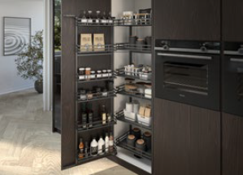
302025_a
The “Iseo” swivelling pull-out from Hettich guarantees optimum organisation and ergonomic access to all contents, even at the back of the tall unit. The flat wire railing in elegant anthracite (DesignLine 400) underscores the clean lines. Photo: Hettich

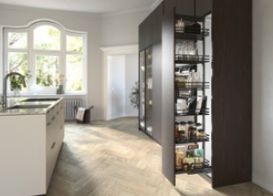
302025_b
Compact storage, cleverly organised: the “Olona” tall unit pull-out brings kitchen utensils to the front, making them easy to see and reach. Photo: Hettich

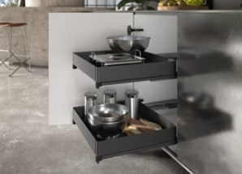
302025_c
Maximum use of space and easy access, even in the base unit: the “Naro” full-extension pull-out creates neat and tidy organisation – even for heavy kitchen appliances. Closed sides and an integrated anti-slip mat keep everything securely in its place. Photo: Hettich

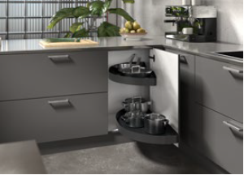
302025_d
Corners used efficiently: the “Salso” swivelling pull-out for the corner unit turns even the most awkward of spaces into easily accessible storage. Powder-coated steel shelves (DesignLine 200) provides a load capacity of up to 36 kg per pull-out. Photo: Hettich

About Hettich
Founded in 1888, Hettich is one of today's largest and most successful manufacturers of furniture fittings on the international stage. The family-owned company is based at Kirchlengern in the furniture making cluster of Germany's East Westphalia region. Some 8,400 members of staff work together to provide our future proof solutions in over 100 countries. Promising "It's all in Hettich", the Hettich brand provides a comprehensive portfolio of services that is consistently and resolutely geared to the needs of customers across the globe. By tradition, top priority has always been at the focus of everything we do to ensure sustainability at social, societal and ecological levels. www.hettich.com

