Hettich Group commits to science-based climate targets
Official signing of the Science Based Targets initiative (SBTi) agreement

The Hettich Group, one of the world's leading furniture fittings manufacturers headquartered in Kirchlengern, has committed to the Science Based Targets initiative (SBTi), thereby reaffirming its pledge to climate protection and a sustainable future. By signing the SBTi agreement, Hettich commits to setting and implementing science-based targets for reducing greenhouse gas emissions in line with the Paris Climate Agreement.

"In line with our motto “Act today, think tomorrow”, we at Hettich take responsibility for the world we live in. Signing the SBTi agreement is an important milestone for Hettich and underlines our responsibility to future generations," explains Timo Pieper, Managing Director at Hettich. ‘We are convinced that by setting clear, science-based targets, we can reduce our carbon footprint, drive innovation and make a positive contribution to climate protection,’ adds Pavan Jha, Sustainability Manager at Hettich.

Commitment to clear targets and sustainable processes

By joining the SBTi, Hettich commits to the following measures:
- 50% reduction in Scope 1 & 2 emissions by 2030
- Switch to 90% renewable electricity by 2030
- Supplier commitment to Scope 3 reduction
The certificate was signed on behalf of all colleagues in the Hettich Group at this year's press conference.
About the Science Based Targets initiative (SBTi)

The Science Based Targets initiative (SBTi) is a collaboration between the Carbon Disclosure Project (CDP), the United Nations Global Compact, the World Resources Institute (WRI) and the World Wide Fund for Nature (WWF). The SBTi supports companies with an independent, transparent and recognised verification process in setting science-based climate targets for reducing greenhouse gas emissions. This contributes to limiting global warming to a maximum of 1.5°C, as envisaged in the Paris Agreement.

The following picture material is available for downloading from www.hettich.com, Menu: Press.

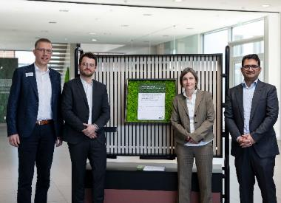
292025_a

Proudly presenting Hettich's scientifically based climate targets: Timo Pieper, Leon Sundermann, Claudia Schumacher and Pavan Jha. Photo: Hettich


292025_b

Timo Pieper, Managing Director at Hettich, Dr Andreas Hettich, Chair of the Hettich Group’s Advisory Board, and Pavan Jha at the symbolic signing of the climate targets. Photo: Hettich
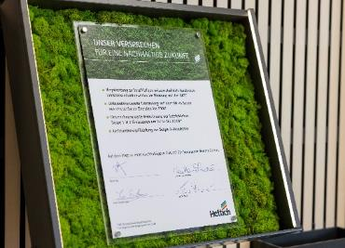
102025_c

Hettich's promise for a sustainable future. Photo: Hettich

About Hettich
Founded in 1888, Hettich is one of today's largest and most successful manufacturers of furniture fittings on the international stage. The family-owned company is based at Kirchlengern in the furniture making cluster of Germany's East Westphalia region. Some 8,400 members of staff work together to provide our future proof solutions in over 100 countries. Promising "It's all in Hettich", the Hettich brand provides a comprehensive portfolio of services that is consistently and resolutely geared to the needs of customers across the globe. By tradition, top priority has always been at the focus of everything we do to ensure social, societal and ecological sustainability. www.hettich.com

