RoomSpin wins German Design Award 2025
Turning swivelling movement brings new drive to transforming office worlds

When interior furnishings and workstations are able to turn in rigidly defined office structures, you get entirely new design and usage concepts. Presenting RoomSpin, Hettich provides a unique, movable system base for transforming furniture and rooms. This innovation and its huge potential for change has now brought RoomSpin the German Innovation Award 2025 in the ”#W2 Excellence in Business to Business – Office Solution” category.

RoomSpin already caused a sensation when it premiered at Orgatec 2024. Taking the example of Kuhn's creative “Layers moved by RoomSpin” office line, the design and manufacturing company behind solutions for high quality interior fixture and fittings, Hettich showed the tremendous potential this gives interior designers, architects and project developers. Based on its unique “translatory rotational movement,” they can now pursue whole new design and planning avenues. Hot on the heels of the Architecture and Office 2024 innovation award comes RoomSpin's second accolade in the form of the German Innovation Award 2025.

Multifunctional use of space
The German Innovation Award goes to products, projects and pioneering achievements that enduringly improve life through innovation and advancement. Increasingly, modern working environments are calling for interior design concepts that provide flexibility and efficiency in the way they use even smaller type spaces. Employing a curated movement, RoomSpin lets staff rearrange their furniture and workspaces in a matter of seconds and match them to the particular work situation. Whatever the chosen concept looks like, office space always remains clearly zoned. Setups, spatial effect, lighting or power and communication sockets – everything can be planned in advance with perfect results. Utilising lever forces, turning RoomSpin based furnishing solutions is far more convenient than moving mobile furniture items that then need rearranging every time demands change. Based on the turning RoomSpin system, room elements can be configured in any way – from cabinets and room dividers that can be used from both sides to single person workstations and areas for holding meetings.

To Hettich's design awards:
https://web.hettich.com/de-de/inspiration/design-award
To get more on RoomSpin, go to:
https://www.hettich.com/en-us/products/new-products/roomspin

The following picture material is available for downloading from the "Press" menu at www.hettich.com:



152025_a
Hettich’s turning RoomSpin system base won the German Innovation Award 2025 in the “#W2 Excellence in Business to Business – Office Solution" category. Photo: Hettich

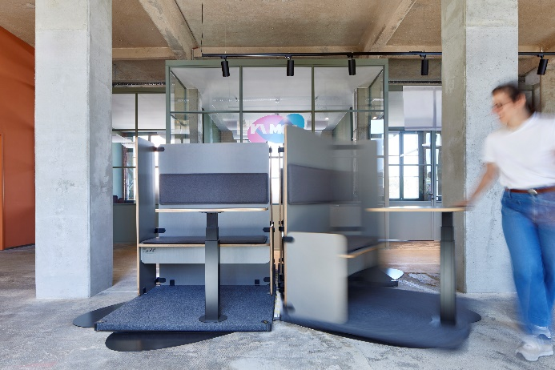
152025_b
This application example shows the possibilities of how flexibly workspaces can be designed with RoomSpin. Thanks to RoomSpin, each workstation module can be rotated as required and adapted to the work situation. Photo: Hettich

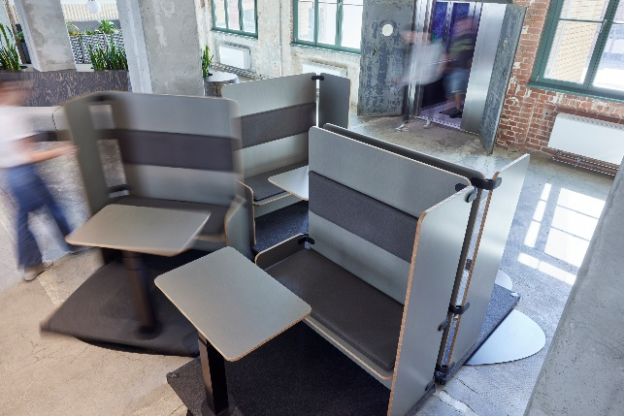
152025_c
Whether individual or team work - everything takes place on the same surface. The configuration can be quickly rearranged with a spin. Photo: Hettich

About Hettich
Founded in 1888, Hettich is one of today's largest and most successful manufacturers of furniture fittings on the international stage. The family-owned company is based at Kirchlengern in the furniture making cluster of Germany's East Westphalia region. Some 8,400 members of staff work together to provide our future proof solutions in over 100 countries. Promising "It's all in Hettich", the Hettich brand provides a comprehensive portfolio of services that is consistently and resolutely geared to the needs of customers across the globe. By tradition, top priority has always been at the focus of everything we do to ensure sustainability at social, societal and ecological levels. www.hettich.com

