ORGATEC 2026: Adaptive Spaces with Hettich
End to end solutions for transformable offices spaces

From transformable furniture to adaptive spaces: Hettich develops future proof solutions for the home, lifestyles and workplaces of tomorrow under its leitmotif, "Transforming Spaces". With "Adaptive Spaces. Made to adapt", The fittings specialist will be showcasing adaptable contract and interior design solutions that efficiently adapt to any situation and people's needs at the ORGATEC 2026 trade fair from 27 to 30 October in Cologne, Germany.

One space, endless possibilities. Adaptive space solutions that enable a variety of different uses and functions on the same footprint are becoming increasingly important in architecture, interior design, property development and in the world of hospitality. To this end, Hettich provides innovative fittings technologies, intelligent motion systems and planning assistance for a wide variety of requirements, all from a single source. In cooperation with the Actiforce and KUHN brands from the Hettich Network, Hettich will be showcasing end to end spatial solutions for adaptive office environments that open the way to innovative planning approaches. The focus of these solutions is on optimising room acoustics, ergonomic working environments and rapid adaptability to different situations.

RoomSpin – the new dimension for "Adaptive Spaces"
Hettich will be demonstrating with a range of applications how rotating interior elements can fundamentally transform the planning and use of office spaces. With just one turn, the "RoomSpin Frame Box" users can switch quickly between an open room situation for teamworking and meetings to an enclosed space to retreat and work alone in. Hettich will also be demonstrating how RoomSpin can transform the function of an entire room in an instant using several adjacent, full-height furniture units: simply rotating the units reveals the other side of the furniture – and with this, an entirely new design and a completely different way of using the space. With this approach, a single room can combine a variety of functions and can be transformed from a workspace into a storage solution, for example, in a matter of seconds. Given the scalability of the SpinLines turning and swivelling systems, space saving interior designs that make efficient use of the space can be realised in all sorts of areas.

Moving people and spaces
Set in a workspace scenario, the Hettich Network will be presenting the results of intense cooperation. The spectrum encompasses design focused soundproofing elements – such as canopy ceilings, wall panels, partitions and curtain elements – made from iswall®, a felt like sound absorbing material. These are complemented and combined with KUHN’s agile LAYERS interior design system, as well as Activity stools, height adjustable desks and the new SF 1050 TILT from Actiforce. A particular feature here is that the height and tilt angle of desktop on the TILT desk support can be adapted to suit each individual user. Certified by "Aktion Gesunder Rücken e.V." (Campaign for Healthier Backs), TILT meets scientifically verified requirements on ergonomic workplace design.

Trade fair visitors can look forward to a diverse interplay of all furniture and spatial elements. The visitors are also invited to bring along their own ideas and projects and explore them with the Hettich team on site.

More about Hettich Network at Orgatec 2026.

The following picture material is available for download under the "Press" menu at www.hettich.com:

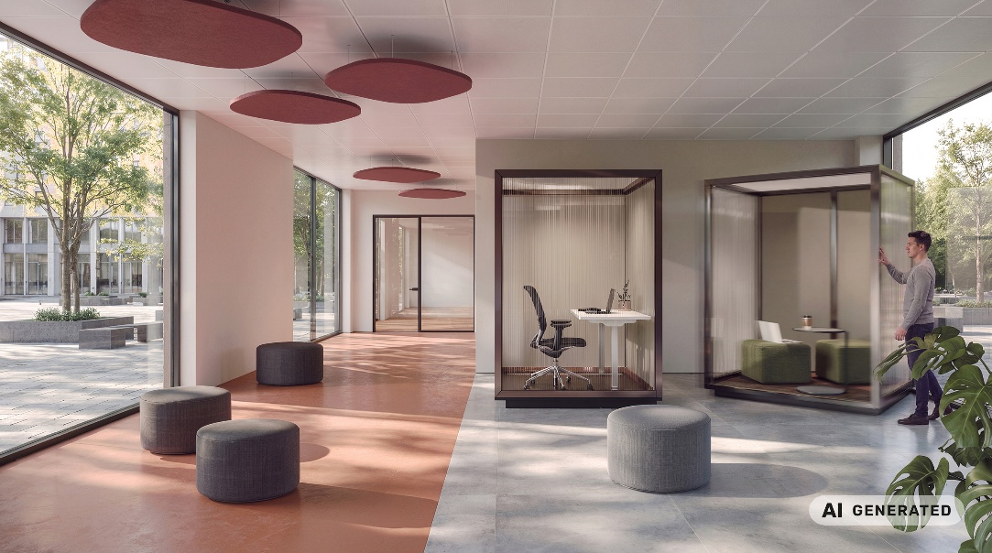
312026_a
The “RoomSpin Frame Box” combines efficient use of space with flexibility in designing the work environment. Just one turn is all that is needed to switch between a teamworking zone and a segregated zone for individuals to work alone in.
Photo: Hettich (AI-generated)

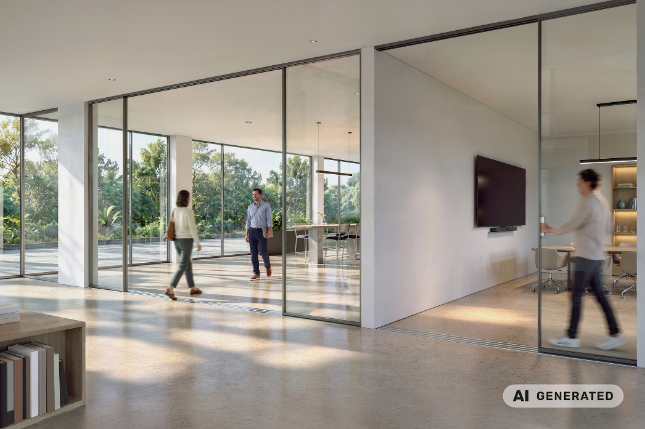
312026_b
Sliding door systems from KUHN can be perfectly adapted to the room’s architecture and can be made from a wide variety of materials. Photo: Hettich (AI-generated)

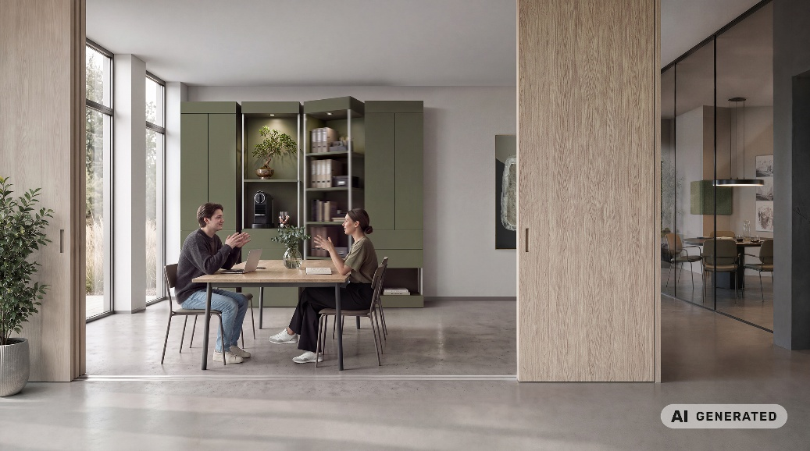
312026_c
The ability to adapt spaces increases their usage potential and enables temporary zoning. Photo: Hettich (AI-generated)

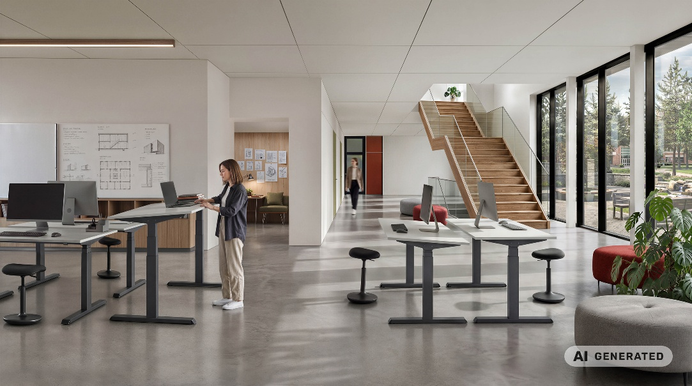
312026_d
Ergonomics plays a key part in the satisfaction, health and well-being of staff. The new SF 1050 TILT height adjustable desks from Actiforce can also tilt the desktop to suit any individual preference. Photo: Hettich (AI-generated)

About Hettich
Founded in 1888, Hettich is one of the world’s largest and most successful manufacturers of furniture fittings. The family-owned company is based in Kirchlengern, in Germany’s East Westphalia region. Hand in hand with its customers, Hettich uses innovative solutions to shape tomorrow's living spaces. Its work centres on users’ needs and on the question of how to provide flexibility in adapting to changing needs at home, in life and at the workplace. The Hettich, FGV, Actiforce and KUHN brands bring together a range of expertise and perspectives within the international Hettich Network. Some 8,200 colleagues consolidate incredible competence to give customers the achievements of so many specialists on a one shop basis. The Hettich Network combines business success with ecological, social and civic responsibility, taking a long-term, multigenerational approach to everything it does. www.hettich.com

