Online configurator for Quadro oven runners
New Hettich service for white goods manufacturers

Hettich's Quadro runner systems have been a reliable feature in state-of-the-art ovens from the manufacturers of a wide range of well-known brands for years. Now, the fittings specialist is offering a practical online configurator that enables appliance manufacturers to quickly get started with the design process. The configurator includes all of the different versions of the runners, including their various features and connection options, enabling manufacturers to plan the ideal Quadro oven runner, visualze it in 3D, and integrate it into existing design systems in just a few steps.

Quadro oven runners are a key convenience and differentiating feature in high-quality appliances. Hettich has a very broad product portfolio perfectly tailored to its white goods customers. Manufacturers can use the online configurator to create their preliminary plans for a new oven model with complete independence and efficience, meaning that they can pour their focus completely into their design wishes and reuqirements. The online configurator makes it easier to choose the ideally suited Quadro runner and supports the overall appliance design work. The configuration created in the configurator is available for downloading as a drawing file and can be imported easily into your own planning software. This means that your initial oven runner configuration, including the CAD data that is generated, enables a fast start with the ongoing design process and is the ideal basis for time-saving processing. Hettich’s experienced developers will be happy to provide support in the final design and realization of the oven model.

Quicker and easier planning with the configurator
Appliance manufacturers will find the configurator on the Hettich website: https://www.hettich.com/short/l37kym8
The registration process is very easy. Once registered, you will have free access to the new configurator and can immediately start with the first layout for a Quadro drawer runner project. Hettich is extending its comprehensive range of services with the online configurator: appliance manufacturers can take the first step themselves – and Hettich will provide personal support until the ideal solution is found. Why not get started right away?

The following picture material is available for downloading from the "Press" menu at www.hettich.com:

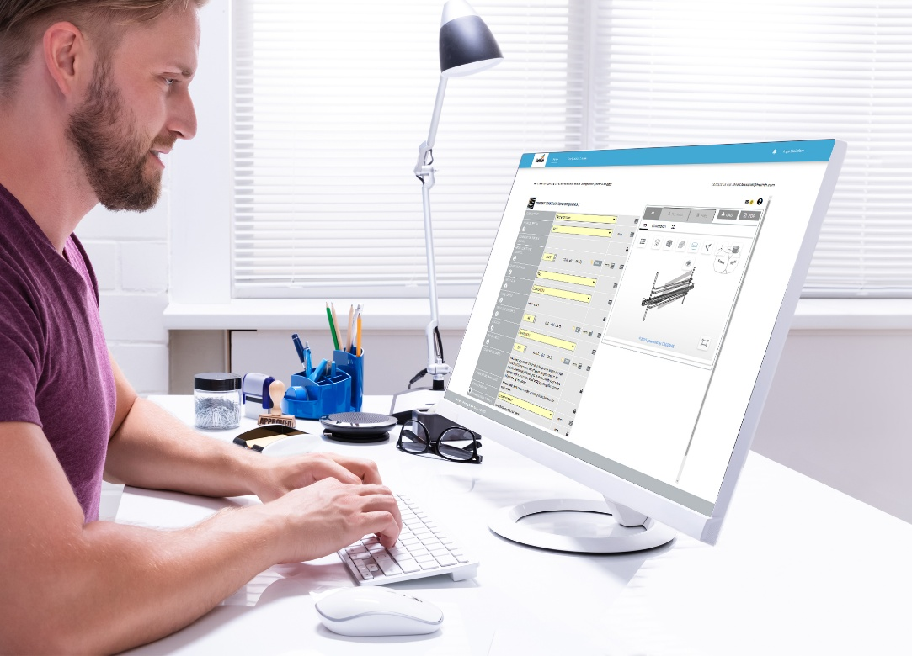
142025_a
The online configurator for Quadro oven runners by Hettich gives manufacturers a rapid introduction to the further design process through the CAD data that it makes available and is the ideal basis for time-saving processing. Photo: Hettich

About Hettich
Founded in 1888, Hettich is one of today's largest and most successful manufacturers of furniture fittings on the international stage. The family-owned company is based at Kirchlengern in the furniture making cluster of Germany's East Westphalia region. Some 8,400 members of staff work together to provide our future proof solutions in over 100 countries. Promising "It's all in Hettich", the Hettich brand provides a comprehensive portfolio of services that is consistently and resolutely geared to the needs of customers across the globe. By tradition, top priority has always been at the focus of everything we do to ensure sustainability at social, societal and ecological levels. www.hettich.com

