Miele and Hettich present a future study for multifunctional living in small space
“Miele Compact Living: Kitchen Unit Powered by Hettich"

How can a fully fledged living and working area be realised in a limited space without compromising quality and comfort? With the "Miele Compact Living: Kitchen Unit powered by Hettich" study, Miele and Hettich are presenting a solution that combines a workplace, kitchen and dining area in one transformable piece of furniture as part of Milan Design Week. The concept can be seen at the Miele Experience Center in Milan from 21 to 26 April 2026.
Growing housing shortages, especially in urban areas, require new approaches to living spaces. Functions such as working, cooking and eating do not take place in parallel, but one after the other. The study translates this principle into a piece of furniture that intelligently combines different usage scenarios on a compact surface. "We see great potential in no longer thinking about spaces statically, but organising them according to their actual use. If functions are sequenced, a piece of furniture can absorb this dynamic and create significantly greater utility on the same surface area," explains Daniel Rehage, Innovation Manager at Hettich.

Movement as a principle: hardware technology for adaptive space utilisation
The exhibit consists of two tall unit elements with integrated kitchen appliances and a height-adjustable work and table surface in front. The appliances are integrated into movable furniture elements and are either visible or completely concealed, depending on how they are used.
The technological basis is provided by fitting solutions from Hettich: the turning‑and‑swivelling system FurnSpin - electrified for the first time in this application - electrically driven drawers and the LegaDrive lifting column system.

FurnSpin enables complete furniture elements to be rotated around their own axis. Appliances such as the oven, coffee machine or steam cooking drawer move forwards and disappear back into the unit when not in use. This creates a change between an open functional zone and a closed front panel in a matter of seconds.
Electrically powered AvanTech YOU "Illumination" drawers open in synchronisation with use and provide access to storage space.
The LegaDrive lifting column system, powered by an electric motor, enables infinitely variable height adjustment of the work surface at the touch of a button.
The electrification of the FurnSpin and drawer systems is based on a new drive concept that Hettich first presented as a concept study at Interzum 2025.

One piece of furniture, three usage scenarios: working, cooking, eating
In the work situation, the table surface is at seat height and offers a tidy work area, while selected functions - such as the coffee machine - are accessible.
When switching to cooking mode, the work surface moves to an ergonomic height. FurnSpin ensures the rotation of the units in the room. Drawers open to reveal access to cooking utensils. This creates a fully equipped cooking environment. In the dining area, the furniture is reduced to a clear, homely mould: appliances disappear from view and the surface becomes a dining table. The system is operated via predefined scenarios using an app or radio button.

The study is aimed at architects, planners and the furniture industry and provides concrete impulses for the discussion on sustainable concepts for compact living.

The following image material is available for download in the menu "Press" at www.hettich.com:

Images
Captions
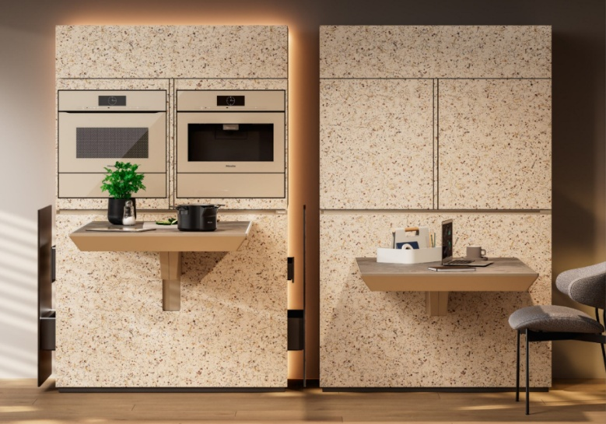
092026_a
One piece of furniture, multiple uses: the concept shows how different functions can be combined in a compact space in one system. Photo: Miele

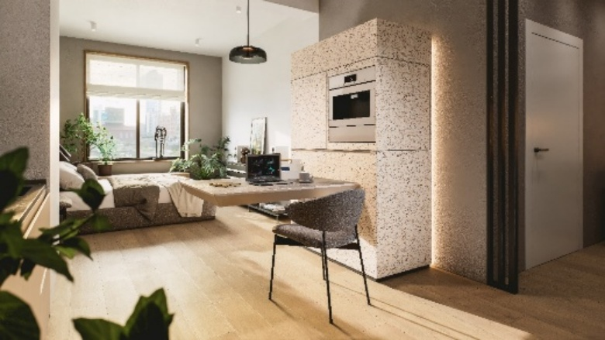
092026_b
Compact design: The height adjustable table top creates a functional workplace, while integrated appliances remain accessible if required. Photo: Miele

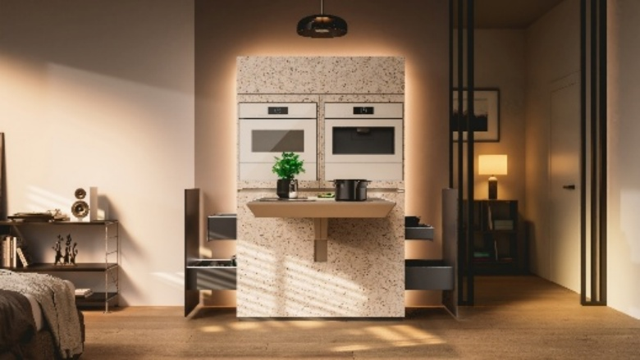
092026_c
Cooking at the touch of a button: a fully-fledged cooking environment is created when required - rotating appliances move into the working area thanks to FurnSpin. Photo: Miele

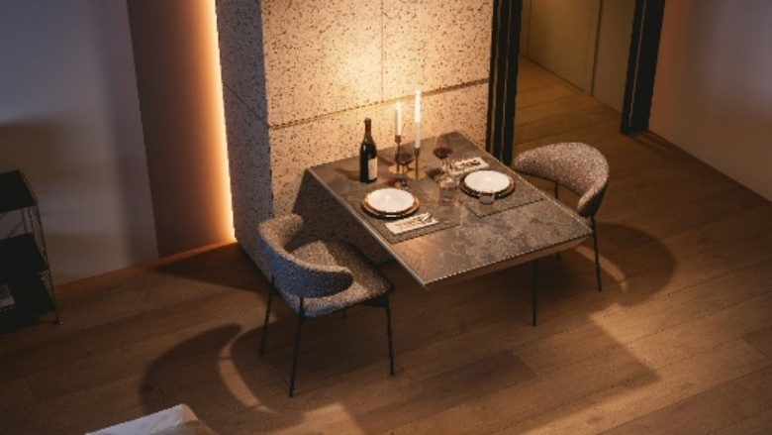
092026_d
From the kitchen to the dining table: the household appliances disappear from view, closed front panels ensure a calm appearance. Photo: Miele

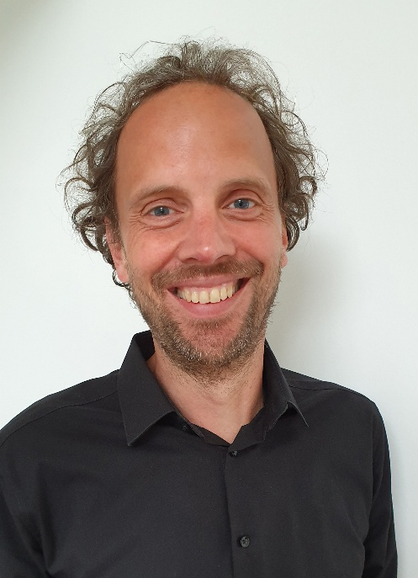
092026_e
Daniel Rehage, Innovation Manager at Hettich, thinks of rooms in terms of their utility: flexible, changeable and designed to enable several functions on the same surface. Photo: Hettich

About Hettich
Founded in 1888, Hettich is one of the world’s largest and most successful manufacturers of furniture fittings. The family-owned company is based in Kirchlengern, in Germany’s East Westphalia furniture production region. Around 8,200 colleagues work together to deliver future ready solutions in more than 100 countries. Under the brand promise “It’s all in Hettich”, the company provides a comprehensive portfolio of products and services consistently aligned with customer needs worldwide. Responsible, sustainable action — socially, societally and environmentally — has always been a top priority for Hettich. www.hettich.com

