That was the Küchenmeile 2025 Kitchen Mile Trade Fair: Manufacturers presented their new products with Hettich
The Kitchen Mile was the trendsetting show of the year and once again the international meeting place for the industry. Some design trends were unmistakable: the kitchen is becoming brighter again, and kitchen design has gained an innovation – that of rotation. A number of manufacturers presented Hettich's unique FurnSpin turn-and-swivel system in a range of applications. Pronorm also used the Kitchen Mile to premiere its purist drawer system, proTech X – developed jointly with Hettich.

As an innovative fittings specialist, Hettich is an indispensable partner for kitchen and appliance manufacturers when developing solutions that simultaneously meet the requirements of the market and of kitchen buyers. The new proTech X designer drawer side profile from Pronorm is based on the ExeoTech drawer system from Hettich. It impresses with a particularly slim, clean-lined design and the ability to reflect different design versions within one system – and it also takes the brand manufacturer's production process to a new level.

FurnSpin revolutionising kitchen design
The FurnSpin turn-and-swivel system from Hettich can be scaled to suit various applications. It makes transforming kitchen furniture from open to closed and vice versa a new form of storage space utilisation and a highlight in the premium kitchen segment. Eggersmann utilises this fitting innovation to demonstrate just how extraordinary kitchen designs can be with the homely GLOW tall unit element, which integrates glass sides and lighting. Nobilia uses a FurnSpin XL in its base unit, and BT 45 showcases it in a total of three different applications. One of these is based on Hettich’s RoomSpin object carrier, which makes entire interiors rotatable.

The 2025 design trends
Kitchens not only have to look good; they should also make everyday life noticeably easier. With its optimised storage solutions, ergonomic drawer systems with lighting, and other fittings innovations, Hettich provides a wide range of solutions that create greater convenience in the kitchen. Openness and visual lightness are further design trends. This is reflected in open shelves, reduced frames, slim contours, and greater transparency. With the new SAH 500 heavy-duty hanger, which makes even heavy furniture appear to float, Hettich has introduced another trend-oriented solution.
In addition, natural materials dominate kitchen design. Wooden structures, along with light surfaces, are becoming even more prominent than before. Natural stone, brushed surfaces, and hand-patinated metals are combined with smooth finishes. Here, organic structures replace pure minimalism. Manufacturers are increasingly focusing on soft transitions with curved edges, rounded unit sides, and semicircular shapes. Ergonomics and well-being play a major role in kitchen design. This is also reflected in warm, earthy, and muted colours. Shades such as beige, greige, sand, sage, olive, and terracotta create a pleasantly calming atmosphere. Black is used more as an accent colour. Refining details such as bronze, gold, and metallic finishes can be found on handles, fittings, and decorative strips.

You can find out more about the current trends in branded kitchens and solutions with Hettich here: https://www.hettich.com/short/r90xn68
The following picture material is available for download from the "Press" menu at www.hettich.com:
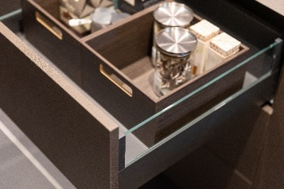
392025_a
Pronorm presented its new proTech X drawer system which, with a drawer side profile of just 11 mm, perfectly matches the design and process requirements of the brand manufacturer. The proTech glassCase design version is shown here. Photo: Hettich

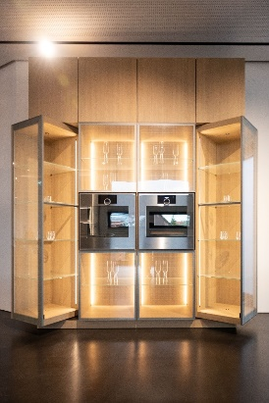
3902025_b
Eggersmann impressed with transparency, light, and innovation in the form of two FurnSpin GLOW systems. Photo: Hettich
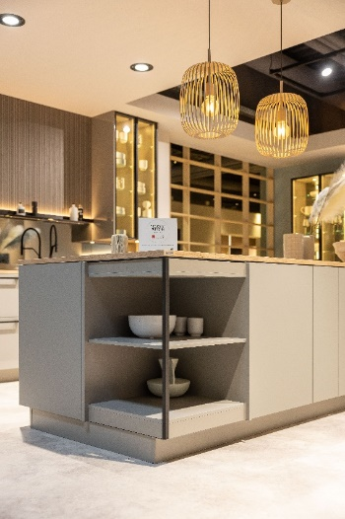
392025_c
Nobilia introduced FurnSpin in various versions in its new kitchen ranges. A FurnSpin M installed below a kitchen island is shown here. Photo: Hettich

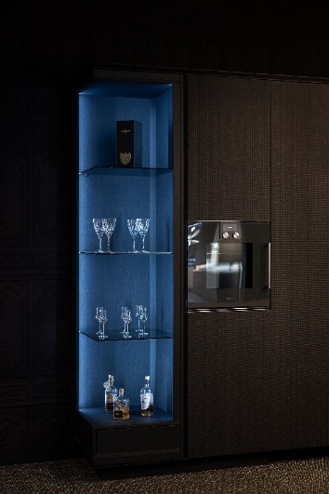
392025_d
BT 45 presented the FurnSpin XL very stylishly with a subtle colour scheme. Photo: Hettich

About Hettich
Founded in 1888, Hettich is one of today's largest and most successful manufacturers of furniture fittings on the international stage. The family-owned company is based at Kirchlengern in the furniture making cluster of Germany's East Westphalia region. Some 8,400 members of staff work together to provide our future proof solutions in over 100 countries. Promising "It's all in Hettich", the Hettich brand provides a comprehensive portfolio of services that is consistently and resolutely geared to the needs of customers across the globe. By tradition, top priority has always been at the focus of everything we do to ensure social, societal and ecological sustainability. www.hettich.com

