**Küchenmeile 2024: Trends and Innovations**

**Brand manufacturers from East Westphalia-Lippe value partnership with Hettich**

**Küchenmeile is a beacon for the global markets because this year as well, the brand manufacturers unveiled the look of their answers to the world's megatrends. The international trade audience witnessed kitchen concepts that capture the zeitgeist and satisfy the needs of a modern society. Behind many of the pioneering new approaches to designing and using kitchens are innovative fittings from Hettich. Küchenmeile set the stage for the who's who of kitchen brands and appliance manufacturers to present a plethora of amazing designs and solutions for a new generation of kitchens.**

Purist, elegant looking front and worktop materials and slimline drawer systems are the new design trend. Premium manufacturers like Nolte Küchen, Sachsenküchen, Pronorm, Beeck and Poggenpohl were the pioneers - now, launching the nBOX drawer system, global player nobilia is heralding a new design era with a slender drawer side profile. At just 10.7 mm, the nBOX drawer side profile comes with minimalist aesthetic appeal. Material slenderness not only gives kitchens an elegant, light and airy look, it also means more space inside the drawer for the user. By the same token, worktops are also slimming down and taking on more vibrancy. Natural stone in all its facets and colour ways - notably marble - dominates the scene in worktop materials. Recycled natural stone is also an option for the worktop. Yet beside all the purism, homeliness too is a growing kitchen feature: delicate designs are paired with rounded contours on kitchen islands, tall units and shelf elements as well as with textured surfaces. Warm and calming wood tones such as light oak are combined with silk matt natural and pastel shades. Black is now taking more of a back seat and preferably combined with light tones. The sense of homeliness is underscored by the trend towards living in interwoven spaces and by bringing kitchen cabinetry more in line with furnishings in the rest of the home. Accent features in gold, copper or stainless steel add touches of extravagance. Customisation is becoming increasingly important in kitchen design. To this end, many brand manufacturers like Pronorm, Eggersmann and Rational are utilising the creative potential offered by Hettich AvanTech YOU drawer system.

**Design highlights that can swivel**

Küchenmeile visitors were left is amazement by the swivelling tall units and kitchen island corner cabinets presented by manufacturers such as Beeck Küchen and SieMatic. These exclusive solutions are based on the innovative FurnSpin turning swivelling fitting from Hettich. Storage space is used here in a surprisingly different way and given a completely unique design because FurnSpin rolls two pieces of furniture into one. A quick turn of the hand transforms the closed furniture front into an open shelf element. In its new S2 Next Generation kitchen line, SieMatic even presented a swivelling Secret Space tall cabinet with elegant lighting. Turning the tall unit to the open position automatically switches on an LED light strip that's vertically integrated in the frame.

**User convenience no finer**

Kitchen appliances are getting smarter all the time. For instance, the latest refrigerator from Samsung uses AI to identify the food that's put in and taken out again. On this basis it suggests recipes on the display or, via app, sends the shopping list to your mobile phone. All very convenient. At the same time, users are placing growing expectations on the ergonomics of kitchen appliances and their ease of use. With its fitting solutions, Hettich can offer both. V-Zug uses the ComfortSwing lift system in its dishwashers, for example, to raise the bottom rack to the height of the top one, making the filling and emptying process all very easy. As such, there were all sorts of exciting discoveries to be made at Küchenmeile – from unexpected practical convenience and new design standards for drawers to innovative furniture solutions.

Hettich offers a guide through the 2024 Küchenmeile trends and innovations in a video and invites interested parties to the Hettich Forum in Kirchlengern to see the solutions live:

<https://web.hettich.com/en-de/inspiration/furniture-and-interior-trends>

The following picture material is available for downloading from the "**Press**" **menu** at **www.hettich.com**:

Ein Bild, das Im Haus, Boden, Tisch, Mobiliar enthält.

**342024_a**

Aesthetic minimalism: the new nBox drawer system from nobilia with a drawer side profile width of just 10.7 mm. Photo: Hettich

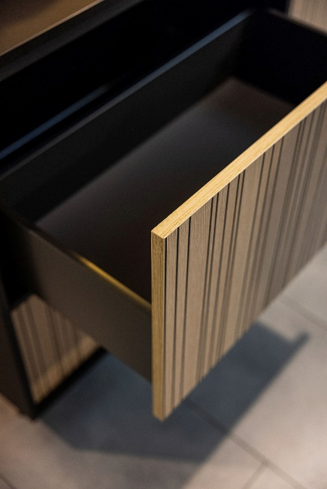

**3402024_b**

Beeck Küchen uses the AvanTech YOU drawer system as a playing field for unusual designs. Black takes a back seat in favour of warm shades and attractive surface textures. Photo: Hettich

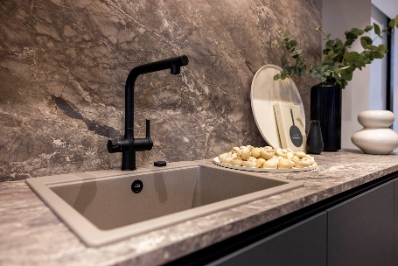

**342024_c**

Nolte's new kitchens featured eye catching natural stone – notably marble – to make statements in kitchen design. Photo: Hettich

Ein Bild, das Möbel, Im Haus, Arbeitsfläche, Wand enthält.

**342024_d**

Sachsenküchen uses natural stone effect finishes as front material on the AvanTech YOU drawer system from Hettich, combining them with warm wood tones. Design with a modern and luxurious look. Photo: Hettich

Ein Bild, das Im Haus, Boden, Inneneinrichtung, Möbel enthält.

**342024_e**

S2 Next Generation from SieMatic with two swivelling Secret Scapes below the kitchen island top with integrated LED lighting. These are based on the innovative FurnSpin turning swivelling fitting from Hettich. Photo: Hettich

Ein Bild, das Im Haus, Wand, Möbel, Inneneinrichtung enthält.

**342024_f**

Swivelling kitchen design in the new Stretta H and L kitchen ranges from Beeck Küchen. A tall unit and a corner cabinet below the island top "turn" into open shelf elements. Photo: Hettich

About Hettich

Founded in 1888, Hettich is one of today's largest and most successful manufacturers of furniture fittings on the international stage. The family owned company is based at Kirchlengern in the furniture making cluster of Germany's East Westphalia region. Some 8,600 members of staff work together to provide our future proof solutions in over 100 countries. Promising "It's all in Hettich", the Hettich brand provides a comprehensive portfolio of services that is consistently and resolutely geared to the needs of customers across the globe. By tradition, top priority has always been at the focus of everything we do to ensure social, societal and ecological sustainability. www.hettich.com