Hettich's "Space and Architecture" area at interzum
Innovative solutions for furnishing workspaces and more

"Transforming Spaces – with innovative motion", that's the furnishing principle Hettich is centring around the unique RoomSpin turning swivelling system with a view to providing an entirely new approach to planning. Hettich is driving forward the transformation of contract furnishing with its innovative fitting solutions. interzum 2025 is giving the company an arena to present practical solutions for workspaces and inspire interior designers, contract fitters and architects to apply these ideas to compact living, open living, public spaces and retail. The focus here is on the efficient and flexible use of rooms, spaces and furniture.

Hettich's "Space and Architecture" area at interzum propagates a fascinating wind of change: everything stays, yet differently. Each workspace solution is based on clearly defined movement flows that create agile and adaptable structures. Whether by sliding or turning – never before has transforming spaces and furniture been so broadly contemplated, attractive and easy to accomplish.

Flexible workspaces
Whereas home office and mobile working are shrinking conventional office spaces, the expectations on efficiency and flexibility are growing in terms of how they're used. Hettich will be showing how movable wall modules that double up as room dividers can be used to create zones permitting flexible usage on both sides. The materials used, for instance, can be glass or sound absorbing products. Whether workshop or silent work – the right space is created exactly where it’s needed. Whiteboards can be positioned wherever chosen, and even desks can be extended by push fit system in next to no time. Right down to well considered organisation for office equipment, this is where flexibility is the name of the game.

RoomSpin – transformation by turning
Developing its RoomSpin turning swivelling system, Hettich has engineered a technical platform that lets users themselves "turn" their workstations and office furniture in a curated movement. Depending on work requirements, the setup is simply rearranged. Key feature: every movement follows a firmly defined choreography, so spatial effect, lighting or power and communication sockets can be planned in advance with perfect results. Presenting “Layers® moved by RoomSpin,” Hettich is offering a turnkey office furnishing concept from partner Kuhn – who specialises in room in room solutions and sliding door systems for the contract segment. The line up not only includes stunningly designed seating and meeting solutions in steel and recycled felt but covers storage furniture too. "Layers®" is furniture and absorber rolled into one and follows an intelligent grid system while remaining dynamic and permitting modular individualisation without the need for tools. Kuhn’s concept demonstrates the potential RoomSpin offers as an innovation for transforming workspaces. Given the specific movement sequence, several wall height RoomSpin furniture elements can be planned next to one another and rotated in cascading fashion. That's truly unique.

Experience SpinLines performance
To witness the transformative power of its SpinLines systems in real life, Hettich has created a special exhibit for interzum 2025 under the motto “All in one”: ComfortSpin, FurnSpin and RoomSpin – the current SpinLines family is united in this homely exhibit and plays with the options there are for transforming furniture and even entire rooms. Inside is suddenly out, closed suddenly open. The entire exhibit can be turned through180 degrees. Hidden inside is an inviting retreat which, say, can be used as a place to work in, and features many other astonishing design details. The potential for shaping a changing home living and working culture is huge.

Hettich’s workspace solutions are just waiting to be discovered by interior designers and contract fitters as the basis for transformative furnishing concepts, and by furniture manufacturers for developing their own product lines.

The following picture material is available for downloading from the "Press" menu at www.hettich.com:

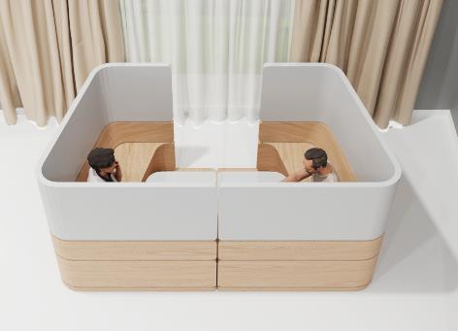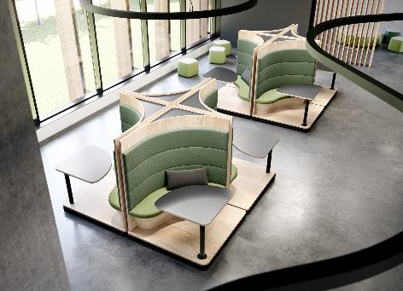
202025_a, 202025_b
At interzum Hettich is showing unique solutions for transforming spaces and furniture through firmly defined movement sequences and for matching them with flexibility to the people using them for their specific activity. Photo: Hettich

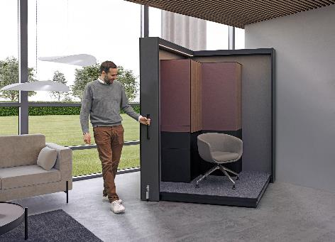
202025_c
"All in one": this SpinLines system furniture comes with incredible versatility – even transforming into a user friendly workstation. Photo: Hettich
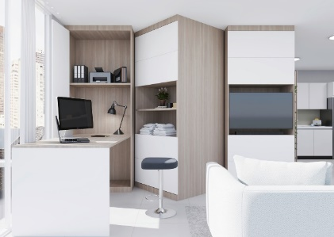
202025_d
Great potential for compact living: several RoomSpins can be arranged in cascading form, making it possible to change room usage by rotation. Photo: Hettich

About Hettich
Founded in 1888, Hettich is one of today's largest and most successful manufacturers of furniture fittings on the international stage. The family-owned company is based at Kirchlengern in the furniture making cluster of Germany's East Westphalia region. Some 8,400 members of staff work together to provide our future proof solutions in over 100 countries. Promising "It's all in Hettich", the Hettich brand provides a comprehensive portfolio of services that is consistently and resolutely geared to the needs of customers across the globe. By tradition, top priority has always been at the focus of everything we do to ensure social, societal and ecological sustainability. www.hettich.com

