Hettich's trade fair debuts at interzum 2025
Innovative product solutions for the industry

At interzum 2025, Hettich is once again showing its prowess as a highly innovative fittings manufacturer with a profound understanding of the market. Structured throughout from a user perspective, the portfolio is moving forward with strategic vision. Hettich products enable the trades, specialist retailers and industry respond conclusively to changing wishes on the home living, lifestyle and work front.

Hettich's new product releases and highlights are being presented at interzum in inspirational furnishing solutions for kitchens, bathrooms, living spaces, bedrooms, white goods, workspaces and outdoors.

Avosys glass and mirror door hinge:
Slimline elegance for kitchen, bathroom and living space
The higher the perceived quality of a glass or mirror cabinet, the more restrained the door hinges need to be. This is why the new Avosys from Hettich cuts a deliberately muted figure, remaining unobtrusive on furniture with slender elegance. Particularly compact in design with a narrow linear mounting plate, the fitting itself takes up so little space that it leaves more room for cabinet contents. The innovative concealed hinge enables a wide range of applications. Distinct benefit: Avosys can be securely bonded or screwed to glass and mirror doors. It is also suitable for screw mounting without cup drill hole on thin, hard materials such as Corian® and HPL. Avosys also makes it easy to produce glass and mirror doors in thicknesses of 3 to 8 mm as well as custom material doors in thicknesses of 10 to 12 mm. Fast, clip on installation makes easy work of fitting the hinge. Coming in time tested Hettich quality, Avosys is the preferred choice for premium furniture in kitchens, bathrooms and living spaces. The market launch for Hettich's new Avosys is planned for the end of 2025.

SAH 500 heavy duty cabinet suspension bracket:
Making heavy wall mounted furniture appear to float
The newly developed heavy duty SAH 500 cabinet suspension bracket from Hettich is the ideal choice for "weighty" wall mounted furniture in kitchens, bathrooms and living spaces, including wall and base units, sideboards and chests of drawers. Spacious looking design with "floating", wall mounted furniture is right on trend: it conveys more of a generous sense of space and, being off the floor, makes cleaning easy – as a real boon for users. Yet the wider and deeper wall mounted furniture is, the heavier it gets too. Loads like this soon mean the end of the line for normal cabinet suspension brackets. – This calls for the SAH 500 cabinet suspension bracket specialists so heavyweight furniture stays securely wall mounted long term too. Tested to hardware for furniture standard EN 15939, it is even possible to achieve load capacities of up to 110 kg per cabinet suspension bracket. What's more, SAH 500 is extremely slender, process efficient and easy to install. Even in confined mounting spaces in the cabinet body, drawers move past the system without collisions. Wherever production calls for a high degree of automation, SAH 500 comes up trumps further still: the cabinet body element without moving parts can be stacked and warehoused, making it highly process efficient. The wall mounted element with working parts skirts production as an accessory part. The new SAH 500 from Hettich will be available from mid 2025.

Evisys guiding hinge:
High load bearing performance for extravagant looking kitchen design
A further newcomer at Hettich is the Evisys guiding hinge that opens up new creative options for kitchen planners. Positioned in the top door section, Evisys brings the necessary opening and closing stability to heavy, extra tall cabinet doors in front of built in refrigerators. In combination with Hettich's fixed door hinges, it's now possible to install doors weighing up to 80 kg – a whopping 10 kg more than before. This means users can load their refrigerator door more heavily while still keeping reveals perfectly aligned. The Evisys with integrated Silent System comes with further added convenience that's highly welcome in everyday kitchen routine: the hinge's damping effect now also closes the refrigerator door gently and quietly.

Upgrade for AvanTech YOU "Illumination":
Lighting mood on furniture in extra warm white too
“No plug, just play” is the motto of the successful "Illumination" design feature from the YOU platform's AvanTech YOU drawer system, which can also be used for wooden drawers. This makes it possible to created emotive lighting features on furniture in kitchens, bathrooms and living rooms. The system's new generation is now even easier to install. Requiring no magnets, the LED system can be positioned wherever chosen on the drawer. In each case, a practical rechargeable battery pack provides the necessary energy. This obviates the need for any complex electrical connections, also making it so easy to retrofit on drawers already installed. A further new addition makes the system even more attractive: suiting personal tastes and needs, the colour temperature can now be changed between extra warm white at 2,700 K and neutral white at 4,000 K. This means the "Illumination" lighting mood can be matched to different applications whenever chosen. Users will also love the new fast charging function that comes with "Illumination": this permits user friendly USB-C battery charging. The new "Illumination" generation for AvanTech YOU and wooden drawers will be available from the end of 2025.

Cabinet interiors from Hettich:
Storage space organised the smart way
With immediate effect, the "Cabinet Interiors" lineup is now being produced within the Hettich Group and is already available to customers. Whether tall units, base units or corner units – Hettich’s well considered, high quality fittings systems can optimise storage spaces behind the furniture front and provide them with innovative functions. This, for instance, means more convenience for all kitchen users: the cabinet interior quickly shows where everything's kept and provides convenient, ergonomic access to cabinet contents. Even small alcoves, narrow cabinets and hard to reach corners can be used more efficiently with solutions from Hettich. For luxuriously quiet and gentle closing, all drawer runners are equipped with Silent System soft closing. The new cabinet interior product series from Hettich offers numerous design and configuration options, and a consistent colour concept harmonises perfectly with other Hettich products, such as drawer systems, the ComfortSpin turntable and the Push to open Silent opening system for hinged doors.

There are even more product highlights to witness first hand at Hettich. Providing a wide range of system solutions that every day transform furniture and spaces into veritable comfort zones, the fittings expert offers its customers and partners from the trades, retail and industry exactly what they need to be successful now and in the future.

The following picture material is available for downloading from the "Press" menu at www.hettich.com:
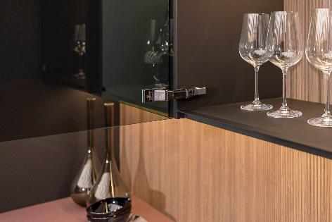
192025_a
Restrained elegance for the kitchen, bathroom and living spaces: the new Avosys glass and mirror door hinge from Hettich enables a minimalist furniture design with lasting user convenience. Photo: Hettich

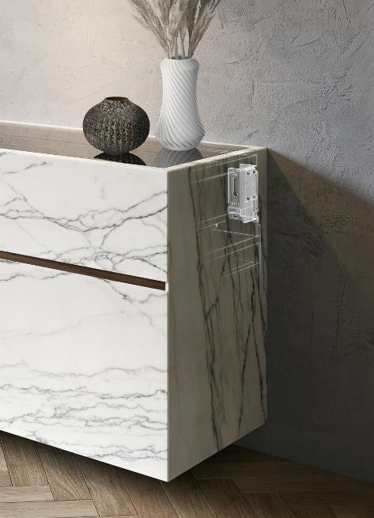
192025_b
Floating furniture design even for heavyweights: the SAH 500 heavy duty cabinet suspension bracket from Hettich is exceptionally slim. Its low fitted height opens up new design freedoms inside the cabinet body. Photo: Hettich

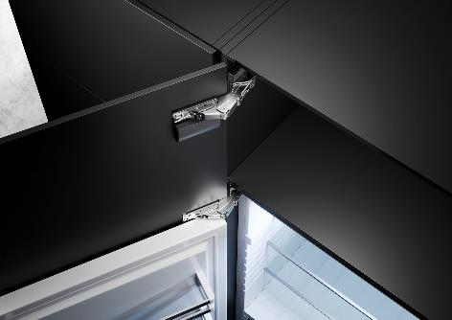
192025_c
High load capacity for spaciously designed kitchens: the new Evisys guiding hinge from Hettich provides the necessary opening and closing stability for heavy, extra tall cabinet doors in front of built in refrigerators – while leaving reveals perfectly aligned. Photo: Hettich

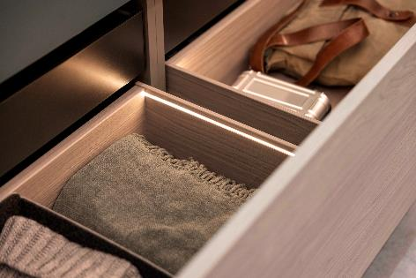
192025_d
AvanTech YOU Illumination – the new generation with changing light colours has arrived: customising accent drawer lighting has never been easier. Photo: Hettich

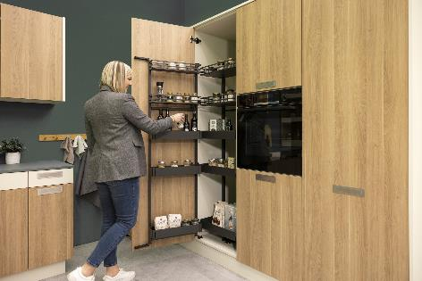
192025_e
Featured in Hettich’s new "cabinet interiors" range, "Iseo" gives tall units optimum organization and ergonomic access, even to the back of the cabinet. Photo: Hettich

About Hettich
Founded in 1888, Hettich is one of today's largest and most successful manufacturers of furniture fittings on the international stage. The family-owned company is based at Kirchlengern in the furniture making cluster of Germany's East Westphalia region. Some 8,400 members of staff work together to provide our future proof solutions in over 100 countries. Promising "It's all in Hettich", the Hettich brand provides a comprehensive portfolio of services that is consistently and resolutely geared to the needs of customers across the globe. By tradition, top priority has always been at the focus of everything we do to ensure sustainability at social, societal and ecological levels. www.hettich.com

