**Washbasin at the right height for everyone**

**Hettich and Primabad make the bathroom more convenient**

**Why not give the bathroom the type of convenience familiar from other walks of life? Dutch bathroom furniture manufacturer Primabad B.V. (**[**www.primabad.com**](https://www.primabad.com/)**) was looking for an aesthetically appealing and practical solution for barrier-free washroom facilities – and found it in cooperation with fittings manufacturer Hettich: the latest "Move" bathroom range conveniently raises the washbasin to any chosen height at the press of a button. To this end, Hettich has modified its lifting column system from the office sector: the wall-mounted "LegaDrive Systems Wall" makes it very easy to bring ergonomics to the bathroom.**Barrier-free bathrooms provide an added degree of safety and enhance quality of life every day – not only for people with limited mobility but for users of any age. Jan Zwanenberg, owner and managing director of Primabad B.V.: "We want barrier-free access to become something that's taken for granted everywhere: in residential housing construction and in healthcare as well as in hotels, shops or in public buildings. The new height-adjustable washbasin from our Move bathroom range makes a small but important contribution to improving ergonomics and convenience in everyday life."

The wall-mounted "LegaDrive Systems Wall**"** system from Hettich conveniently moves the washbasin top to the right height: at the press of a button, the entire block is raised or lowered in a gentle, agreeably quiet movement cycle. Electric adjustment is infinitely variable over a travelling range of 200 millimetres. To customise the design of the washbasin environment, the system can be used for moving a total weight of up to 80 kilograms. Further attractions for tradespeople and interior designers include the ease of installation and the ability to fit the system at any later date. Requiring only one person, installation is quick and easy. As a result, "LegaDrive Systems Wall" is recommended as a versatile and extremely practical system that provides a highly cost-efficient key to designing ergonomic bathrooms for household members of all ages.

The following picture material is available for downloading from the "**Press**" **menu** at **www.hettich.com**:

**Images**

**Captions**

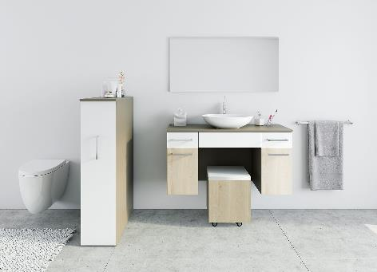

**042022_a**

The washbasin moves to the chosen height at the push of a button: barrier-free bathrooms provide an added degree of safety and enhance quality of life every day. Photo: Hettich

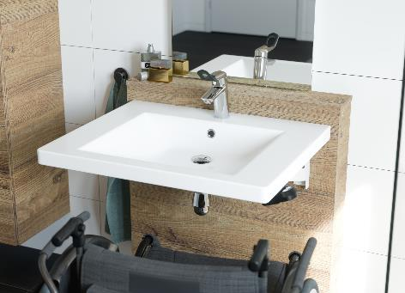

**042022_b**

The wall-mounted "LegaDrive Systems Wall**"** system conveniently moves the washbasin top to a height that suits the individual user. Photo: Primabad

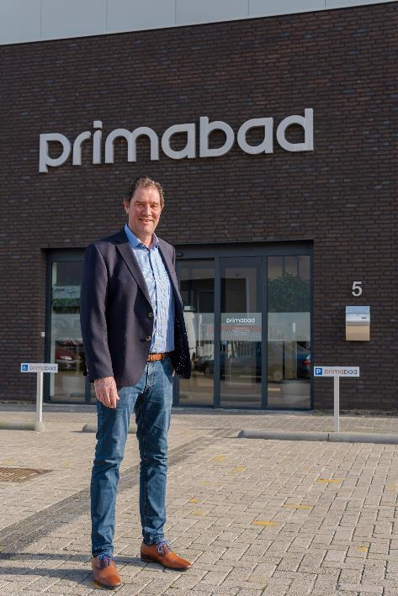

**042022_c**

Jan Zwanenberg, owner and managing director of Primabad B.V.: "The height-adjustable washbasin from our Move bathroom range makes a small but important contribution to improving ergonomics and convenience for all users in everyday life." Photo: Primabad

About Hettich

Hettich was founded in 1888 and is today one of the world's largest and most successful manufacturers of furniture fittings. Over 6,600 members of staff in almost 80 countries work together towards the objective: developing intelligent technology for furniture. Hettich thus inspires people all over the world and is a valuable partner for the furniture industry, trade and craft. The Hettich brand stands for consistent values: for quality and innovation. For reliability and customer proximity. Despite its size and international significance, Hettich has remained a family business. Being independent of investors means that the company has a free hand in shaping its future with a focus on the human element and sustainability.