Successful partners on the Emerald Isle:
NAA Ltd. sells its one-millionth Hettich drawer

Hettich and NAA Ltd. - two family-owned companies with more than 100 years of history and now led by the fourth generation – have enjoyed a remarkable partnership since 1995. Today, NAA, a full-service supplier to the furniture and woodworking industry in Ireland, has reached a significant milestone: the sale of its one-millionth Hettich drawer.

“Our partnership with Hettich has been a key driver of NAA’s growth in Ireland,” explains NAA Managing Director Luke Hickey. “We started working with Hettich in 1995, when my father Conor and my uncle Rory were running the business here in Dublin. Since 2022, my sister Laragh and I have been the fourth generation to lead the company.” NAA Managing Director Laragh Hickey adds: “The introduction of Hettich’s first drawer system, InnoTech, to the Irish market marked a real turning point for us and our customers. It laid the foundation for delivering one million drawers to date. We have grown together with our customers – some of whom are now among the largest kitchen manufacturers in Ireland – by consistently focusing on quality, innovation and reliability.”

Looking ahead, NAA sees Hettich’s versatile AvanTech YOU
drawer platform as the system that will continue to inspire Irish customers. Luke Hickey confirms: “We remain firmly committed to supporting the market with first-class products, first-class service and a lifetime dealer warranty that reflects our absolute confidence in the Hettich brand.”
"Hettich on Tour 2026" comes to Ireland
To give customers in Ireland the opportunity to experience Hettich’s innovative strength first-hand, the 2026 „Hettich on Tour“ roadshow – featuring the latest product highlights and services – will visit Ireland from 8 June to 9 July 2026, stopping at NAA in Dublin on 12 June.
Summing up why Hettich and NAA complement each other so well, Luke Hickey shares his personal motto: “You can buy products anywhere, but service comes from people.”

Images available for download
The following image material is available under the “Press” section at www.hettich.com :

Images
Captions
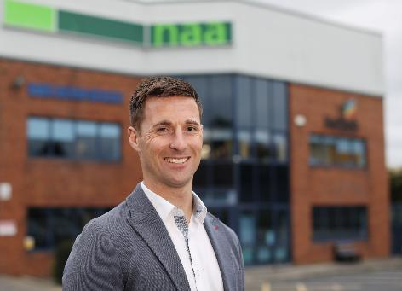
072026_a
“Our partnership with Hettich has been a key factor in our growth in Ireland,” explains NAA Managing Director Luke Hickey. Photo: NAA Ltd.

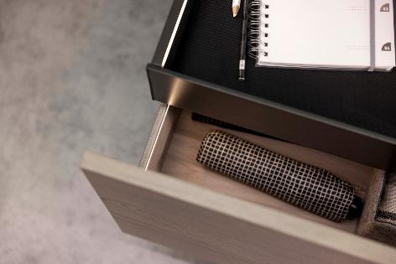
072026_b
The versatile AvanTech YOU Illumination drawer platform from Hettich continues to inspire customers in Ireland: the “Illumination” feature provides atmospheric lighting accents. Photo: Hettich

About Hettich
Founded in 1888, Hettich is one of the world’s largest and most successful manufacturers of furniture fittings. The family-owned company is based in Kirchlengern, in Germany’s East Westphalia furniture-production region. Around 8,200 colleagues work together to deliver future-ready solutions in more than 100 countries. Under the brand promise “It’s all in Hettich”, the company offers a comprehensive portfolio of products and services consistently aligned with customer needs worldwide. Responsible and sustainable action – socially, societally and environmentally – has always been a top priority for Hettich.www.hettich.com

