"Hettich on tour" European roadshow continues
On the way to the next customer!

Over the past two years, "Hettich on tour" has become synonymous with a very special closeness to customers. After the winter break, the next season will now run from March 2022. Fitted out with the latest new product releases, two Hettich vans will be embarking on their journey through Europe. They will be calling on companies from the trades, retail and industry. The benefits to customers and partners are obvious: the entire workforce will get the opportunity to experience key Hettich innovations first-hand and try them out straight away – right on their very own doorstep.
Now they're out on the road again! In 2022, "Hettich on tour" is starting in Germany and in neighbouring Belgium, Holland, Austria and Switzerland. After that, and for the first time, Ireland and Scandinavia are on the tour schedule. In the summer, the vehicles will then be on route through the Baltic states and Poland from where the journey will take them to Hungary. Stops in Romania, Italy and, once again, in Germany will conclude this year's tour in the autumn.

Product training for everyone
Since the tour was launched in 2020, the practice focused concept has proven itself time and again: instead of large trucks, Hettich uses normal vans with a small footprint, plus its own field service colleagues as drivers. This makes it possible for everyone involved to plan "Hettich on tour" with far more flexibility and efficiency. The focus, of course, is on the benefits to partners: Hettich goes directly to the customer with its top new releases and, during every visit, really every employee working with Hettich products in the company - from master craftsperson to apprentice - can be reached. The Hettich teams are appropriately trained and equipped for their mission under the special pandemic conditions. On location, they will be ready to answer all questions and look forward to getting direct feedback.

Sustainability is not being neglected during "Hettich on tour" either: to conserve the hosts' energy resources, the tour vans can manage without any connection to the power supply at every port of call. A solar panel system on the roof makes the vehicles self-sufficient. At the moment, unfortunately, the European tour cannot be carried out entirely with electric vans. So, in terms of planning and scheduling, a very conscious effort will be made to use both vehicles as efficiently as possible. This means as few miles as possible for as many customer appointments as possible. Short transfers between the countries not only benefit staff, but the environment too.

New products and ideas on board
In 2022, Hettich will be on its way to customers with some refreshing product highlights: the new, customised LED signature lighting for the AvanTech YOU drawer platform will be on show, as will the practical TopLine L, WingLine L and SlideLine M sliding door systems. The new Actro 5D generation will be presented as a drawer runner providing the ultimate in smooth and quiet running action. The unbeatable soft closing performance from Sensys, the side hung door hinge that has proven itself in millions of applications, can also be tried out first-hand. In its dark obsidian finish, Sensys goes perfectly with the look of the interesting new addition to the Hettich portfolio: Cadro, the modular aluminium frame system, opens up new design flexibility for greater flexibility in furniture making. And finally, on board too will be Veosys, the robust, weatherproof stainless steel hinge designed specifically for outdoor and shipbuilding use.

During the winter break, the "Hettich on tour" vehicles have not only been given a new look on the outside - but there have also been a number of design changes to the interior as well: the further optimised modular vehicle layout now makes it possible to present as many as six new products at one and the same time. In 2022, the entire interior will be coming in a much more homely design, almost like a miniature trade fair. Supplementary information can be displayed directly to customers via a large on-board screen.

Well informed online: the tour landing page
The accompanying communication covering all aspects of "Hettich on tour" is also being further extended in 2022: a dedicated landing page https://www.hettich.com/short/afcb2n will give information about the course of the tour with dates and stops. This will also provide product information of a more detailed nature. This way interested customers and partners can get to know the new products better or prepare for the tour visit, e.g. with specific questions about the products and about assembling and fitting them. Exactly where "Hettich on tour" will be visiting will also be announced in the newsbox at www.hettich.com, and the teams will be reporting on their experiences during the European roadshow through Hettich's social media channels until the autumn.

The following picture material is available for downloading from www.hettich.com, menu: Press:
Images
Captions

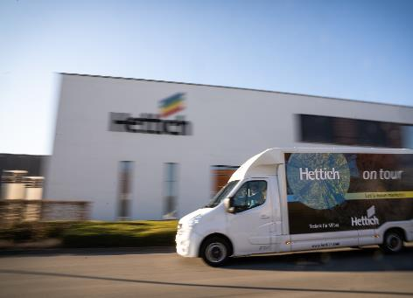
072022_a
They'll be on Europe's roads again in 2022: during the winter break, Hettich has converted its two tour vans specifically for the new season. Photo: Hettich

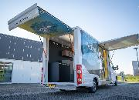
072022_b
Despite the pandemic, witness Hettich's product highlights first-hand: in 2022, "Hettich on tour" is passing through several European countries, bringing the latest top new products directly to fabricators and specialist retailers. Photo: Hettich

About Hettich
Hettich was founded in 1888 and is today one of the world's largest and most successful manufacturers of furniture fittings. Over 6,600 members of staff in almost 80 countries work together towards the objective: developing intelligent technology for furniture. Hettich thus inspires people all over the world and is a valuable partner for the furniture industry, trade and craft. The Hettich brand stands for consistent values: for quality and innovation. For reliability and customer proximity. Despite its size and international significance, Hettich has remained a family business. Being independent of investors means that the company has a free hand in shaping its future with a focus on the human element and sustainability.

