"Hettich on Tour 2026" is getting underway!
Top innovations delivered right to your doorstep

From April to the end of November 2026, furniture-fittings manufacturer Hettich will once again take its well-known roadshow across Europe. Customers and partners in the Czech Republic, Slovakia, Hungary, Slovenia, Croatia, Ireland, Latvia, Lithuania, Romania and Portugal will have the opportunity to try out the latest product innovations right on their doorstep. Hettich’s promise — “We’re coming to you!” — also means that retailers as well as cabinetmakers and carpenters can request an individual stop while the tour is on the road.

It couldn’t be easier: the Hettich team will visit with a mobile compact showroom, giving entire workshop and production teams the chance to try out Hettich’s newest products and solutions in person. Introduced in 2020, the customer-focused “Hettich on Tour” format will once again see a Hettich vehicle travelling across Europe in 2026. The mobile showroom presents key product highlights in a compact space, while the tour team shares first-hand practical expertise on state-of-the-art fittings technology, provides useful installation tips and introduces Hettich’s comprehensive service offering — everything that helps make day-to-day work noticeably easier.
A highlight inside the redesigned vehicle will be Hettich’s FurnSpin rotating and swivelling system, which rotates entire furniture elements through 180 degrees in a smooth, fluid movement. Open doors or flaps are no longer in the way — most of the cabinet body moves effortlessly with just a gentle turn, revealing the unit’s interior. One more rotation returns FurnSpin to its closed position, with the front neatly restored. Remaining virtually concealed, the fitting includes all the familiar convenience functions such as soft-closing and push-to-open for handleless furniture design.

Emotional appeal combined with first-class design is also delivered by the versatile AvanTech YOU drawer system, offering countless design options. Hettich also provides an unrivalled variety of drawer runner systems: with precision runners such as Actro YOU, Quadro YOU, Actro 5D and Quadro 5D, the platform offers the perfect solution for every system and load capacity. The result is smooth, safe opening and closing, with perfectly aligned reveals for premium furniture design. Thanks to its modular platform concept, manufacturers can now plan furniture first and decide later which runners to use.

The proven premium Sensys hinge will also be showcased in various applications, along with the Novisys fast-installation concealed hinge featuring integrated soft-closing for the mid-price segment. Thanks to Hettich’s platform principle, Novisys can be combined with other Hettich hinge systems.
Follow "Hettich on Tour 2026"
There is once again plenty to discover in the Hettich Roadshow in 2026. To see when and where the “Hettich on Tour” team will be stopping, visit the tour website. Retailers, associations and craft businesses who decide at short notice can once again request an individual stop directly in front of their premises while the tour is under way.

The following image material is available for download under the "Press" menu at www.hettich.com:

Images
Captions

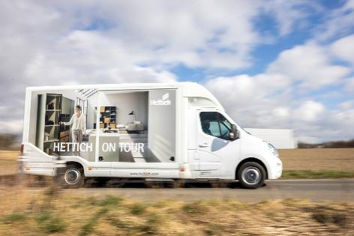
052026_a
On the road first-hand for customers from Lithuania to Portugal: the “Hettich on Tour” roadshow will once again cross Europe in 2026.
Photo: Hettich

About Hettich
Founded in 1888, Hettich is one of the world’s largest and most successful manufacturers of furniture fittings. The family-owned company is based in Kirchlengern, in Germany’s East Westphalia furniture-production region. Around 8,200 colleagues work together to deliver solutions designed for the future in more than 100 countries. Under its brand promise “It’s all in Hettich”, the company offers a comprehensive portfolio of services consistently aligned to customer needs worldwide. For Hettich, sustainable action — socially, societally and environmentally — has always been a top priority. www.hettich.com

