Hettich presents the future of assembly machinery at interzum 2023
Digital helpers for the cabinetmaker's workshop

Hettich is taking the next step on the road to digital transformation in the cabinetmaker's workshop, linking its process technology with digital services, assembly aids in 3D printing and augmented reality. At interzum 2023, Hettich will be showing how digital capabilities can be used even today to benefit assembly machinery and shape it up for the future.

Open AR app, use your smartphone or tablet to search for problems in the machine and rectify faults all by yourself. What might sound like a long way off is already successful practice in many industries. If it were left to Hettich, augmented reality (AR) will soon be part of the standard workshop lineup. In just the same way as other digital helpers.

Now as ever, drilling and insertion machines from Hettich's BlueMax series belong to the equipment base in many workshops. Precision, ease of handling, safety and a needs based product range speak in favour of these firm favourites. Users can now discover a very helpful feature even as early as getting started: every machine comes with a QR code that takes them directly to the Hettich Technical Assistant. Not only providing assistance with installing and setting the machine, this digital helper also comes with other tools that aid the assembly process. This way, machine users benefit from even easier operation and immediate assistance with application related questions. The digital assistant also provides up to date videos on the correct way to start up and set an assembly machine as well as on using it in the workshop. Machines already on the market are simply "upgraded" with the QR code in the form of a sticker.

Cabinetmakers and interested parties are also invited to experience AR in practice on Hettich's stand in hall 8.1, stand C31/B40. On an actual BlueMax machine, Hettich's assembly experts will be showing what processing will look like in the future with the aid of a tablet and dedicated AR app. The user will benefit from intuitive guidance – from getting started to straightforward application assistance. The experts will also be explaining why AR is an important component in responding to the growing shortage of skilled workers.

Taking the example of 3D printing, Hettich will be illustrating the flexibility with which assembly machinery can be supplemented with digital peripherals, while also producing jigs in reality. These little tools and drilling jigs are key to machining furniture quickly and easily. In future, the data needed will also be made available for downloading. What's more, a video will be giving visitors an impressive glimpse at Hettich's vast product portfolio and the digital services that are available on all aspects of these assembly machines.
For more on Hettich at interzum 2023, go to:
https://interzum.hettich.com

The following picture material is available for downloading from the "Press" menu at www.hettich.com:

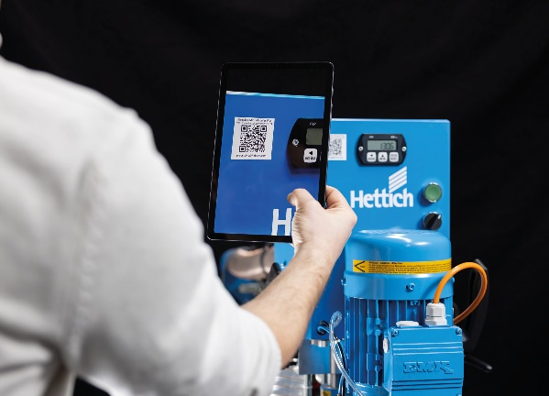
082023_a
The QR code on the BlueMax machine takes users directly to the Hettich Technical Assistant, which provides help on installing and setting the machine. Photo: Hettich

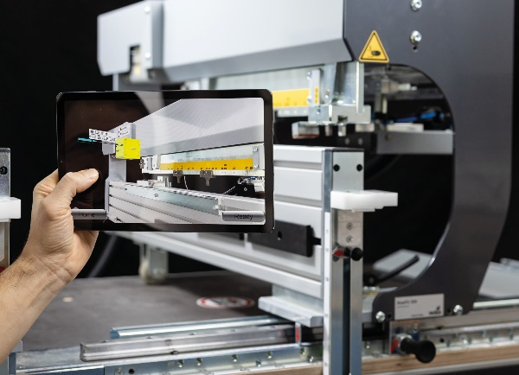
082023_b
In future, a dedicated AR app will give users intuitive guidance on getting started and provide a helping hand. Photo: Hettich

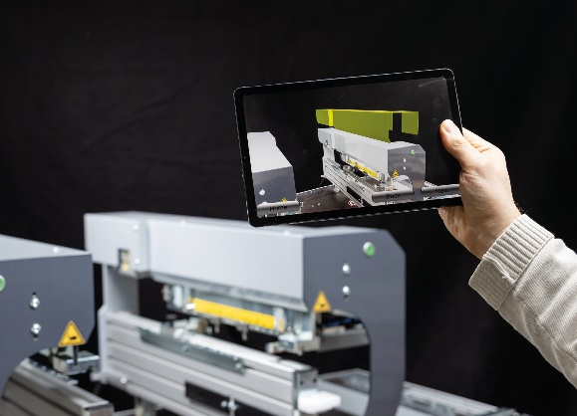
082023_c
A tablet or smartphone and the AR app will in future make it easier to diagnose and rectify faults. Photo: Hettich

About Hettich
Hettich was founded in 1888 and is today one of the world's largest and most successful manufacturers of furniture fittings. Some 8,000 colleagues in almost 80 countries work together towards the objective: developing intelligent technology for furniture. On this basis, Hettich inspires people across the globe and is a valuable partner to the furniture industry, retailers and the trades. The Hettich brand is synonymous with consistent values: with quality and innovation. For reliability and closeness to customers. Despite its size and international significance, Hettich has remained a family run business. Independent of investors, the company's future is shaped freely, humanely and sustainably. www.hettich.com

