**Double win for Hettich in iF Design Awards**

**Prizes go to AvanTech YOU Illumination and Quadro Compact FE 20 for wine refrigerators**

**No fewer than two newly developed products from Hettich have attracted the prestigious iF Design Award this year: in the "Home Furniture" category, the jury picked out the AvanTech YOU Illumination LED drawer lighting feature, with the coveted iF accolade then going to the Quadro Compact FE 20 runner for wine refrigerators in the "Kitchen"category".**

The AvanTech YOU drawer system takes every effort out of individualising design to meet any customer preference in colour, format and material. The platform's new design option has now won over the iF Jury as well: every drawer can be given its very own LED signature lighting with the AvanTech YOU Illumination feature. In clip on designer profiles, homogeneous LED light at 4,000 °K illuminates open drawers on the inside or adds a mood defining statement on the outside. And glass inlays with polished or ground edges are also presented in the best light with AvanTech YOU Illumination. The system works without any additional cables in furniture which means it is easily fitted at any later stage.

Also receiving an iF design award, the Quadro Compact FE 20 runner system for wine refrigerators combines outstanding design and user friendly convenience in a way that meets discerning expectations. Wine bottles should be moved without vibration so as not to impair quality and taste. Providing jerk-free action, the Quadro Compact from Hettich gently moves the wine refrigerator's pull-out shelves in and out. A hybrid ball bearing system ensures particularly smooth, low vibration running performance. Optional features, such as the soft and self closing mechanism, enhance user convenience and provide ways of differentiating. Coming in a dark surface finish, the pull-out runner perfectly matches the wine refrigerator's classy design too.

Hettich Managing Director Uwe Kreidel explains: "AvanTech YOU Illumination gives both the trades as well as kitchen and furniture manufacturers further opportunities to set themselves well apart from the competition. Because this way they can offer their discerning customers individualised, attractively designed drawers with an exclusive feel and noticeable quality right up into the premium segment. Our Quadro Compact FE 20 runner for wine refrigerators too not only impresses with its elegant, dark look but also with its gentle, smooth action. Introducing this runner system from our tried and tested Quadro family, we are giving electrical appliances the same superior design and user friendly drawer convenience that's familiar from the home furniture segment. The fact that both Hettich products have now also won the iF Design Award 2022 in addition to the Red Dot Design Award 2022 is confirmation that our ongoing development work is right on track."

The following picture material is available for downloading from **www.hettich.com, menu: Press**:

**Images**

**Captions**

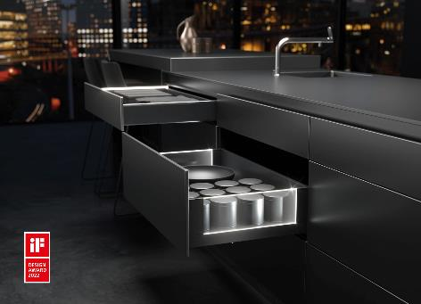

**192022_a**Winner of the iF Design Award 2022 in the "Home Furniture" category: the AvanTech YOU Illumination feature from Hettich brings elegant signature lighting to drawers. Photo: Hettich

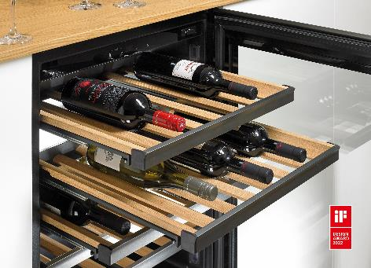

**192022_b**Winner of the iF Design Award 2022 in the "Kitchen" category: Hettich's Quadro Compact FE 20 runner system for wine refrigerators not only provides gentle running action, it looks good too. Photo: Hettich

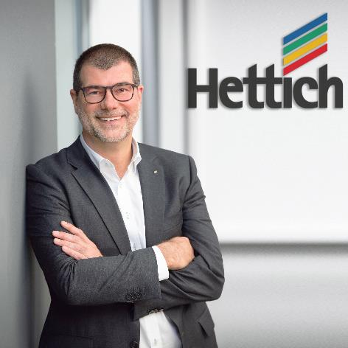

**192022_c**Uwe Kreidel, Hettich's Managing Director: "Getting two coveted accolades in the 2022 iF Design Awards confirms that our ongoing development work is right on track." Photo: Hettich

About Hettich

Hettich was founded in 1888 and is today one of the world's largest and most successful manufacturers of furniture fittings. Over 7,400 members of staff in almost 80 countries work together towards the objective: developing intelligent technology for furniture. Hettich thus inspires people all over the world and is a valuable partner for the furniture industry, trade and craft. The Hettich brand stands for consistent values: for quality and innovation. For reliability and customer proximity. Despite its size and international significance, Hettich has remained a family business. Being independent of investors means that the company has a free hand in shaping its future with a focus on the human element and sustainability.