Hettich helps shape the first “Adaptable Building Conference”
Focus on adaptable building and room concepts

Hettich is a founding member of the new "Adaptable Building Club" (ABC), a network that brings together stakeholders from research, architecture, the public sector, technology, and construction. The ABC’s first symposium will take place in Rotterdam on 22 January 2026, focusing on the development and implementation of a new generation of buildings. The aim is to ensure that buildings can adapt to people’s changing needs in the future, while conserving resources and maintaining property value over the long term.

Buildings are often designed for a single purpose, with fixed layouts and lifespans, which is increasingly problematic in urban areas. The lack of adaptability for alternative uses leads to demolition, vacancy, and loss. The ABC network is working to replace static, single-purpose structures with buildings that can evolve as quickly as the world around them. The adaptability of a property depends largely on holistic planning. With flexible infrastructure, room usage and interior design can change over time. Movable structures that enable adaptive and efficient use of space are becoming increasingly important. At Hettich, the “Space2Architecture” business unit is deeply involved in the transformation of furniture and spaces and plays an active role in the network.

Technical innovation for adaptive living
With the “RoomSpin” technical platform, Hettich has developed an innovative solution for transforming spaces. Rotatable furnishing elements of various sizes and functions can be planned on this platform. One example of the potential of this innovation is a pilot project for modernising existing buildings, which Hettich has implemented with the housing company VIVAWEST in Dortmund: a rotating bed creates a work, play, or leisure room at the back during the day, depending on the furniture design. This increases available space and quality of living without increasing the floor area.
Daniel Rehage, responsible for innovation management at the Hettich Group, will be a speaker at the first “Adaptable Building Conference” in Rotterdam, presenting the diverse possibilities of dynamic room transformation.

The following picture material is available for download under the "Press" menu at www.hettich.com:

Images
Captions
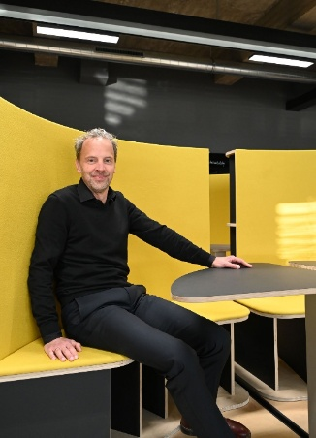
032026_a
Daniel Rehage, Innovation Manager at the Hettich Group, is one of the speakers at the first “Adaptable Building Conference” organised by the ABC network on 22 January in Rotterdam. Photo: Hettich

About Hettich
Founded in 1888, Hettich is one of today’s largest and most successful manufacturers of furniture fittings on the international stage. The family-owned company is based in Kirchlengern, located in Germany’s East Westphalia furniture production cluster. Around 8,400 staff members work together to deliver future-proof solutions in over 100 countries. With the promise “It’s all in Hettich”, the Hettich brand offers a comprehensive portfolio of services that is consistently and resolutely geared to the needs of customers worldwide. By tradition, top priority has always been placed on ensuring sustainability on social, societal, and ecological levels. www.hettich.com

