“Keep Manufacturing in Europe”
Hettich at the ‘European Convoy for Industrial Competitiveness’ in Brussels
On 7 September 2026, Hettich will be taking part in the ‘European Convoy for Industrial Competitiveness’ with two vehicles, thereby sending a clear signal about the future of Europe as an industrial hub. Together with numerous European companies and associations, Hettich actively supports the initiative, which, under the slogan ‘Keep Manufacturing in Europe’, advocates for a level playing field, an investment-friendly environment and the preservation of industrial workplaces.

As a company in the steel processing industry, Hettich relies on efficient and competitive European value chains. Rising costs, increasing regulatory burdens and competitive disadvantages compared with non-European providers are putting numerous industrial sectors in Europe under increasing pressure.
For Hettich, the design of the Carbon Border Adjustment Mechanism (CBAM) is of particular importance. Whilst steel and numerous intermediate products are already covered, this has not yet been the case for many steel-intensive components and finished products, such as furniture fittings. This creates the risk that manufacturing stages – and with them workplaces – will move away from Europe, whilst finished products are increasingly imported. This does not prevent the emissions, but merely shifts them elsewhere. As part of the downstream industrial value chain, Hettich recognises the need to prevent distortions of competition and to ensure a level playing field for all stakeholders. Hettich does not see climate protection and industry as being at odds with one another, but rather believes that the two must be considered together: European companies must be able to decarbonise their production without being structurally disadvantaged as a result compared with their international competitors.
“European industry needs a framework that enables innovation, investment and sustainable growth. Only if the entire value chain remains competitive can investment, employment and industrial value creation be strengthened in Europe in the long term,” explains Jan Hobert, Director of Procurement at Hettich. “Politicians must now ensure that relevant downstream products are also consistently included in the Carbon Border Adjustment Mechanism (CBAM) and in trade defence instruments such as safeguards and anti-dumping measures. This is the only way to achieve genuine equality of opportunity and ensure that industrial value remains in Europe.”

By taking part in the “European Convoy for Industrial Competitiveness” in Brussels, Hettich is championing a strong industrial sector in Europe, with a level playing field throughout the entire European value chain – from the raw materials industry to the manufacturing sector. The “European Convoy for Industrial Competitiveness” was initiated by the European Association of Steel, Pipe and Non-Ferrous Metals ( EUROMETAL ), which acts as the European umbrella organisation and representative body for the trade and distribution of steel, pipes and non-ferrous metals.

The following picture material is available for download under the "Press" menu at www.hettich.com:
Image
Caption

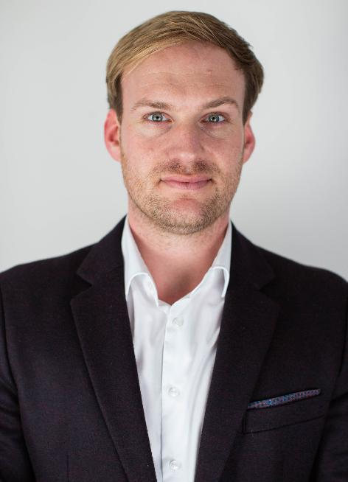
342026_a
Jan Hobert, Director of Procurement at Hettich: “It is crucial for our sector that regulations such as the Carbon Border Adjustment Mechanism CBAM are designed fairly throughout the entire value chain. We must avoid any disadvantages for processing companies in Europe." Photo: Hettich
About Hettich
Founded in 1888, Hettich is one of the world’s largest and most successful manufacturers of furniture fittings. The family-owned company is based in Kirchlengern, in Germany’s East Westphalia furniture production region. Around 8,200 colleagues work together to deliver future ready solutions in more than 100 countries. Under the brand promise “It’s all in Hettich”, the company provides a comprehensive portfolio of products and services consistently aligned with customer needs worldwide. Responsible, sustainable action — socially, societally and environmentally — has always been a top priority for Hettich. www.hettich.com

