Hettich presents "Transforming Spaces" at Interzum 2025
Secure your free trade fair ticket now

“TRANSFORMING SPACES – with innovative motion.” is Hettich's show motto this year at the Interzum in Cologne. The fittings manufacturer can hardly wait to present its innovations to the trade audience from 20 to 23 May, and extends an invitation to visit Hettich's world in hall 08.1, stand C31/B30. Hettich has already activated its landing page covering all aspects of the event. This is where interested trade visitors can now get free tickets for their visit to the show.

When people can be creative using and even redesigning their surroundings, when spaces and furniture can be transformed into something exceptional or completely innovative, that's when "transformation" becomes a truly emotional experience. – At interzum 2025, the only way trade visitors can experience this is with Hettich. A new special show will be whisking them off into fascinating worlds of transformable furniture. And there are further highlights to discover among the inspirational interior solutions for kitchen and bathroom, living space and bedroom, white goods, workplace and outdoor living. Visitors can take a look at future-orientated assembly machinery in practice, discover more about Hettich's extensive range of eServices – and be amazed at everything else Hettich can do to boost their success in business. Showcasing innovations and customised service offerings, Hettich is once again presenting itself in 2025 as a leading, holistically thinking strategy partner for the furniture industry, fabricators and appliance manufacturers.

And this too is all part of Hettich's visitor friendly service: showgoers can now get their personal voucher code by going to https://www.hettich.com/t4w1z6, giving them free admission to the Interzum in Cologne. This voucher campaign from Hettich will get underway in advance of the show event and continue after the Interzum starts for as long as availability lasts. The vast range of information, ideas and suggestions on the landing page won't fail to whet your appetite for Interzum 2025. One more reason to look in at Hettich online right now. In May, Hettich's entire line up will be there to experience in Cologne.

The following picture material is available for downloading from the "Press" menu at www.hettich.com:
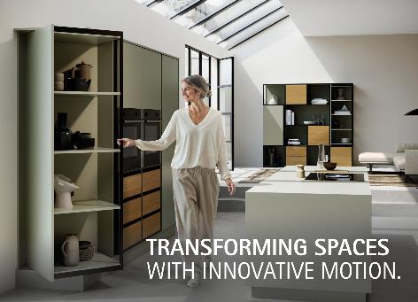
092025_a
"Transforming Spaces – with Innovative Motion." – At Interzum 2025, Hettich will be showing how the fascination of versatile furniture worlds makes "transformation" an emotional experience. Photo: Hettich.

About Hettich
Founded in 1888, Hettich is one of today's largest and most successful manufacturers of furniture fittings on the international stage. The family owned company is based at Kirchlengern in the furniture making cluster of Germany's East Westphalia region. Some 8,400 members of staff work together to provide our future proof solutions in over 100 countries. Promising "It's all in Hettich", the Hettich brand provides a comprehensive portfolio of services that is consistently and resolutely geared to the needs of customers across the globe. By tradition, top priority has always been at the focus of everything we do to ensure sustainability at social, societal and ecological levels. www.hettich.com

