Hettich at architect@work in Hamburg
"RoomSpin" opens up new perspectives for multifunctional room design

On 17 and 18 September 2025, fittings specialist Hettich will be presenting the new "RoomSpin" and the "Layers by Kuhn" furniture portfolio together with its partner Kuhn at architect@work in Hamburg (stand 11). With the turning and swivelling system "RoomSpin", transformation in space is taken literally: the entire interior design can be transformed with a single movement – for maximum space efficiency and multifunctional use. Under the guiding theme of "Progressive Living", Hettich will be showcasing pioneering interior solutions that completely rethink living and working.

Architect@work in Hamburg is focusing on the topic of transformation. With "RoomSpin", Hettich supplies a system that allows entire furnishing elements to be rotated through 180 degrees. This creates flexible spaces that can be restaged as required – from working environments to living situations and retail. Using the example of the "Store" workspace storage solution from the "Layers" portfolio, Hettich and Kuhn demonstrate how movement opens up new perspectives for interior design. As a modular furniture programme on the "RoomSpin" base, "Store" becomes a versatile interior solution that convincingly combines design, function and sustainability.

Added value for architects and planners
The "RoomSpin" base support from Hettich gives architects, interior designers and planners new freedom: its curated turn and swivel movement enables clearly structured room concepts that can be reliably planned, including spatial effect, lighting and connections. Sustainable materials, recyclability and long-lasting durability emphasise the need to use surfaces efficiently and responsibly.
"Transformation is one of the central tasks of contemporary architecture," emphasises Sebastian Voss, Global Sales Director Workspace & Architecture at Hettich. "With "RoomSpin", we show how movement redefines entire rooms and how we work with our partners to develop concepts that make rooms more flexible, more functional, more space-saving and at the same time more sustainable – in line with the requirements of today and tomorrow."

Following the presentation in Hamburg, Hettich will be presenting "RoomSpin" and "Layers by Kuhn" 2025 at further architect@work trade fairs: on 29/30 September. October in Barcelona, on 5/6 November 2025 in Paris and on 3-4 December 2025 in Düsseldorf.

The following picture material is available to download from the "Press" menu at www.hettich.com:

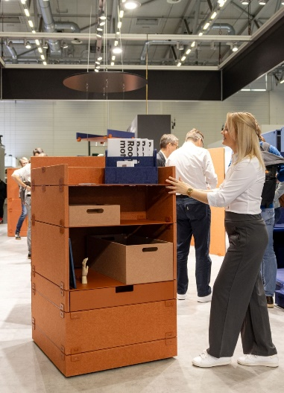
432025_a
The new "RoomSpin" from Hettich: The "Layers Store moved by RoomSpin" shows how rooms can be designed to be more flexible, functional and sustainable at the same time to meet the requirements of today and tomorrow. Photo: Hettich

About Hettich
Founded in 1888, Hettich is one of today's largest and most successful manufacturers of furniture fittings on the international stage. The family-owned company is based at Kirchlengern in the furniture making cluster of Germany's East Westphalia region. Some 8,400 members of staff work together to provide our future proof solutions in over 100 countries. Promising "It's all in Hettich", the Hettich brand provides a comprehensive portfolio of services that is consistently and resolutely geared to the needs of customers across the globe. By tradition, top priority has always been at the focus of everything we do to ensure sustainability at social, societal and ecological levels. www.hettich.com

