**New from Hettich: "Steelforce" lines for the trades**

**Height adjustable desks get things moving in the office**

**The working world is changing dramatically, work and home environments are increasingly merging. In the light of the New Work megatrend, the focus is shifting towards people's well-being, while also raising the question of how office workplaces can be designed more ergonomically. In terms of configuring furniture, one winner has already emerged: the height adjustable desk! With this in mind, Hettich has expanded its portfolio and is launching "Steelforce". The new, all inclusive lines for home working and office permit customised desk planning on the basis of height adjustable desk support frames. For the trades, this means that Hettich now provides even more product choice for ergonomic design and convenience in everyday office life.**

Anyone with an office job knows the problem all too well: we all sit around too much and don't move enough. Height adjustable desks provide the choice of sitting and standing, always making it possible to work in the preferred position. They also make work organisation far more flexible in shared offices: each ergonomic sit/stand workstation is quickly adapted to the specific task in hand or to different users.

**Customised desk planning**The subject of living and working and how best to combine them has been on Hettich's mind since well before the pandemic. The company has been active in the office market for decades.Launching "Steelforce", it is now presenting a comprehensive range for home working and the office. Configured for ease of assembly, all systems are quality finished and designed for reliable and safe permanent use. Standard convenience features, such as soft start and collision detection with a modern gyro sensor for the lifting columns, prove their worth in everyday use. Low energy consumption in standby mode also makes the electrically adjustable desk models attractive for customers. Two Steelforce ranges are available for retailers and the trades: Homeoffice Line and Professional Line.And because many trade businesses are more than busy at the moment, they can even order them from Hettich complete with desktop.

The Steelforce Homeoffice Line with its smaller but multifunctional desks is both space saving and cost efficient. And where space comes at a premium, the "Slim" desk support frame with extra short foot stabilisers provides noticeably better ergonomics and practical convenience.

The Steelforce Professional Line impresses with a high level of stability and clean looking design: this series was developed specifically to meet the exacting demands and expectations of professional users. Powerful motors make the desk support frames ideally suited for high dynamic loads: they can quickly and quietly lift up loads of up to 120 kg, and even up to 150 kg in the case of angled solutions. Customers can select any chosen geometry to suit their desk needs.

Today's brief team meeting standing up for a change? – Large conference tables too should be dynamic in adapting to user's wishes and adjust in height. Complementing the Steelforce models, Hettich offers LegaDrive Systems, a versatile modular desk support frame for the office segment that can also be used to create unusual desk designs in any size up to XXL.

Finally, desk planning is perfected in every last detail with the right extras: efficient storage space solutions and practical cable management as a simple remedy for cluttered desks, or practical acoustic partitions to permit better concentration at work. – All this provides noticeably more convenience, better ergonomics and a tidy feel-good atmosphere at every workplace.

**Healthy and productive at the workplace**For Hettich, one thing is certain: user friendly desks that let you quickly alternate between sitting and standing should now come as standard in everyday office life, whether at home or in a shared office. Because anyone feeling comfortable at their workplace is likely to be more productive and more content overall. – A factor companies should also bear in mind when vying for urgently sought-after skilled staff.

Philipp Rode, Managing Director at Hettich: "We are observing a growing wish for ergonomic workplaces in the market – and not only there but also among those working from home. Our new Steelforce range lets us offer the trades and retail much more than just attractive desk support frames that simply move up and down. Our solutions for better ergonomics and convenience at the workplace permit individually tailored desk planning for a wide range of customer needs, doing so from small, height adjustable desks at home to large conference tables."  
**Landing page:** <https://www.hettich.com/short/i83qgtg>

The following picture material is available for downloading from the "**Press**" **menu** at **www.hettich.com**:

**Images**

**Captions**

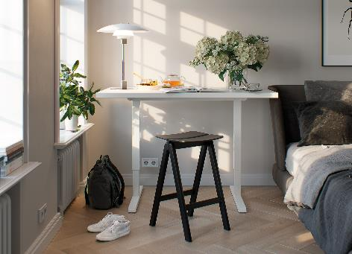

**162022_a**

Upgraded ergonomics for working from home: the small, multifunctional desks from the Steelforce 300 series are both space saving and cost efficient. Photo: Hettich

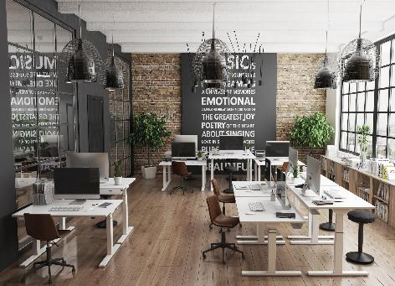

**162022_b**

Great performers in the office: the Steelforce Professional Line impresses with a high level of stability and clean looking design. Photo: Hettich

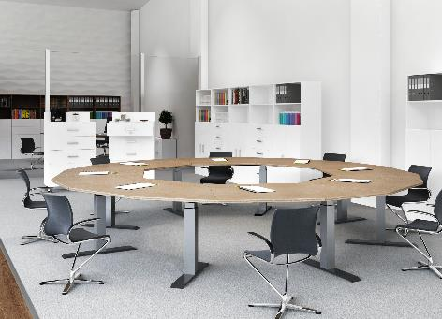

**162022_c**

Brief meeting standing up: Hettich also offers customised solutions for large conference tables with LegaDrive Systems. Photo: Hettich

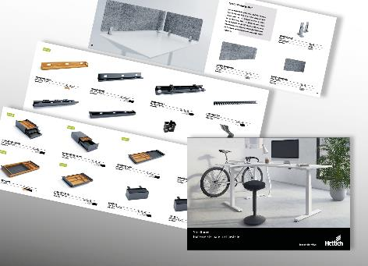

**162022_d**

Also part of the Steelforce lineup: versatile storage space and cable management solutions as the key to a neat and tidy work surface. Photo: Hettich

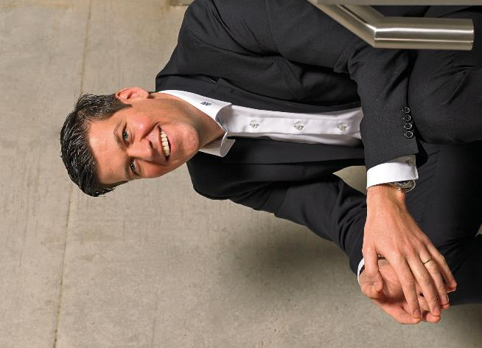

**162022_e**

Philipp Rode, Managing Director at Hettich: "Launching Steelforce, we're bringing better ergonomics to everyday office life. Our new ranges give the trades and retailers attractive solutions for planning customised desks, from small, height adjustable desk for working from home to large conference table." Photo: Hettich

About Hettich

Hettich was founded in 1888 and is today one of the world's largest and most successful manufacturers of furniture fittings. Over 7,400 members of staff in almost 80 countries work together towards the objective: developing intelligent technology for furniture. Hettich thus inspires people all over the world and is a valuable partner for the furniture industry, trade and craft. The Hettich brand stands for consistent values: for quality and innovation. For reliability and customer proximity. Despite its size and international significance, Hettich has remained a family business. Independent of investors, the company's future is shaped freely, humanely and sustainably. www.hettich.com