Hettich at Sicam 2026 in Pordenone/Italy:
An innovative movement for the furniture world of tomorrow

At Sicam 2026, Hettich will once again be showcasing itself as a driving force for the international furniture industry. Under the theme “Transforming Spaces – with innovative motion”, the fittings specialist will be exhibiting from 20 to 23 In October, in Hall 5, Stand A33/B32, intelligent fitting systems and furniture concepts that combine design, comfort and efficiency in innovative ways. The focus is on solutions and platforms that open new possibilities for manufacturers in terms of Design and Engineering and tangibly improve the day-to-day lives of end customers.

With practical innovations and consistently user-focused developments, Hettich supports its partners in industry, the skilled trades and the retail sector in responding flexibly to market demands and creating furniture that offers genuine added value. The exhibits at the stand impressively demonstrate how modern living spaces can be transformed through smart mobility, efficient manufacturing and high-quality Design.

Niosys’ newfast assembly concealedhinge:
Quick to click. Smooth to move.
With its excellent value-for-money Niosys range, Hettich is presenting a new product at Sicam 2026 that is specifically tailored to the needs of modern furniture manufacturers. Designed for design-led furniture manufacturing, the Niosys concealed hinge combines ease of use with particularly straightforward processing. At its heart is the innovative AnyClick system, which enables convenient and safe assembly, even with large and heavy furniture doors. The Niosys’ precise 3D adjustment makes it easier to align the front panels accurately, revealing perfect alignment. By offering a choice of cross-shaped or linear mounting plates, Niosys provides the right solution for a wide variety of door configurations, from standard to specialised applications. The cross mounting plate for Niosys hinges enables quick, safe and straightforward assembly. As a cost-effective entry-level panel with precise setup, it provides an efficient base for a wide variety of furniture designs. The slim linear mounting plate complements a minimalist design aesthetic, ideal for high-quality furniture with clear lines. When flush fitted, it ensures safety in fastening with precise alignment of the front panels. For added user comfort, Niosys is also equipped with the integrated Silent System damping mechanism. This ensures that the furniture doors always close gently, smoothly and almost silently.
The modular YOU platform:
Narrow drawer side profiles for all segments
With the YOU platform, Hettich is consistently pursuing its goal of combining design freedom, cost-effectiveness and maximum flexibility for its drawer solutions within a comprehensive modular system. The three drawer systems – ExeoTech, AvanTech YOU and AvoriTech – cater to different requirements and can be flexibly combined with Quadro YOU or Actro YOU runners. Thanks to identical cabinet drill holes and modular components, a wide variety of market segments – from high-volume models to exclusive premium solutions – can be efficiently catered for using narrow drawer side profiles. The decision regarding the handles and drawer system is not made until the end of the manufacturing process. This enables the creation of bespoke solutions without any additional design work. Manufacturers benefit from a wide range of variants whilst maintaining lean processes. The ‘Illumination’ design feature for AvanTech YOU is also one of the platform’s highlights. This LED system that can be retrofitted requires no complicated electrical installation. It creates atmospheric lighting effects on the furniture and emphasises the individual character of high-quality interior solutions.

Turning and swivelling system FurnSpin:
Inspiring furniture ideas with even more possibilities
Hardly any other Hettich innovation embodies the guiding principle of ‘Transforming Spaces’ quite as much as FurnSpin. The unique FurnSpin turning and swivelling system transforms closed units into open display areas with a fluid movement, creating surprising user experiences. The free FurnSpin online configurator makes planning easier by assisting furniture designers with their designs and automatically generating drilling patterns and dimensions. A new feature of the FurnSpin is its integrated cable management system, which allows for concealed cable routing for features such as lighting. This is how furniture is created that combines functionality and emotional appeal in a unique way.

Avosys glass and mirror door hinge:
Understated elegance for high-quality furniture
With the ‘ Avosys ’ glass and mirror door hinge, Hettich offers an elegant solution for glass, mirrors and special materials. This particularly compact hinge is visually unobtrusive and creates more usable storage space inside the furniture. Whether glued or screwed together – Avosys opens a wide range of applications for high-quality kitchens, bathrooms and living room furniture, whilst supporting minimalist design concepts.

Interior fittings from Hettich:
Making smart use of storage space
Interior fittings s is also one of the key themes of Hettich’s exhibition stand. Well-designed pull-out systems provide a clearer overview, ergonomic access and make optimum use of the available storage space in tall, base or corner cabinets. Among other things, Hettich is showcasing the Naro full-extension base unit drawer at Sicam, which makes even heavy kitchen appliances easily accessible. Closed side panels and an integrated anti-slip mat ensure safety and optimum use of space.

SAH 500 - heavy-duty cabinet suspension bracket:
Maximum load capacity with minimal installation space
With its heavy-duty cabinet suspension brackets, the ‘ SAH 500 ’, Hettich presents a high-quality solution for sophisticated wall-mounted furniture. This innovative system can support loads of up to 110 kilograms per cabinet suspension bracket, whilst also impressing with its particularly slim design. This opens new design possibilities for the interior of the furniture, without compromising on stability or ease of assembly.

„roominspirations“:
Experience creative concepts digitally
Anyone looking for inspiration beyond their visit to the trade fair will find it on the digital platform ‘roominspirations’. There, Hettich provides numerous furniture concepts from the kitchens, bathrooms, living room, bedroom, workspace, retail and outdoor sectors as interactive 3D applications, including data packages, free of charge for use in your own planning. This enables trade visitors to continue to make use of the ideas presented at Sicam even after the trade fair has ended and to apply them to their own projects.

The following picture material is available for download under the "Press" menu at www.hettich.com:
Images
Captions
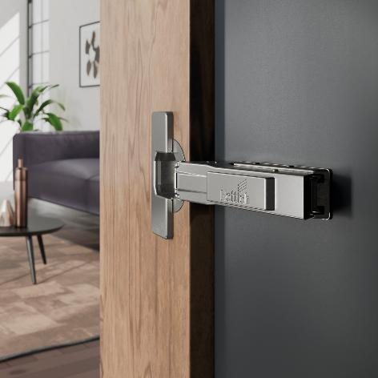
292026_a
A new door hinge from Hettich: Niosys impresses with its easy assembly thanks to the AnyClick system, precise 3D adjustment and the integrated Silent System for soft-close operation. Photo: Hettich
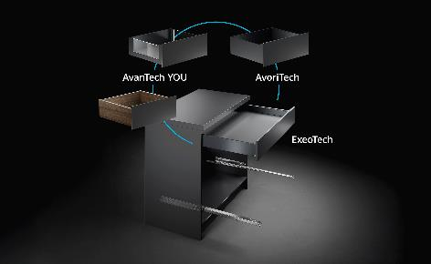
292026_b
Covering all market segments cost-effectively: Hettich’s YOU platform offers narrow drawer side profiles on sturdy runners, ranging from high-volume models to exclusive bespoke designs. Photo: Hettich

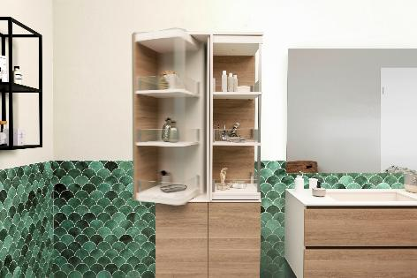
292026_c
Hettich’s Turning and swivelling system FurnSpin completely redefines storage space: with a single turn, the furniture unit switches from the closed to the open position. Photo: Hettich

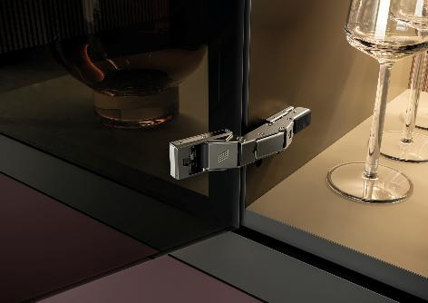
292026_d
Minimalist furniture design offering lasting ease of use for kitchens, bathrooms and living areas: the Avosys glass and mirror door hinge from Hettich exudes understated elegance. Photo: Hettich

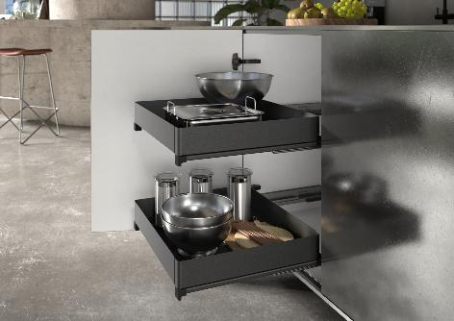
292026_e
Maximum use of space and easy access: the Naro full-extension base unit drawer from Hettich’s product range of cabinet fittings keeps things tidy and can even support heavy kitchen appliances. Photo: Hettich

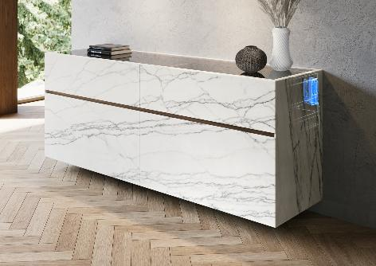
292026_f
Specialist in high load-bearing capacities: Hettich’s SAH 500 heavy-duty cabinet hanger opens new design possibilities for wall-mounted furniture and combines stability with an exceptionally slim profile. Photo: Hettich

About Hettich
Founded in 1888, Hettich is one of the world’s largest and most successful manufacturers of furniture fittings. The family-owned company is based in Kirchlengern, in Germany’s East Westphalia furniture production region. Around 8,200 colleagues work together to deliver future ready solutions in more than 100 countries. Under the brand promise “It’s all in Hettich”, the company provides a comprehensive portfolio of products and services consistently aligned with customer needs worldwide. Responsible, sustainable action — socially, societally and environmentally — has always been a top priority for Hettich. www.hettich.com

