**Hettich at HoutPro+ 2022 trade fair**

**More service and practice focused solutions for carpenters**

**"Hettich - always at your service. Your partner. Your inspirer. Your networker." It is with this clearly structured service lineup that the fittings specialist will be receiving the trade audience at HoutPro+ 2022 in Hertogenbosch, the Netherlands. Hettich's stand in hall 6 will be showing how living and working can be combined even better and how versatile spatial solutions make it possible to live comfortably even on a small footprint. Visitors will also get the opportunity to discover how to create customised furniture in a design focused and cost effective way or how Hettich eServices can be used to boost their own work efficiency.**

"The products we develop and our services always focus on the trades' needs. Carpenters want to excite their customers with innovative, tailor made furniture solutions. As a partner to the trades, we can offer precisely those digital tools and products that make this possible in a way that couldn't be easier, more conclusive and cost effective in the future too," explains Mark Bomer, Regional Sales Manager for the Netherlands/Belgium at Hettich.

**Hettich eServices: getting there quicker**

Time is a scarce resource and no one wants to waste it online in the search for information and products, in ordering or in planning. At HoutPro+, Hettich will be presenting its extended range of eServices and the new service pages at Hettich.com with quick access for every target group. A dedicated "Cabinet Maker & Interior Designer" domain has been created for the trades, presenting all of Hettich's analogue and digital services in clearly structured form on one page. You can go straight on to any chosen section heading: Inspiration, Product Information, CAD & Planning or Assembly Aids. Permitting seamless and efficient work steps, all services are cleverly interlinked. And the personal contacts at Hettich are also shown with photo and contact details.

**Solutions that impress the customer too**

Hettich's product highlights at HoutPro+2022 centre on the international megatrends of individualisation, urbanisation, digitisation and new work. To this end, the manufacturer will be presenting new products for all sorts of lifestyles and working situations: the AvanTech YOU drawer platform that can be configured in many different ways, the creative Cadro aluminium frame system, the new "Steelforce" range for height adjustable desks as well as the WingLine L folding door system or the TopLine XL sliding door system being used for versatile spaces.

**AvanTech YOU: drawers just as you please**

The versatile and adaptable AvanTech YOU drawer system from Hettich takes the effort out of customising design to meet any preference in colour, format and material. The platform principle means all components can be combined in any chosen way. This gives the trades a vast range of options for creating furniture with an individual look and for designing exclusive interiors. The drawers can be configured in three colours and five heights with steel, aluminium or wooden rear panels. DesignProfiles and DesignCapes can be used to make all manner of statements with a look of individuality. And you can choose absolutely any material for the drawer side profile inlays. All of these options can be used to respond quickly and confidently to new design trends with AvanTech YOU and tap into new customer segments.

By way of option, the new AvanTech YOU Illumination feature now even gives furniture its own signature lighting: clip on LED design profiles or illuminated glass inlays create stunning mood effects and a touch of elegance. A practical rechargeable battery pack provides the necessary energy. The easy to install system requires no complicated electrical connection work, making it easy to fit at any later stage. The "wow" effect is guaranteed on opening the illuminated drawers. It is no coincidence that this ingenious idea from Hettich has already won the iF Design Award and the Red Dot Award this year.

**Cadro: the aluminium frame system for endless furniture ideas**

Fast assembly and high quality precision finish are the hallmarks of the Cadro frame system from Hettich. Aluminium profiles, connecting nodes and complementary accessories, this is all that's needed to create finely structured and highly practical furniture concepts – from creative designs in your own furniture collection to exclusive shop fittings and on trend kitchen, bathroom and living room furniture. Cadro now makes it so easy to customise any furniture you make, be it open or closed, standalone or attached to one side, wall mounted or floor standing. Cadro is based on aluminium profiles in matt black or stainless steel look, each designed for 16 mm shelves, 6 mm glass shelves as well as 4 mm glass shelves for display cabinets. Needless to say, Cadro can also be combined with other Hettich fittings and systems, such as drawers, sliding doors and hinged doors. As a show highlight, for example, Hettich is presenting Cadro in combination with the TopLine XL sliding door system: turning a walk in wardrobe into a very convenient storage wizard that can be individually tailored to a wide variety of floor plans and fitting situations.

**TopLine XL sliding door system: strong for extra large wardrobe formats**

Developed specially for large and heavy fronts, TopLine XL from Hettich sets new standards in bringing purist design to ceiling height wardrobes. Its extremely shallow design with inconspicuously integrated Silent System makes the fitting almost invisible. The ease of installing the system alone is nothing short of impressive: the large format door panels can be set down on the floor without the risk of damaging the bottom fittings, quickly hung and easily adjusted. With "TopLine XL", doors weighing up to 100 kg gently open and close with effortless ease. Specially developed rollers with particularly good shape retention provide the basis for this new, easy running action. The system also takes you by surprise with technical finesse for even greater practical convenience in three door wardrobes: the middle door opens intuitively both to the left and right.

**WingLine L: folding sliding door system for more room in the room**

The WingLine L folding sliding door system with Push/Pull to move will even open ceiling height, handleless wardrobe doors almost by themselves in response to a light press – doing so too with an impressive panorama effect. At a height of up to 2400 mm and width of 600 mm per door wing, the system opens up a surprisingly spacious wardrobe with all content in perfect view. At the same time, the fitting can be provided with soft opening and closing. With its minimal door protrusion, WingLine L also makes it possible to fit drawers and pull-outs behind the folding sliding door. The system can be used in a variety of ways for customising interior design: if required, even an entire kitchen block can vanish behind the folding doors, or WingLine L can be used wherever space is too confined for hinged doors to conveniently open up previously wasted storage space. WingLine permits tool-less door installation, requiring only one person to assemble cabinets. This way, WingLine L makes it incredibly easy to create new furniture ideas.

**Steelforce: healthy and productive at the workplace**

Whether working from home or in the office: comfortable desks that make it possible to change quickly from sitting to standing are part of the standard outfit in the modern workplace. The height adjustable Steelforce desk support frames add dynamic and better ergonomics to every office routine. In spring 2022, Hettich started marketing its "Steelforce" range for height adjustable desks and accessories. Two ranges are available for the trades and retailers: the cost efficient Homeoffice Line and high performance Professional Line.Configured for ease of assembly, these systems are quality finished and designed for reliable and safe permanent use. The comprehensive range of Steelforce desk support frames provides the right solution for small and large projects and comes with a wide range of attractive accessories, from practical storage space and cable management to acoustic screen. And because many trade businesses are more than busy at the moment, they can even order them from Hettich complete with desktop and get them delivered direct.

**HoutPro+ landing page with all manner of information**

Hettich has set up a dedicated landing page at <https://fairs.hettich.com/en-de/home> for the carpentry trade: this is where you can find an overview of Hettich's latest product solutions and services. Anyone unable to make it to the trade fair this year can also get comprehensive information here and contact the Hettich team direct with any questions.

The following picture material is available for downloading from the "**Press**" **menu** at **www.hettich.com**:

**Images**

**Captions**

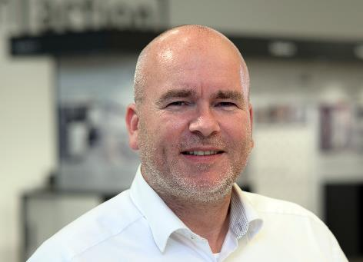

**392022_a**

Mark Bomer, Regional Sales Manager for the Netherlands/Belgium at Hettich: "At HoutPro+, we will be presenting ourselves as a partner, inspirer and networker for the industry. What we have to offer the trades couldn't be clearer: Hettich - always at your service." Photo: Hettich

Ein Bild, das Text, computer, drinnen, Person enthält.

**392022_b**

Hettich provides assistance across the board with targeted services in every project phase. The new service page provides all information and offerings in compact, target group focused form. Photo: Hettich

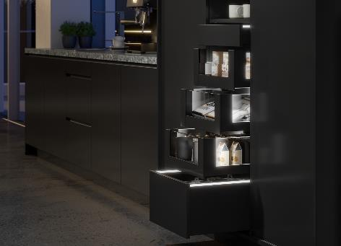   
**392022_c**

Homogeneous LED light in clip on profiles: "AvanTech YOU

Illumination" now gives furniture its very own LED signature lighting. Photo: Hettich

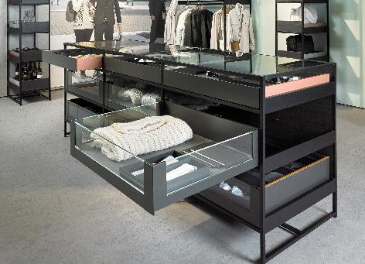

**392022_d**

Not only stylish in shops: thanks to Cadro, individually tailored furniture construction is now even easier. The aluminium frame system can be combined with other Hettich solutions, here for example with the AvanTech YOU drawer platform. Photo: Hettich

Ein Bild, das drinnen, Fenster, Tisch, Möbel enthält.

**392022_e**

The Cadro aluminium frame system can also be used to create high quality display cabinets. Photo: Hettich

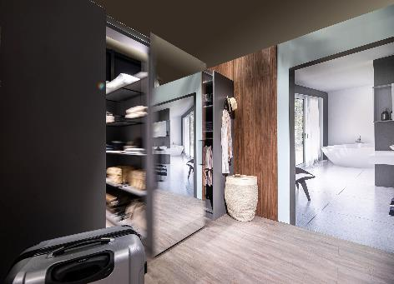

**392022_f**

TopLine XL sliding door system paired with Cadro aluminium frame system: the centre section of this walk in wardrobe easily and conveniently moves to the left and right. Photo: Hettich

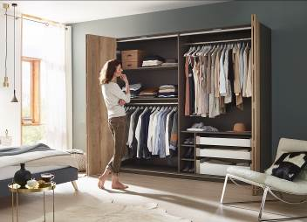

**392022_g**

The WingLine L folding door system creates surprising panorama effects on the wardrobe. Photo: Hettich

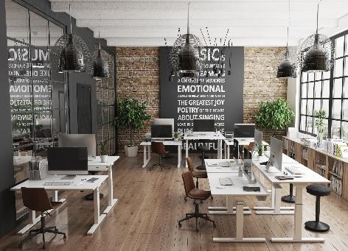

**392022_h**

Better ergonomics in the office from height adjustable desks: the Steelforce Professional Line impresses with a high level of stability and clean looking design. Photo: Hettich

About Hettich

Hettich was founded in 1888 and is today one of the world's largest and most successful manufacturers of furniture fittings. Over 7400 members of staff in almost 80 countries work together towards the objective: developing intelligent technology for furniture. On this basis, Hettich inspires people across the globe and is a valuable partner to the furniture industry, retailers and the trades. The Hettich brand is synonymous with consistent values: with quality and innovation. For reliability and closeness to customers. Despite its size and international significance, Hettich has remained a family run business. Independent of investors, the company is free to shape its future in a humane and sustainable manner.[www.hettich.com](http://www.hettich.com)