**Making the trades and retailers ready for the future**

**Hettich as a partner, inspirer and networker at Holz-Handwerk 2022**

**How can we combine home and work life even better in the future? And how can we still live comfortably in a small space? How can we give the customer furniture that's one of a kind? And how can we boost our work efficiency even further? – Hettich wants to give the industry practical answers to all this at Holz-Handwerk "Summer Edition" 2022. It is with the clear cut "Hettich - Always at your service." lineup that the fittings specialist will be welcoming all interested trade visitors on stand 304 in hall 10.1.**

After the long and mandatory pandemic shutdown, the Hettich team is particularly looking forward to the first big attended trade fair. "In Nuremberg we are presenting ourselves as a partner, inspirer and networker for the industry," explains Jan Hübschmann, Retail/Trades Sales Manager for Central Europe at Hettich. "The products we develop and our digital services always focus on the trades' needs. Cabinet makers and carpenters want to excite their customers with innovative, tailor made furniture solutions. And we can give the trades precisely the instruments and products that will let them do this in a way that couldn't be more easy, conclusive and cost effective in the future."

Practical services and interesting advancements catering to the megatrends of individualisation, urbanisation, digitisation and new work are at the focus of Hettich's show presentation. It was only this spring, for example, that the fittings specialist started marketing its "Steelforce" range for height adjustable desks and accessories. But that's just one of the highlights Hettich has in store for trade visitors in Nuremberg, explains Jan Hübschmann: "We are launching a fantastic show concept in 2022: every day of the fair, we'll be staging short live events on megatrends, products and services for our visitors directly on the stand. Anybody wishing to take a look around first or go straight into detail on specific aspects will find all sorts of interesting ports of call on our newly designed stand."

**Faster with Hettich eServices**

This is all part of Hettich's free service line up: the convenient and easy to use online tools make the work of carpenters, fabricators or retailers faster and more efficient in every project phase. The generally available data link to various CAD/CAM systems is a key aspect here too. At the dedicated "eServices" consultation point, showgoers can discover how easy it is to optimise their processes, from development, inspiration and planning right through to realisation, assembly and marketing.

**"Paul explains how": technical information from the expert**

There's always something worth seeing in the stand's "Paul explains how" zone: live assembly demonstrations give trade visitors useful information on Hettich's assembly machines. Hettich's intelligent work assistants not only make the various production steps faster and more accurate but also safer and more reliable. Hettich offers practical work aids as well as automatic drilling and insertion machines for every stage of the furniture making process – valuable assistance in machining and assembling drawers as well as in fitting runners, hinges, mounting plates, connecting fittings, drawer fronts or handles.

**Impressive product solutions**

At Hettich, you can once again discover innovative solutions and new products for all sorts of lifestyles and working situations, such as the AvanTech YOU drawer platform that can be configured in many different ways, the creative Cadro frame system, the Actro 5D pull-out system, the TopLine XL sliding door system being used for making versatile spaces, the new "Steelforce" range for height adjustable desks as well as room sliding solutions from Kuhn, a Hettich Group company. Trade visitors will get plenty of opportunity to try out the products for themselves on location, put their questions direct and talk shop with the Hettich team.

**AvanTech YOU: drawers just as you please**

The versatile and adaptable AvanTech YOU drawer system from Hettich takes the effort out of customising design to meet any preference in colour, format and material. The platform principle means all components can be combined in any chosen way. This gives the trades a vast range of options for creating furniture with an individual look and for designing exclusive interiors. The drawers can be configured in three colours and five heights with steel, aluminium or wooden rear panels. DesignProfiles and DesignCapes can be used to make all manner of statements with a look of individuality. And you can choose absolutely any material for the drawer side profile inlays. All of these options can be used to respond quickly and confidently to new design trends with AvanTech YOU and tap into new customer segments.

By way of option, the new AvanTech YOU Illumination feature now even gives furniture its own signature lighting: clip on LED design profiles or illuminated glass inlays create stunning mood effects and a touch of elegance. A practical rechargeable battery pack provides the necessary energy. The easy to install system requires no complicated electrical connection work, making it easy to fit at any later stage. The "wow" effect is guaranteed on opening the illuminated drawers. It is no coincidence that this ingenious idea from Hettich has already won the iF Design Award and the Red Dot Award this year.

**Cadro: the aluminium frame system for endless furniture ideas**

Fast assembly and high quality precision finish are the hallmarks of the Cadro frame system from Hettich. Aluminium profiles, connecting nodes and complementary accessories, this is all that's needed to create finely structured and highly practical furniture concepts – from creative designs in your own furniture collection to exclusive shop fittings and on trend kitchen, bathroom and living room furniture. Cadro now makes it so easy to customise any furniture you make, be it open or closed, standalone or attached to one side, wall mounted or floor standing. This is all based on aluminium profiles in matt black or stainless steel look, each designed for 16 mm shelves, 6 mm glass shelves as well as 4 mm glass shelves for display cabinets. Needless to say, Cadro can also be combined with other Hettich fittings and systems, such as drawers, sliding doors and hinged doors. As a show highlight, for example, Hettich is presenting Cadro in combination with the TopLine XL sliding door system: turning a walk in wardrobe into a very convenient storage wizard that can be individually tailored to a wide variety of floor plans and fitting situations.

**Actro 5D: precision that gets things moving**

Long life, incredible stability and outstanding running performance are characteristic of the new Actro 5D generation from Hettich. The sturdy runner system for wooden drawers has been consistently optimised for fast, straightforward installation and front panel adjustment: 5-way adjustment involves no tools and is completely intuitive. Thanks to flexible synchronisation adapters, Actro 5D also makes Push to open Silent work on asymmetrically shaped wooden drawers or on extremely wide front panels. Actro 5D has a load capacity of up to 70 kg. This is the key to perfect front panel alignment even with large size wooden drawers: every open drawer is perfectly horizontal.

Noticeable convenience in everyday use comes from Actro 5D's agreeably low opening forces and particularly smooth, quiet running action. This is all down to optimised synchronous control: safely protected by the runner profile, it ensures a smooth movement cycle between the profiles and minimises running noise. Incidentally: Actro 5D's cabinet body drilling pattern is also compatible with Hettich's customisable AvanTech YOU drawer platform. This way, further design options can be used to secure a strong position in a wide range of different furniture segments while matching value for money to whatever your customers are looking for.

**Steelforce: healthy and productive at the workplace**

Whether working from home or in the office: comfortable desks that make it possible to change quickly from sitting to standing are part of the standard outfit in the modern workplace. The height adjustable Steelforce desk support frames add dynamic and better ergonomics to every office routine. Two Steelforce ranges are available for the trades and retailers: the cost efficient Homeoffice Line and high performance Professional Line.Configured for ease of assembly, these systems are quality finished and designed for reliable and safe permanent use. The comprehensive range of Steelforce desk support frames provides the right solution for small and large projects and comes with a wide range of attractive accessories, from practical storage space and cable management to acoustic screen. And because many trade businesses are more than busy at the moment, they can even order them from Hettich complete with desktop and get them delivered direct.

**Kuhn: end to end answers to ceiling high sliding doors**

Now featuring the Kuhn system family, this is the first time that Hettich has supplemented its existing sliding doors with sliding elements not fastened to a frame. The system for high end interior design is completely modular in design. This gives fabricators the ultimate in design flexibility for all situations - for fitting to walls and ceilings or for ceiling integration: as a furniture application, through door, room divider, partition or complete room in room solution. High performance roller technology and intelligently designed profile cross sections permit unique door dimensions. Whatever the time of day and wherever you happen to be, Kuhn's web based configuration software lets you plan your sliding door in precisely any way you choose.

**Trade fair landing page with all manner of information**

Covering all aspects of Holz-Handwerk, Hettich has set up a dedicated landing page <https://fairs.hettich.com/en-de/home>

Before, during and after Holz-Handwerk, this is where you can find Hettich's complete trade fair line up at a glance and in compact form: information on products and services, but also on the show team and the programme of live events on the Hettich stand. This is where anyone unfortunately unable to make it to the fair this year can get comprehensive information and contact the Hettich team direct with any questions.

The following picture material is available for downloading from the "**Press**" **menu** at **www.hettich.com**:

**Images**

**Captions**

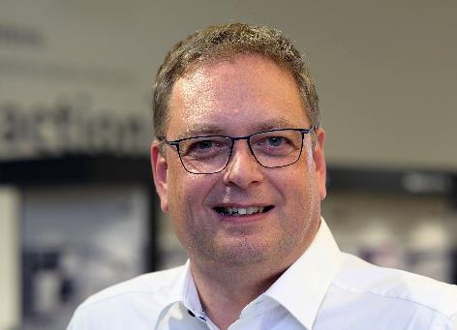

**222022_a**

Jan Hübschmann, RetaiI/Trades Sales Manager for Central Europe at Hettich: "After the long mandatory shutdown, the Hettich team is particularly looking forward to this first big attended trade fair. In Nuremberg, we are presenting ourselves as a partner, inspirer and networker for the industry. Our motto is: Hettich – Always at your service.“

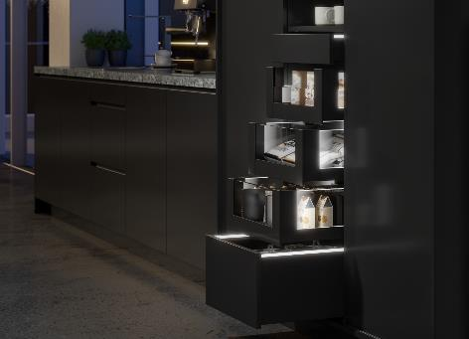

**222022_b**

Homogeneous LED light in clip on profiles: "AvanTech YOU

Illumination" now gives furniture its very own LED signature lighting. Photo: Hettich

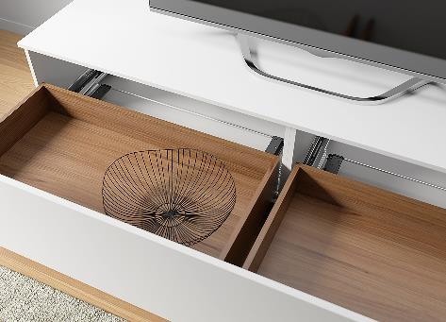 **222022_c**The new generation of Actro 5Drunners provides smooth running performance for wooden drawers and effective multisynchronisation for extra wide front panels: Actro 5D can even be used with Push to open Silent for XXL drawer formats. Photo. Hettich

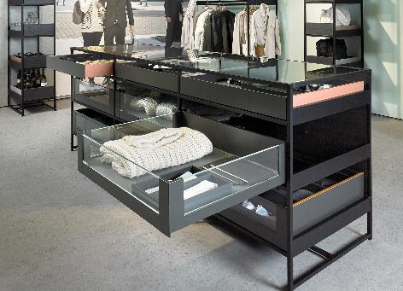

**222022_d**

Not only stylish in shops: thanks to Cadro, individually tailored furniture construction is now even easier. The aluminium frame system can be combined with other Hettich solutions, here for example with the AvanTech YOU drawer platform. Photo: Hettich

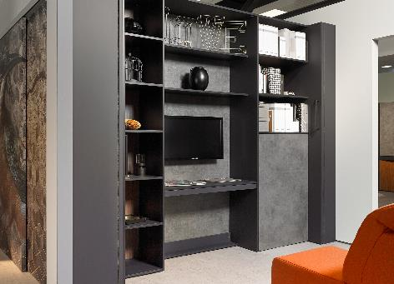

**22202_e**

The footprint stays as it, but the space transforms. Repositionable, ceiling height wall elements with TopLine XL create space wherever it happens to be needed. Photo: Hettich

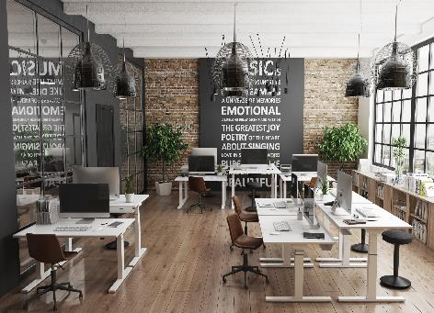

**222022_f**

Better ergonomics in the office from height adjustable desks: the Steelforce Professional Line impresses with a high level of stability and clean looking design. Photo: Hettich

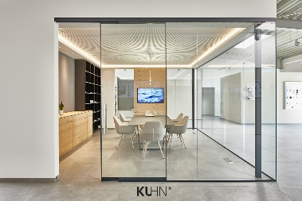

**22202_g**

End to end answers to ceiling high sliding doors.

Now featuring the Kuhn system family, this is the first time that Hettich has supplemented its range of sliding doors with sliding elements not fastened to a frame. Photo: Kuhn

About Hettich

Hettich was founded in 1888 and is today one of the world's largest and most successful manufacturers of furniture fittings. Over 6,700 members of staff in almost 80 countries work together towards the objective: developing intelligent technology for furniture. Hettich thus inspires people all over the world and is a valuable partner for the furniture industry, trade and craft. The Hettich brand stands for consistent values: for quality and innovation. For reliability and customer proximity. Despite its size and international significance, Hettich has remained a family business. Being independent of investors means that the company has a free hand in shaping its future with a focus on the human element and sustainability. [www.hettich.com](http://www.hettich.com)