**Hettich at Puumessut 2023:**

**Every key success is in Hettich**

**At last, it's now show time again in Finland: fittings specialist Hettich will be using Puumessut in Jyväskylä from 6 to 8 September to present its new product releases. The focus is on innovative and creative fittings solutions for customised furniture design.**

Hettich will be providing compelling ways of addressing how the furniture industry, trades and specialist retailers can respond to the changing expectations users are placing on home living, lifestyle and the working environment. Highlights on Hettich's stand D-242, located right next to Mokki, the Finnish retailer for Hettich products, will include new design features for the AvanTech YOU drawer platform, the WingLine L handleless folding door system and the smartphone controlled Hettlock Bluetooth locking system. The InnoTech Atira drawer system provides particularly good value for money, as do the Quadro runners for wooden drawers that feature impressive new front panel adjustment functions.

**AvanTech YOU Illumination: showing furniture in its best light**

The versatile and adaptable AvanTech YOU drawer system from Hettich takes every effort out of customising design to meet any preference in colour, format and material. The platform principle means all components can be combined in any chosen way. This opens up a wide range of design options for interior design. By way of option, "AvanTech YOU Illumination" now even gives furniture its own signature lighting: clip on LED DesignProfiles or illuminated glass inlays create stunning mood effects and a touch of elegance. A practical rechargeable battery pack provides the necessary energy,without the need for any costly and complicated wiring.

**WingLine L: folding sliding door system for new design perspectives**

Can opening a wardrobe or cabinet become something of an experience? It can! Whether in the wardrobe, in alcoves or in the top mounted kitchen unit: WingLine L from Hettich is the folding sliding door system that can't fail to impress in all sorts of applications. The "Push / Pull to Move" opening mechanism creates panorama effects, design flexibility and a high level of user convenience. It was this, in fact, that gave WingLine L the Red Dot Product Design Award back in 2018. Bringing out the new generation of WingLine L, Hettich is now going a step further in drawer running and design quality as well as in the various ways there are to adjust the system.

**Hettlock Bluetooth: digital security for personal belongings in the office**

In the modern office, desk sharing, open spaces and co working are all part of the agenda. This is where a dedicated and secure place for personal belongings and confidential documents, in a locker say, is an absolute must. Anyone needing it can book a locker using a free app. Hettlock Bluetooth gives staff access to their personal storage space by smartphone, NFC chip or, by way of option, also by numerical code or fingerprint. The electronic lock makes it easy to manage user rights, brings flexibility to using storage space and provides online information on battery status and user history at all times.

**Quadro 5D: new diversity for the drawer runner platform**

Coupled with high cost efficiency, the Quadro bottom mounted drawer runner from Hettich brings a look of elegance and perfect performance to opening and closing wooden drawers. Offering a new platform ranging from simple part extension to full extension runners with 30 kg load capacity and 5D front panel adjustment, Hettich is now positioning its Quadro range as a veritable all rounder. And if even more capacity is needed for particularly large, heavy wooden drawers, the premium Actro 5D runner – capable of carrying loads of up to 70 kg – can also be used with identical drawer dimensions and cabinet body drill holes. This means Quadro now gives furniture and kitchen manufacturers an unequalled range of options for differentiating between product lines while guaranteeing maximum efficiency in production and also providing a cost effective way of matching performance to any particular need.

Puumessut 2023 is inviting visitors to discover everything that's in the fittings manufacturer: It’s all in Hettich.

[www.hettich.com](http://www.hettich.com)

The following picture material is available for downloading from the "Press" menu at www.hettich.com:

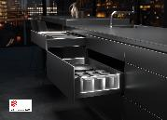

**222023_a**

Stunning mood effects and a touch of elegance: as an option, AvanTech YOU from Hettich now gives drawers their own LED signature lighting. Photo: Hettich

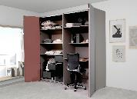

**222023_b**

The new generation of WingLine L folding door fittings delivers amazing panorama effects, compelling practical functions and high quality design. Photo: Hettich

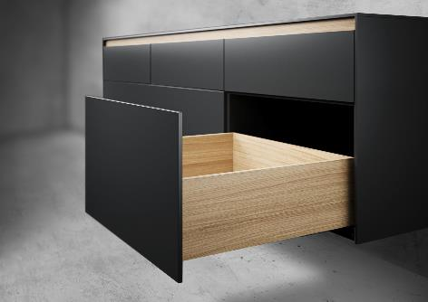

**222023_c**

The Quadro 5D drawer runner makes it so easy to achieve perfectly aligned drawer fronts. This sets off large surface furniture design and testifies to high quality. Photo: Hettich

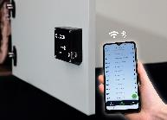  
**222023_d**

Using a free app, Hettlock Bluetooth brings versatile usage and easy management to the locker unit. Photo: Hettich

About Hettich

Founded in 1888, Hettich is one of today's largest and most successful manufacturers of furniture fittings on the international stage. The family owned company is based at Kirchlengern in the furniture making cluster of Germany's East Westphalia region. Some 8,000 members of staff in almost 80 countries work together to give the industry future proof solutions. Promising "It's all in Hettich", the Hettich brand provides a comprehensive portfolio of services that is consistently and resolutely geared to the needs of customers across the globe. By tradition, top priority has always been at the focus of everything we do to ensure sustainability at social, societal and ecological level. [www.hettich.com](http://www.hettich.com)