Hettich and Maxim Kashin Architects win two ‘Best of Best’ awards at the ICONIC AWARDS 2026
Suprematist furniture pieces featuring innovative fitting technology

What happens when Russian avant-garde art meets modern furniture design and innovative fitting technology? This can give rise to entirely new perspectives on furniture and rooms. This is demonstrated by two extraordinary design pieces developed by architect Maxim Kashin of Maxim Kashin Architects in collaboration with Hettich. Inspired by Suprematism, the designs combine a consistently geometric aesthetic with functional furniture technology from Hettich. Both designs have now been awarded the ‘Best of Best’ prize at the German Design Council’s ‘ICONIC AWARDS 2026’: the ‘Suprematist furniture installation for Hettich’ in the ‘Interior’ category and the ‘Suprematist Bureau for Hettich’ in the ‘Product’ category.
The ICONIC AWARDS are an international platform for architecture, interior design and product innovation. For Hettich and Maxim Kashin Architects, the award is a special endorsement of their shared approach: modern fitting systems can inspire unique, ‘iconic’ design concepts for furniture and interiors.
Suprematism Reinterpreted
The artistic concept behind the two award-winning pieces of furniture draws on Suprematism, a movement founded by Kazimir Malevich at the beginning of the 20th century. It was a movement within the Russian avant-garde that emerged in the early 20th century. A defining feature is the focus on pure, non-representational art and basic geometric shapes. The architect Maxim Kashin has now translated these design principles into artistic pieces of furniture for Hettich, which also boast functional qualities. Sculptural compositions emerge from surfaces and geometric solids, their appearance constantly changing depending on the angle of view and the movement of individual elements.

Sculpture or furniture? Both!
It was precisely this interplay that also impressed the international jury of the ICONIC AWARDS: in their view, the ‘Suprematist Bureau’ combines Russian avant-garde art with modern, largely invisible fitting technology to create a functional piece of furniture. What at first appears to be a sculpture turns out to be a well-designed piece of office furniture which, by rotating and opening its components, constantly takes on new geometric forms. Transformation also plays a central role in the ‘Suprematist furniture installation’, which has likewise won an award: geometric surfaces, reflections and movement cause the furniture and the space to merge visually. Finished on the outside with elegant walnut veneer, the bright red interiors of some of the drawers and cabinet bodies serve as a nod by these two pieces of furniture to the era of Russian avant-garde art.

FurnSpin brings movement to the art object
Hettich’s innovative FurnSpin turning and swivelling system provides a key technical prerequisite for this versatility. Thanks to its translational rotational movement, an entire piece of furniture can be rotated through 180 degrees in the blink of an eye: in the case of the ‘Suprematist Bureau’, too, the interior turns inside out, transforming closed front panels into an open storage area. The surprising thing is that, rather than opening doors or flaps, a large part of the cabinet body itself is moved. The fittings remain virtually hidden, allowing the furniture’s distinctive design to take centre stage. In this way, technology, as a design feature, also becomes a means of transformation. Movement alters the geometry, function and perception of the piece of furniture.
For architects and designers, this opens up opportunities to combine function and design in unexpected new ways. As well as FurnSpin, other Hettich systems are used in the two award-winning pieces of furniture. These include the AvanTech YOU drawers, some of which are equipped with the ‘Illumination’ LED lighting feature, or telescopic shelves on Actro 5D drawer runners, as well as the Sensys fast assembly concealed hinge for furniture doors and the interior fittings Iseo, Lario, Olona, Salso and Senio. In the case of the ‘Suprematist Bureau’, the ICONIC AWARDS jury highlights how innovative fitting technology can also open up artistically inspired forms for practical, functional spaces.

Hettich is committed to professional exchange
The jointly developed furniture pieces were previously presented to an international audience of industry professionals at the Furniture Interior Woodworking (FIW) 2026 trade fair in Almaty, Kazakhstan. Hettich Central Asia now wishes to continue its conversation with the architecture and design community: On 10 December 2026, the team at Hettich’s headquarters in Kirchlengern is planning to host the first ever “Hettich Design Days 2026” event, specifically for Russian-speaking architects, interior designers and designers. The focus will be on professional exchange and new ideas for furniture and interior design concepts.
The following images are available for download from the ‘Press’ menu on www.hettich.com:
Images
Captions
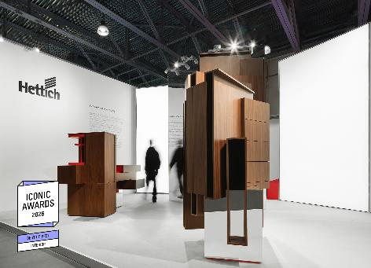
362026_a
The project “Suprematist furniture installation for Hettich” was awarded the “ICONIC AWARDS 2026” “Best of Best” prize in the “Interior” category. Photo: Maxim Kashin Architects

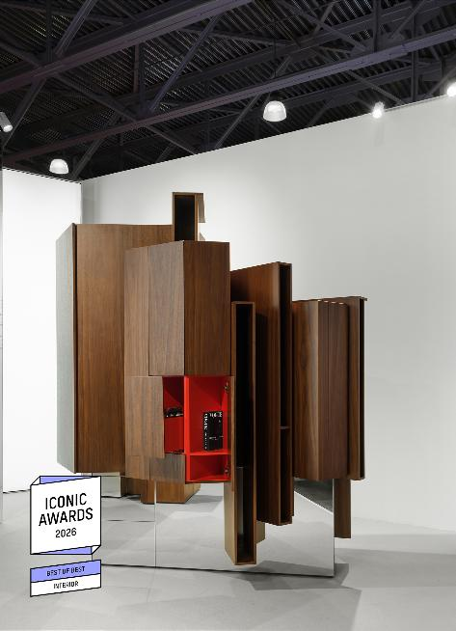
362026_b
“Suprematist furniture installation for Hettich”: Hettich’s fitting technology complements the design’s extraordinary aesthetic and ensures that the sculptural furniture is fit for purpose. Photo: Maxim Kashin Architects

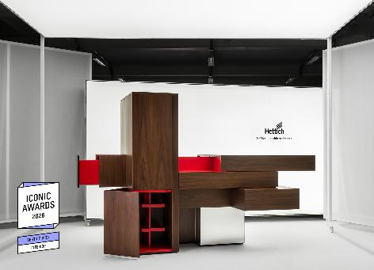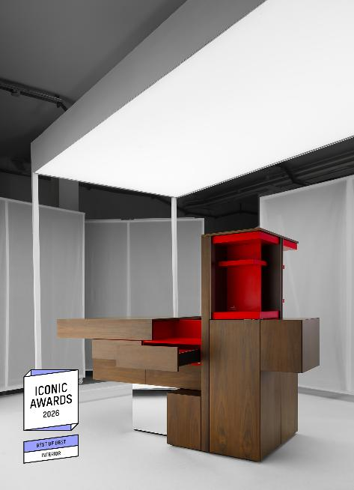
362026_c, _d
Winner of the “ICONIC AWARDS 2026” “Best of Best” in the “Product” category: in the “Suprematist Bureau for Hettich”, architect Maxim Kashin incorporated, amongst other things, the Turning and swivelling system FurnSpin. Photos: Maxim Kashin Architects
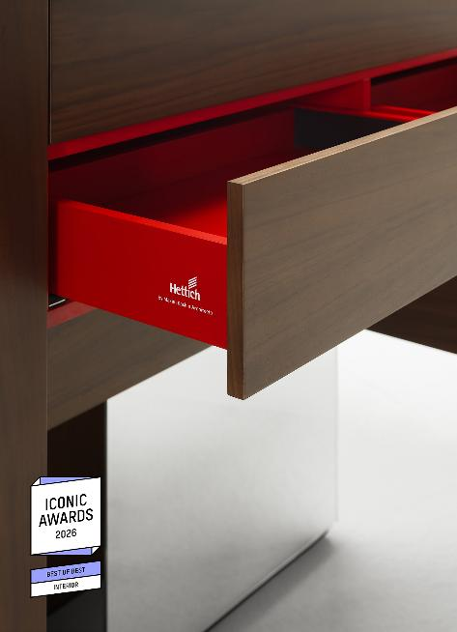
362026_e
With an elegant walnut veneer on the outside and bright red AvanTech YOU drawers on the inside, the ‘Suprematist Bureau for Hettich’ evokes the Russian avant-garde art of the early 20th century. Photo: Maxim Kashin Architects

About Hettich
Founded in 1888, Hettich is one of the world’s largest and most successful manufacturers of furniture fittings. The family-owned company is based in Kirchlengern, in Germany’s East Westphalia region. Hand in hand with its customers, Hettich uses innovative solutions to shape tomorrow’s living spaces. Its work centres on users’ needs and on the question of how to provide flexibility in adapting to changing needs at home, in life and at the workplace. The Hettich, FGV, Actiforce and KUHN brands bring together a range of expertise and perspectives within the international Hettich Network. Some 8,200 colleagues consolidate incredible competence to give customers the achievements of so many specialists on a one-stop-shop basis. The Hettich Network combines commercial success with environmental, social and societal responsibility, and bases its actions on a long-term, intergenerational perspective. www.hettich.com

