Formatio becomes “Moved by RoomSpin” network partner
Reimagining interior furnishings together with Hettich

With the development of the SpinLines product family, Hettich has adopted a disruptive approach to furniture and room concepts. RoomSpin in particular demonstrates the potential of rotating furnishings for efficient space usage and multifunctional room design. Formatio Einrichtungen GmbH & Co. KG has been welcomed as Hettich’s first official “Moved by RoomSpin” network partner. The first joint project has already been successfully completed: together, the partner companies created the interior design of a room in the basement of a villa in Potsdam, featuring a modern gym on one side and a customized storage area on the other.

People’s changing needs for living and working were the impetus for Hettich to develop the innovative SpinLines spin-and-swivel systems. It was clear to the fittings specialist that new applications could only be conceived if existing boundaries in the field of furniture design were pushed back. Hettich is building a partner network, “Moved by RoomSpin”, to realize solutions that incorporate RoomSpin and handcraft them to match a wide range of applications.

The Perfect Match
Formatio combines tailor-made solutions with a high level of automation and considers itself an industrially oriented manufacturer in the cabinetmaking trade. Particularly due to its digital processes running through planning, design, and production, it was clear to Hettich that Formatio was predestined to be a “Moved by RoomSpin” partner. After Hettich demonstrated the RoomSpin technology to Formatio in 2023, it became apparent that a collaborative partnership would bring significant added value for both parties. The first joint project, “Villa Potsdam”, proves that flagship projects can be realized when manufacturers and producers pool their expertise. “We had already started thinking about a concept for the least attractive room in our lovely home – a 40-square-metre basement with light shafts,” explains the private owner. The project was jointly managed by Formatio and Hettich, providing everything from a single source, including advice on finishes, lighting, colours, and sports flooring.

State-of-the-art gym and storage in one
For Jan Christoph Kahre-Heidemann, Managing Director of Formatio, this project was a unique opportunity. “A pioneering project in an extraordinary location, ideally suited to evaluate the performance of the innovative RoomSpin technology in practice," he explains, looking back. Four floor-to-ceiling built-in pieces of furniture utilising RoomSpin were arranged along one wall and can be rotated in a cascade pattern. Each piece of furniture was individually designed and manufactured in accordance with the customer’s wishes. The primary side includes everything needed for a perfectly equipped gym: storage space for dumbbells and other sports equipment, as well as drawers for towels. Even a flat screen and a refrigerator were installed. In addition to the efficient use of space, the focus of the interior design is on creating a sense of well-being through high-quality furniture design, crafted from real walnut wood with a slatted finish. Rotating the built-in furniture reveals a perfectly designed storage area. Whether for skiing and diving equipment or children’s toys, Formatio has planned each section specifically for the items to be stored, creating a prime example of tailored interior design. The private owner enjoys twice the benefit. Normally, twice the space and furniture on at least two walls would be required to meet all storage needs. But thanks to the RoomSpin technology, the space required can be halved, leaving three walls free for designer touches. In this case, one wall was mirrored and another was used as an equipment wall. “Now, this room is the one in our home with the absolute wow factor – a fitness room oozing convenience and well-being, and plenty of hidden space for everything that needs to fit into a basement, with us having so many children and hobbies,” says the client happily. “A big thank you to the entire team!"

The project demonstrates the enormous potential for transforming furniture and spaces with Hettich’s SpinLines product family, as it can be scaled for various applications – whether in public and private buildings, retail, or New Work environments. Hettich’s project team also has positive feedback: “The trusting collaboration between Formatio and Hettich is an excellent opportunity for us to validate and further develop RoomSpin to meet key customer and end-user needs.”

Architects and planners interested in transformative interior design using the RoomSpin object carrier will not only find an expert architectural team at Hettich as a point of contact but also specialized manufacturers to realize projects through the “Moved by RoomSpin” partner network currently being developed.

You will find further information here:
Spaces to Architecture – Flexible modular solutions for office, retail and living spaces | Hettich

The following picture material is available for download from the "Press" menu at www.hettich.com:

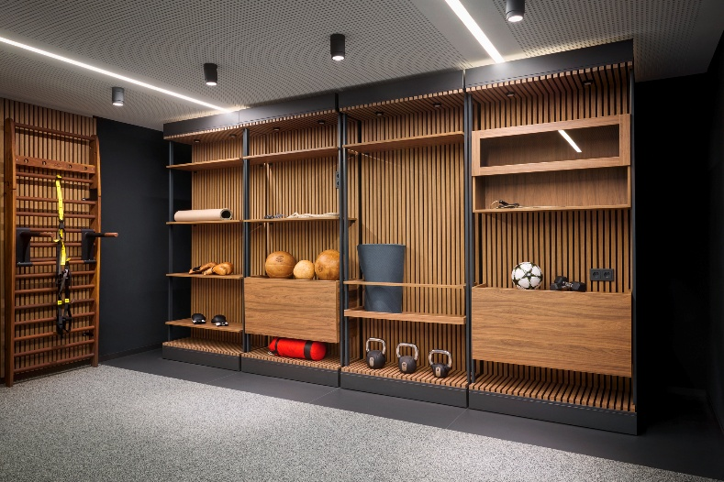
332025_a
The result of a successful “Moved by RoomSpin” partnership between Formatio and Hettich: on the primary side of the four wall elements is a gym designed down to the last detail, made from high-quality materials and creating a feel-good atmosphere. Photo: Hettich

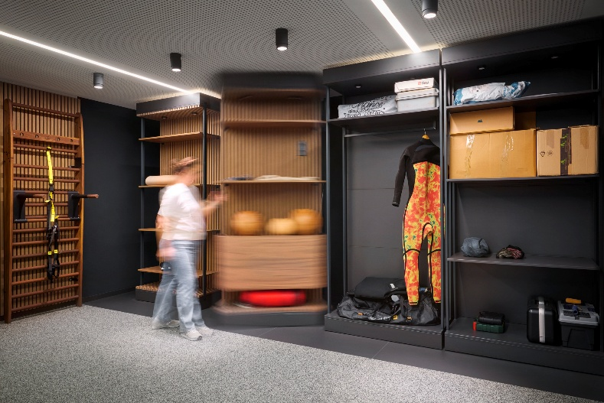
232025_b
The floor-mounted RoomSpin technology enables the wall elements to be rotated easily. This creates a completely different use of space within the same area. Photo: Hettich

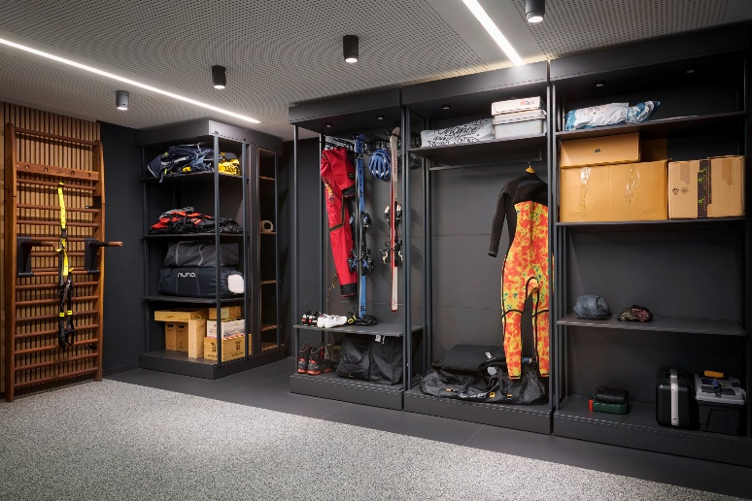
232025_c
On the other side, there is a spacious storage area with a design individually tailored to the items being stored.
Photo: Hettich

About Hettich
Founded in 1888, Hettich is one of today's largest and most successful manufacturers of furniture fittings on the international stage. The family-owned company is based at Kirchlengern in the furniture making cluster of Germany's East Westphalia region. Some 8,400 members of staff work together to provide our future proof solutions in over 100 countries. Promising "It's all in Hettich", the Hettich brand provides a comprehensive portfolio of services that is consistently and resolutely geared to the needs of customers across the globe. By tradition, top priority has always been at the focus of everything we do to ensure sustainability at social, societal and ecological levels. www.hettich.com

