**SieMatic shows Easys Compact from Hettich for the first time**

**Deluxe handleless opening for refrigerators**

**The high quality kitchens from SieMatic Möbelwerke GmbH & Co. KG (**[**www.siematic.com**](http://www.siematic.com)**) place a particular focus on design quality and user convenience. The new Easys Compact electromechanical door opening system from Hettich will also be making its debut at the manufacturer's in-house exhibition from 17 to 22 September 2022 in Löhne.**

Carl-Heinrich Moning, technical developer at SieMatic: "Easys Compact is the perfect door opener for providing end to end handleless design in our kitchens. The new system enables us to combine our high design standards with noticeably more user convenience from the refrigerator." Easys Compact demonstrates its strengths in everyday practice: the system reliably and safely opens every refrigerator door; providing strong opening forces, a single unit is sufficient even for heavy doors. okThe pressure sensor can be positioned at any chosen height – convenience for all refrigerator users no matter how tall and of any age.

SieMatic is presenting Easys Compact in a Gaggenau refrigerator. But the slimline unit can also be used in most other refrigerators. Because Easys Compact uses the predefined holes provided directly on the refrigerator and also comes with an intuitive plug connection. This rules out installation mistakes and makes fast work of fitting the system. As Easys Compact is mounted independently of the carcase, it is even possible to use standard carcases. Activated via an interface, smart voice control can, of course, also be used to give touch-free opening with Easys Compact. In white or dark finish, the system always blends in unobtrusively with surrounding surfaces. Hence, Easys Compact permits on trend, handleless design and a high level of functionality in everything ranging from furniture to electrical appliance.

Following Easys Compact's debut at manufacturer SieMatic, Hettich is planning a selective market launch for the new system in the first quarter of 2023.

[www.hettich.com](http://www.hettich.com)

The following picture material is available for downloading from the Press section at **www.hettich.com**:

**Images  
Captions**

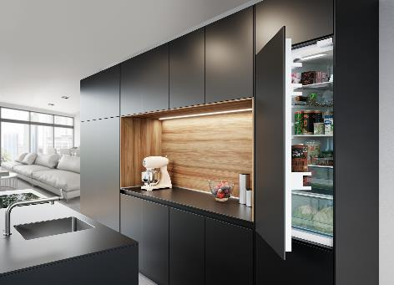

**332022_a**

Debut for Easys Compact: SieMatic shows the new electromechanical door opening system from Hettich for the first time. Photo: Hettich

About Hettich

Hettich was founded in 1888 and is today one of the world's largest and most successful manufacturers of furniture fittings. Over 7,400 members of staff in almost 80 countries work together towards the objective: developing intelligent technology for furniture. On this basis, Hettich inspires people across the globe and is a valuable partner to the furniture industry, retailers and the trades. The Hettich brand is synonymous with consistent values: with quality and innovation. For reliability and closeness to customers. Despite its size and international significance, Hettich has remained a family run business. Independent of investors, the company is free to shape its future in a humane and sustainable manner. [www.hettich.com](http://www.hettich.com)