The kitchen as a versatile living space
Kitchen Fair “Küchenmeile” 2026: What's new
Usage concepts with Hettich

Life is in full swing in the modern kitchen, with everything that makes for personalised living. To ensure that in the kitchens, it’s not just places where people can not only cook, but also live and work, are Solutions are needed that offer flexible options for use allow. With its intelligent Fitting technology: the base for the further development of the Kitchens as a versatile living space. What how varied and individual these solutions may be Various kitchen manufacturers are demonstrating at the Kitchen Fair “Küchenmeile” 2026.

Hettich views fitting technology as going far beyond mere function, as an integral part of holistic living environments. Exercise, Design, ease of use and functionality come together to form a a positive user experience. Various kitchen manufacturers have uses this to develop exciting design and spatial concepts that A new take on movement, user-friendly storage spaces to make the most of the space and ensure the furniture can be used flexibly. The Kitchen retailers can look forward to attractive offers at Küchenmeile 2026 solutions that are making the kitchen more and more of a transform a multifunctional space. This is how new Create incentives for kitchen customers to make a purchase.

Dynamism for holistic living
New ways of using the space and movement patterns resolve the boundaries between the kitchens, living area and workspace are becoming increasingly blurred. The flagship of this transformation is the cutting-edge innovation, FurnSpin from Hettich. The multi-award-winning Turning and swivelling system FurnSpin makes furniture design versatile and creates storage space in a in a way never seen before. Manufacturers such as Beeck, Burgbad, Eggersmann, Nobilia, Rotpunkt and SieMatic have already high-quality solutions incorporating the Turning and swivelling system FurnSpin into their included in the What's new programme. Rotpunkt becomes FurnSpin present, for example, in a high-bay warehouse application. The system’s range of applications extends from rotatable top mounted cabinets and elegant glass display cabinets with lighting right through to floor-to-ceiling units. FurnSpin also shows what the what makes Hettich’s innovative fitting technology stand out: dynamism, Comfort and ease of use. The technology remains almost Invisible – the systems blend in perfectly with the materials and furniture design. This forms an important part of the The appeal of the solutions.

A new push for folding door solutions
With WingLine L, Hettich offers a folding door system that also with a dynamic sequence of movements – the Panorama-Impact – inspiring. Ballerina Kitchens presents a collection on the theme of “Storage planning for an organised kitchen routine” a space-saving top mounted cabinet with WingLine L and a new comfort unit. A gentle push on the kitchen front is all it takes, and the cabinet opens automatically and then closes Silent System. The benefits: effortless opening and quick access the contents of the cupboard. WingLine L is available from Häcker, Nobilia and Schüller, amongst others, in other exciting applications at the Kitchen exhibition on display.

Minimalist drawer design
In its new range, Pronorm is now placing even greater emphasis on Design considerations. The product, which was only recently awarded the Red Dot Award Hettich’s excellent ExeoTech drawer system, featuring a slim 11 mm drawer side profile and flawless, precise edges defines a distinctive identity for the kitchen manufacturer Design language. With proTech pure, proTech glassCase and proTech purMaxi supplies Pronorm with various configuration options for the minimalist drawer system before.

Once again this year, the Küchenmeile makes it clear that Hettich’s innovative fitting solutions are a guarantee of success for the kitchen industry is and always will be.

The following picture material is available for download under the "Press" menu at www.hettich.com:
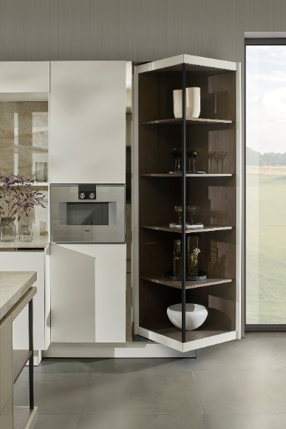
222026_a
The innovative Turning and swivelling system FurnSpin brings a new dynamic to the Designs for premium kitchens and makes the use of storage space unrivalled outside. Here is a swivelling tall unit with FurnSpin by SieMatic. Photo: SieMatic
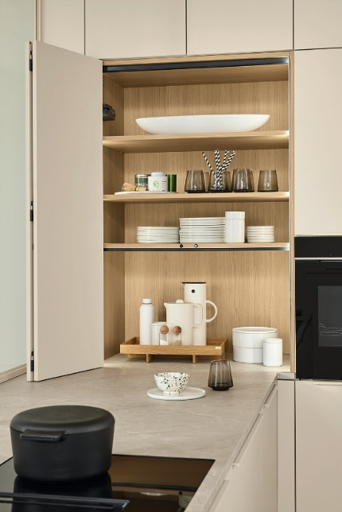
222026_b
Effortless comfort: Ballerina Kitchens presents the WingLine folding door system L with a Panorama effect in a top mounted cabinet. A sequence of movements, which never fails to impress and provides quick access to the offers the contents of the cupboard. Photo: Ballerina-Küchen

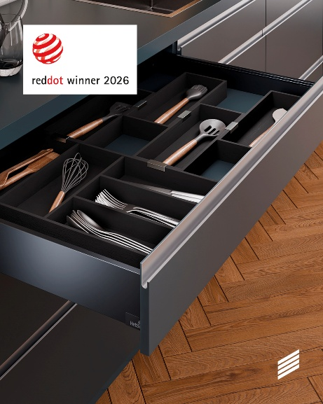
222026_c
With its sleek, flawless design, just 11 mm thick, ExeoTech sets a new standard The drawer side profile has a distinctive design language, for which the Drawer system awarded the ‘Red Dot’ Product Design 2026 prize was awarded. Photo: © Red Dot

Über Hettich
Hettich wurde 1888 gegründet und gehört heute zu den weltweit größten und erfolgreichsten Herstellern von Möbelbeschlägen. Stammsitz des Familienunternehmens ist Kirchlengern im Möbelcluster Ostwestfalen. Rund 8.200 Kolleginnen und Kollegen arbeiten gemeinsam daran, unsere zukunftsfähigen Lösungen in über 100 Länder zu liefern. Die Marke Hettich steht mit ihrem Unternehmensversprechen „It's all in Hettich“ für ein umfassendes Leistungsportfolio, das sich weltweit konsequent an den Bedürfnissen der Kunden orientiert. Nachhaltiges Handeln unter sozialen, gesellschaftlichen und ökologischen Aspekten hat dabei traditionell schon immer höchste Priorität. www.hettich.com

