**Hettich and Swood now strategy partners**

**New tool links product databases**

**Hettich and Swood by Eficad, the CAD/CAM woodworking and furniture software suite integrated within Solidworks, have teamed up over recent months to develop a link between Hettich's hardware products database and Swood's libraries. From now on, this means the latest product range from fittings specialist Hettich will also feature in Swood solutions libraries.**

Building on their strategic partnership, Swood and Hettich are providing a user friendly tool that's been developed to let Swood users access all Hettich products within their shared libraries while letting them update everything whenever they want to. This saves any need to set up a hardware library by hand. Not only leaving Swood users on the cutting edge of Hettich's latest innovative product lineup, the tool also lets them use every element of data in their 3D woodworking and furniture modelling work.

Created automatically, SwoodBox' smart components not only incorporate Hettich's hardware 3D model for visualising the end product but also every step in the machining process, such as drilling and cutting operations on surrounding elements, tops and panels, taking the 3D model to a stage that's ready for production.

More and more, automation is becoming key in the furniture industry. Being so, Swood and Hettich will continue working together and further optimise intelligent components for 3D design within Solidworks and enhance user friendliness.

The following picture material is available for downloading from **www.hettich.com, menu: Press**:

**Image**

**Caption**

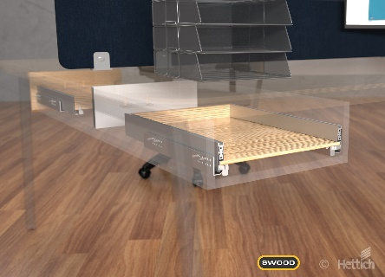

**202021_a**

Hettich's latest product gallery is now available from Swood's solutions libraries. Graphics: Hettich

About Hettich

Hettich was founded in 1888 and is today one of the world's largest and most successful manufacturers of furniture fittings. Over 6,600 members of staff in almost 80 countries work together towards the objective: developing intelligent technology for furniture. Hettich thus inspires people all over the world and is a valuable partner for the furniture industry, trade and craft. The Hettich brand stands for consistent values: for quality and innovation. For reliability and customer proximity. Despite its size and international significance, Hettich has remained a family business. Independent of investors, the company's future is shaped freely, humanely and sustainably. www.hettich.com