**Hettich America merges with FGV America**

**Hettich America, a global leader in premium functional ﬁttings and precision-engineered hardware, has acquired fellow hardware powerhouse, FGV America. The acquisition is now official following its initial announcement in late 2024, marking the formal close of the deal.**

The merger represents a key milestone in both companies’ shared strategy to strengthen market presence and exposure across the competitive North American market. With aligned values, long-term vision, and deep industry expertise, the merger brings together two family-owned businesses with over 200 years of combined experience, signifying a profound and enduring partnership based on mutual respect and a shared commitment to advancing the furniture fittings industry.

“Hettich and FGV are the perfect match in the functional hardware industry,” said Matthias Bertl, CEO of Hettich America. “With this new partnership, clients of both brands will benefit from our different value propositions and efficiencies in our operations, ensuring reliability in the current volatile market.” Bertl, who took the helm of Hettich America earlier this year, made the joint announcement with Kosta Esabalidis, CEO of FGV America.

While the Hettich Group is now the 100% shareholder of the FGV group, both brands will continue to operate independently, preserving their unique market identities and existing customer relationships. This ensures continuity and consistency for existing clients across the U.S. and beyond. Integration efforts are underway to align backend operations, such as SAP systems, financial structures, and internal processes, to improve efficiency and enhance service capabilities.

Together, Hettich and FGV are poised to deliver an expanded product portfolio, broader design flexibility, and increased value to partners, cementing their leadership in the global hardware space and shaping the future of lifestyle-driven furniture solutions.

The following picture material is available for downloading from **www.hettich.com, Menu: Press.**



**022025-US_a**

Matthias Bertl, CEO of Hettich America.

Photo: Hettich

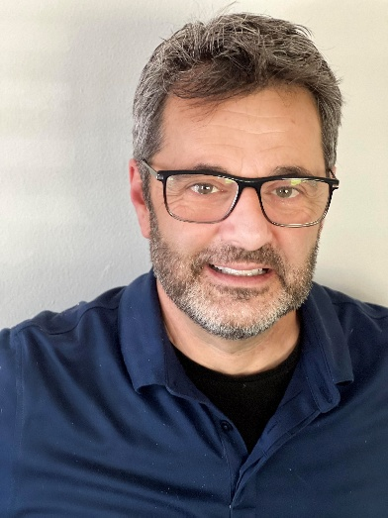

**022025-US_b**

Kosta Esabilidis, CEO of FGV

Photo: Hettich

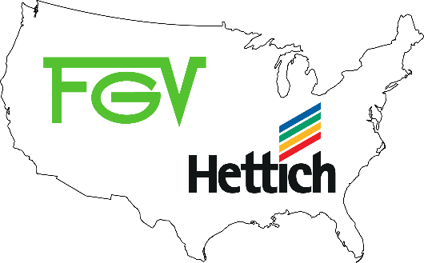

**022025-US_c**

Photo: Hettich

About Hettich

Founded in 1888, Hettich is one of today's largest and most successful manufacturers of furniture fittings on the international stage. The family-owned company is based at Kirchlengern in the furniture making cluster of Germany's East Westphalia region. Some 8,400 members of staff work together to provide our future proof solutions in over 100 countries. Promising "It's all in Hettich", the Hettich brand provides a comprehensive portfolio of services that is consistently and resolutely geared towards the needs of customers across the globe. By tradition, top priority has always been the focus of everything we do to ensure sustainability at social, societal and ecological levels.

[www.hettich.com](http://www.hettich.com)

About FGV

Quality, innovation and functionality at the right price, together with “Made in Italy” design and production: this is FGV. A leading company in the production of fittings and solutions for furniture, FGV offers a complete range of products. Among them hinges, drawers, slides, hanging brackets, alternative openings and sliding systems suitable to meet the most demanding market needs.

Founded in 1947 in the heart of Brianza, in Veduggio con Colzano, FGV is now present in all continents with six production and seven distribution sites together with a network of more than 70 distributors. FGV stands for innovation in opening systems for furniture and offers state–of-the-art solutions for your home. The R&D team is committed to developing solutions where functionality and design come together in the best way, always keeping a clear focus on the optimal quality-price ratio. From product design to quality control, from equipment selection to assembly every step of each process is meticulously taken care of. This enables FGV not only to meet customer needs but creates a true, lasting collaboration with our customers.

[www.fgvamerica.com](https://hettich-my.sharepoint.com/personal/felicitas_lechner_hettich_com/Documents/www.fgvamerica.com)