**HOLZ Basel, Switzerland: Hettich to Begin Marketing FurnSpin in Switzerland**

**The turn-and-swivel system enables unique furniture design**

**Hettich will officially launch its innovative FurnSpin turn-and-swivel system for the furniture trade at HOLZ, the leading trade fair for the woodworking industry, held from 14 to 18 October in Basel, Switzerland. This unique technology opens up new possibilities for cabinetmakers in furniture and interior design. The fittings specialist will also present its brand-new product innovations for this year in Hall 1.1, Booth E20.**

The special FurnSpin technology, based on translational rotation, enables furniture elements to rotate through 180 degrees – with just a flick of the wrist. The movement is perfectly balanced and impresses time and again. Hettich developed this world first as a scalable system from the outset, allowing rotating furniture elements to be created in a wide range of sizes and weight classes for kitchens, bathrooms, living areas, and offices. The Hettich team will bring some ideas on how FurnSpin can be used to HOLZ and will also introduce the new online configurator to cabinetmakers, simplifying the planning of furniture that showcases FurnSpin. The HOLZ trade fair is the ideal opportunity to experience this unique development live. This award-winning technology has great potential to impress discerning customers with its unique furniture design possibilities and new ways of utilising storage space.

**Discover More Product Innovations**

There are also other new products to discover, such as the SAH 500 heavy-duty cabinet suspension brackets, which can handle loads of up to 110 kg per bracket, or the super-slim, easy-to-install Avosys glass and mirror door hinge, which blends seamlessly with furniture. The new interior fittings from Hettich will also prove to be a highlight, enabling storage spaces in wall units, base units, and corner units to be utilised ergonomically and to their full potential. Another highlight is the “Illumination” LED system for atmospheric lighting of AvanTech YOU drawers, which are now even easier to install.

The Hettich team is looking forward to the HOLZ trade fair. Plan your visit now and secure your ticket: [Holz 2025 | Secure your tickets now](https://www.holz.ch/de/tickets)

The following picture material is available for download from the "**Press**" **menu** at **www.hettich.com**:

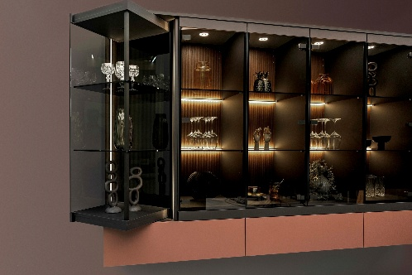

**462025_a**

Furniture incorporating FurnSpin can be made with different materials and even include integrated LED lighting. Photo: Hettich

**Ein Bild, das Wand, Im Haus, Weinglas, Wein enthält.
**

**462025_b**

Restrained elegance for kitchens, bathrooms, and living spaces: the new Avosys glass and mirror door hinge from Hettich enables minimalist furniture design with lasting user convenience. Photo: Hettich

**Ein Bild, das Im Haus, Boden, Schublade enthält.
**

**462025_c**

AvanTech YOU Illumination – the new generation with changing light colours has arrived: customising accent drawer lighting has never been easier. Photo: Hettich

About Hettich

Founded in 1888, Hettich is one of today's largest and most successful manufacturers of furniture fittings on the international stage. The family-owned company is based at Kirchlengern in the furniture making cluster of Germany's East Westphalia region. Some 8,400 members of staff work together to provide our future proof solutions in over 100 countries. Promising "It's all in Hettich", the Hettich brand provides a comprehensive portfolio of services that is consistently and resolutely geared to the needs of customers across the globe. By tradition, top priority has always been at the focus of everything we do to ensure social, societal and ecological sustainability. www.hettich.com