Holz‑Handwerk 2026: Discover new potential with Hettich
Hettich transforms its trade fair stand into an interactive experience space
Under the motto “Do what you're made of – with Hettich”, the fittings specialist shows how carpenters can fully leverage their strengths with Hettich as a partner. Visitors to Holz‑Handwerk from 24 to 27 March can discover these possibilities for themselves at the Hettich stand 12.0‑805 in Hall 12.0: whether furniture solutions, product innovations, digital tools or assembly – Hettich is creating a large interactive experience space at the leading trade fair for the craft sector that encompasses all processes.
Hettich is sending a clear message to the carpentry trade: “We believe in you, and in the fact that with your passion and love for wood and unique furniture construction you can achieve even more. We understand the responsibility we bear as a manufacturer and partner to so many creative and committed carpenters,” explains Jan Huebschmann, Sales Manager at Hettich. “Topics such as digitalisation, the shortage of skilled workers, marketing or cost pressure often absorb a great deal of capacity, leaving little room for manoeuvre. That’s why we provide targeted support with ideas, innovations and practical solutions and services that strengthen the trade and make everyday life easier: ‘Do what you're made of – with Hettich.’ Here, people and their skills take centre stage,” he continues.
At Holz‑Handwerk, Hettich invites all visitors to try out new things and experience how much untapped potential they can realise when they combine innovative technology and services with their own skills.
Discover. Experience. Make.
A visit to the Hettich stand thrives on personal dialogue and participation. Tailored advice, practical tips and interactive activities create new impulses and memorable experiences. Visitors can capture their personal Hettich moment in a photo box. At Paul’s workstation, they can get hands‑on and test and adjust FurnSpin. And in the bar area, there is an opportunity to reflect on the newly gained insights together in a relaxed atmosphere. The centrepiece of the stand is the trend exhibits, which present Hettich solutions in real environments for the kitchen, bathroom, living room and bedroom. Here, visitors can experience the perfect interplay of movement, quality and design – and see what possibilities this opens up for their own furniture ideas, quality standards or differentiating features.

FurnSpin: Experience design and assembly live
The hardware innovation FurnSpin, Hettich’s turning‑and‑swivelling system, opens up new opportunities for unique furniture and room concepts with a true experience factor. Its unique kinematics revolutionise storage planning and turn “turning” into the new “opening”. Furniture elements can be rotated 180 degrees with just one movement. This unites two designs in one piece of furniture: the closed front view and the open shelf with convenient access from two sides. Anyone who tries out this movement immediately sees the creative design and storage potential. At his workstation, Hettich colleague Paul explains the system with humour and demonstrates the assembly and adjustment of the award‑winning turning‑and‑swivelling system.

Product highlights for unlocking even more potential
The next highlight awaits in the kitchen exhibit: Hettich’s new cabinet interiors – optimal use of storage space combined with a stylish look and convincing ergonomics. The consistent concept can be customised and adapted in many ways, from classic internal drawers to carefully designed tall and corner unit interiors. Four design lines offer maximum creative freedom: steel baskets made of chrome‑plated round wire, powder‑coated steel pull‑out shelves with solid surfaces, pull‑out shelves with chrome‑plated round wire railing, or with modern flat wire railing.
Another advantage: colour‑coordinated anthracite elements pick up the design language of other Hettich products to ensure a harmonious overall appearance, from drawers through to the Sensys fast‑installation hinge series. Further innovations – such as the SAH 500 heavy‑duty hanger, the next generation of the WingLine L folding door system, the LED lighting upgrade for AvanTech YOU and wooden drawers, or the convenient Captura and Giro electronic locking systems – are all waiting to be discovered, experienced and tested.
The Hettich team is looking forward to exchanging ideas and receiving fresh inspiration from the carpentry trade. More information is available at the: Hettich trade fair page.

The following picture material is available for download under the "Press" menu at www.hettich.com:
Images
Captions

022026_a
At HOLZ-HANDWERK 2026, Hettich creates experiences that strengthen the furniture makers and carpenters, make everyday workshop life easier, and reveal just how much more potential lies within every carpenter. Photo: Hettich

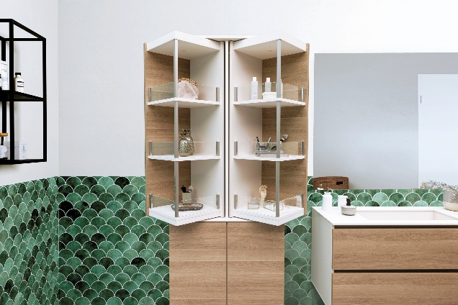
022026_b
The Turning and swivelling system FurnSpin opens up new potential for unique furniture design in a wide range of applications for the carpentry trade. Here is a bathroom unit with double-sided rotating FurnSpin tall unit. Photo: Hettich

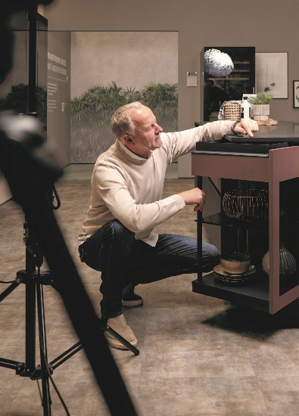
022026_c
Hettich colleague Paul uses his workstation to explain how easy it is to install and adjust the innovative Turning and swivelling system FurnSpin. Photo: Hettich

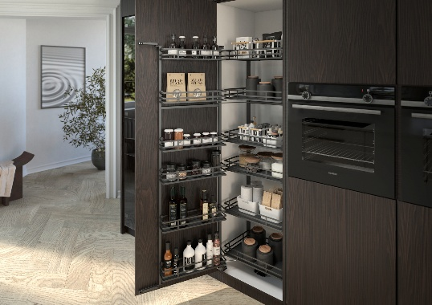
022026_d
The new cabinet interiors from Hettich offer a wide range of design options that make storage space even more efficient and ergonomic to use. Photo: Hettich

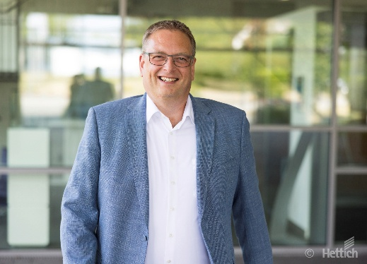
022026_e
Hettich Sales Manager Jan Huebschmann and his team are passionate about wood craftsmanship. They are convinced that there is still a lot of potential in the carpentry trade - especially if the strengths are bundled together. Photo: Hettich

About Hettich
Founded in 1888, Hettich is one of the world’s largest and most successful manufacturers of furniture fittings. The family-owned company is based in Kirchlengern, in Germany’s East Westphalia furniture-production region. Around 8,200 colleagues work together to deliver solutions designed for the future in more than 100 countries. Under its brand promise “It’s all in Hettich”, the company offers a comprehensive portfolio of services consistently aligned to customer needs worldwide. For Hettich, sustainable action — socially, societally and environmentally — has always been a top priority. www.hettich.com

