“RoomSpin” by Hettich receives 2026 German Design Award
Turning swivelling system sets new design benchmark

Every year since 2012, the German Design Council has presented awards for innovative products, projects, manufacturers, and designers from the German and international design industries. The selection process for the German Design Award 2026 centred on themes of change – technology, sustainability, and society. In the “Excellent Product Design” category, Hettich’s turning and swivelling “RoomSpin” system impressed the jury without doubt.

With “RoomSpin”, Hettich provides a system that enables entire furniture elements to rotate 180 degrees. This creates versatile spaces that can be reinvented to suit changing needs – from work environments and home-living situations to retail concepts. The innovative turning movement transforms spaces in seconds: “RoomSpins” unique “translatory rotational movement” lets users effortlessly reposition room elements in a coordinated motion, creating the ideal space for any situation. At the same time, lighting, electrical connections, and zoning can be planned and implemented seamlessly – a key benefit for interior designers and project planners. The jury found that “RoomSpin” sets new standards in adaptability thanks to the flexibility it provides in choreographing spaces.

For Hettich, the award also sends an important signal, demonstrating its role as an innovation leader: unique on the market, the SpinLines product family allows the family-owned company to push previous boundaries in furniture design while opening up new possibilities for transforming spaces. “This award confirms the path we are taking: we are using our Hettich ingenuity to make true advances – for people, markets, and entire industries. My thanks go to our team which, driven by courage, excellence, and passion, is setting new benchmarks,” emphasises Hettich Managing Director Michael Lehmkuhl.

Further information
To get more on Hettich's design awards, go to: https://web.hettich.com/de-de/inspiration/design-award
More on “RoomSpin”: https://www.hettich.com/en-us/products/new-products/roomspin

The following picture material is available for download under the "Press" menu at www.hettich.com:

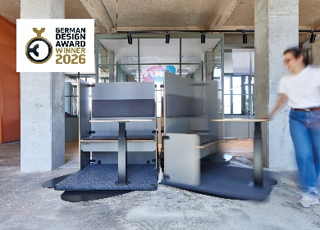
532025_a
“RoomSpin” from Hettich has received the 2026 German Design Award in the “Excellent Product Design” category. Photo: Hettich

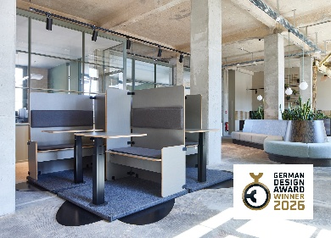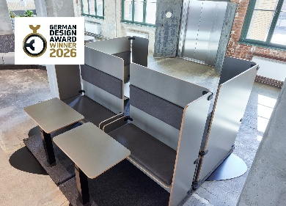
532025_b, c
This application example demonstrates the flexibility with which “RoomSpin” can configure workspaces. Each workstation module can be rotated as needed and adapted to any work situation. Photo: Hettich


532025_d
Michael Lehmkuhl, Managing Director at Hettich, honours the dedication and expertise of the Hettich team at the awards ceremony.

About Hettich
Founded in 1888, Hettich is one of today’s largest and most successful manufacturers of furniture fittings on the international stage. The family-owned company is based in Kirchlengern, located in Germany’s East Westphalia furniture production cluster. Around 8,400 staff members work together to deliver future-proof solutions in over 100 countries. With the promise “It’s all in Hettich”, the Hettich brand offers a comprehensive portfolio of services that is consistently and resolutely geared to the needs of customers worldwide. By tradition, top priority has always been placed on ensuring sustainability on social, societal, and ecological levels. www.hettich.com

