ExeoTech wins the Red Dot Award 2026
Hettich drawer system wins product design award

Clean-lined, sleek, iconic: ExeoTech is more than just a drawer system – it’s a design highlight. For this, ExeoTech received the ‘Red Dot’ Product Design 2026 award at the Red Dot Awards.

ExeoTech stands for ‘Form pushes Function’. With its drawer side profile that is just 11 mm thick and its impeccably precise edges, the drawer system defines a distinctive design language that complements a wide range of styles. This feature opens up new possibilities in furniture design. In addition to the colour options of white, silver and anthracite, pot-and-pan drawers can be designed with railing, high-sided panels or custom side panels. This offers considerable scope for differentiation. Moreover, there is a wide range of bespoke interior organisation options. And thanks to a standardised drilling pattern, different guides can be fitted with ease to suit specific requirements.
This means that ExeoTech can be adapted not only to various applications, but also to different furniture segments. The well-thought-out design also enhances the efficiency of the drawer systems, which can be assembled quickly and integrated just as easily into automated production processes. Therefore, there were plenty of reasons for the jury of this internationally renowned competition to award the ExeoTech drawer system the 2026 ‘Red Dot’ Product Design Award. ExeoTech is currently on display alongside other award-winning designs at the Red Dot Design Museum in Essen, which is housed in the former boiler house of the Zollverein Coal Mine Industrial Complex and is a UNESCO World Heritage Site. It's well worth a visit.

More informations

The following picture material is available for download under the "Press" menu at www.hettich.com:

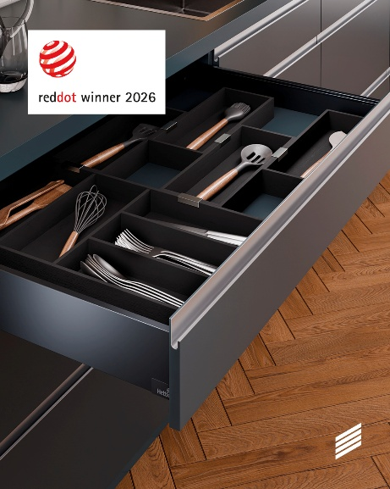
172026_a
With its sleek, flawless drawer side profiles, just 11 mm thick, ExeoTech has established a distinctive design language, for which the drawer system was awarded the ‘Red Dot’ Product Design 2026 prize. Photo: © Red Dot

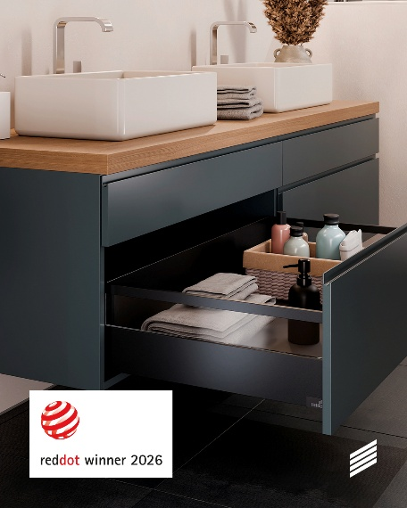
172026_b
The ExeoTech drawer system offers a wide range of options, allowing this award-winning design to be adapted to various applications and sectors. Photo: © Red Dot

About Hettich
Founded in 1888, Hettich is one of the world’s largest and most successful manufacturers of furniture fittings. The family-owned company is based in Kirchlengern, in Germany’s East Westphalia furniture production region. Around 8,200 colleagues work together to deliver future ready solutions in more than 100 countries. Under the brand promise “It’s all in Hettich”, the company provides a comprehensive portfolio of products and services consistently aligned with customer needs worldwide. Responsible, sustainable action — socially, societally and environmentally — has always been a top priority for Hettich. www.hettich.com

