Hettich strengthens its presence in Central Asia
New subsidiary in Almaty brings Hettich closer to customers and partners across Central Asia.

With the official inauguration of Hettich Central Asia
on 12 June 2026 in Almaty, Kazakhstan, Hettich continues its successful development in Central Asia. The subsidiary, which has a regional warehouse, paves the way for closer cooperation with customers and partners. In this way, Hettich underlines the family-run company’s long-term commitment to this fast-growing region. Customers benefit from greater availability of solutions, shorter communication channels and an even stronger local presence.

A growth region with strong potential

With Hettich Central Asia, Hettich strengthens its presence further in the Central Asian markets. The local team based in Almaty looks after the markets in Kazakhstan, Uzbekistan, Kyrgyzstan and Tajikistan. At the same time, having a local presence opens up additional opportunities
for business development in the region.

Central Asia is one of the most dynamic regions for the furniture industry. A growing population, rising investment and increasing demand for high-quality housing and interior solutions are creating attractive opportunities for customers, partners and the industry as a whole. The region offers a wide range of growth opportunities and is becoming increasingly important for international companies.

“With the opening of Hettich Central Asia, we are opening a new chapter in our company’s history. This step reflects the trust placed in us by our customers and partners, the dedication of our team, and the many people whose hard work has helped drive this development. We do not see this opening as a destination, but as the beginning of a shared journey, and we look forward to many new partnerships, projects and successes in Central Asia,” says Waldemar Janzen, Global Management Sales Eastern Europe at Hettich.

A long-term investment taking us closer to customers

Hettich has had a presence in Kazakhstan since 2014. The local subsidiary was established in September 2025, followed by the opening of the regional warehouse in Almaty in early 2026. The official opening of Hettich Central Asia on 12 June 2026 marks another important milestone in the company’s development in Central Asia. Under the leadership of Bakhtiyar Nurmatov, General Manager of Hettich Central Asia, the company is steadily expanding its operations in the region. The local organisation and the new logistics infrastructure in Almaty lay the foundations for the expansion of our activities in the Central Asian markets and open new opportunities for collaboration with customers and partners in the region. The regional warehouse in Almaty improves the availability of the Hettich product portfolio in Central Asia. At the same time, Hettich can support customers and partners with even greater flexibility and responsiveness. Short supply chains, local contact persons and on-site technical support create tangible value across the entire value chain.

The product range in Central Asia includes not only Hettich’s product solutions, but also the products from the FGV brand. The local subsidiary will focus on customer proximity, personalised advice, quick response times and close collaboration with retail partners, furniture manufacturers, architects and interior designers.

Hettich already has a strong network of retail partners, furniture manufacturers, architectural firms and design studios in the Central Asian markets. The aim is to work together to expand this network further and create additional opportunities for market partners in Central Asia.

“The opening of Hettich Central Asia symbolises a new beginning, trust and our shared vision for the future. From this moment on, we move forward together with our customers and partners. As one team, we are laying the foundations for a successful future in Central Asia,” says Timo Pieper, Managing Director at Hettich.

The official opening of Hettich Central Asia took place during the FIW 2026 (Furniture Interior Woodworking) international trade fair in Almaty, one of the most important industry events in the region. The event brought together representatives from the furniture industry, the retail sector and the architecture and design sectors in the region, and provided a forum for discussion, inspiration and new partnerships.

The following photographs are available for download in the menu "Press" at www.hettich.com:
Images
Captions
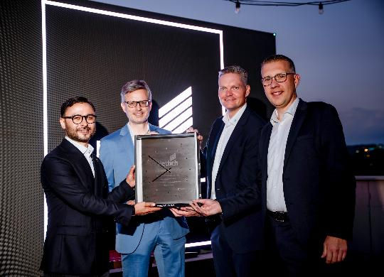
182026_a
Bakhtiyar Nurmatov, General Manager of Hettich Central Asia, accepts a symbolic opening gift from the Hettich Group. (From left to right: Bakhtiyar Nurmatov, Dr Andreas Hettich, Waldemar Janzen and Timo Pieper) Photo: Hettich

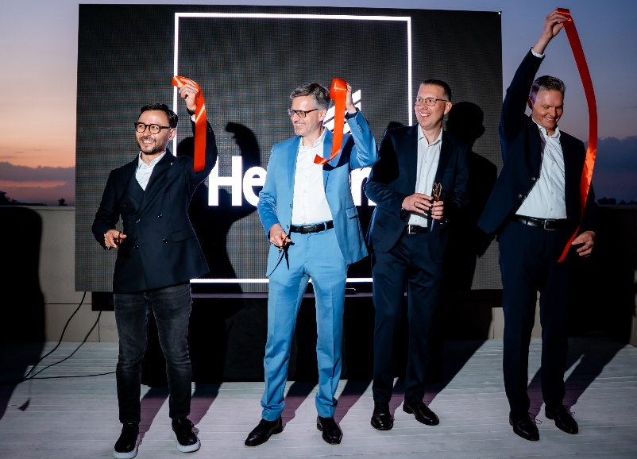
182026_b
Hettich Central Asia was officially opened on 12 June 2026 with the traditional ribbon-cutting ceremony. (From left to right: Bakhtiyar Nurmatov, Dr Andreas Hettich, Timo Pieper and Waldemar Janzen) Photo: Hettich

About Hettich
Founded in 1888, Hettich is one of the world’s largest and most successful manufacturers of furniture fittings. The family-owned company is based in Kirchlengern, in Germany’s East Westphalia furniture production region. Around 8,200 colleagues work together to deliver future ready solutions in more than 100 countries. Under the brand promise “It’s all in Hettich”, the company provides a comprehensive portfolio of products and services consistently aligned with customer needs worldwide. Responsible, sustainable action — socially, societally and environmentally — has always been a top priority for Hettich. www.hettich.com

