The “Das ganze Leben” joinery workshop creates designer furniture that combines long-lasting durability and versatility
When design evolves, but quality remains constant

For over 10 years, the joinery and design workshop ‘Das ganze Leben’ has been synonymous with furniture that lasts for generations. The fledgling partnership with Hettich was the ideal complement to the designers’ vision: both companies believe in furniture that adapts to people’s lifestyles. Whether it’s flexible use of space, systems that can be retrofitted or modular systems – Hettich is integrated into almost every piece of furniture in ‘Das ganze Leben’. And not merely as a technical detail, but as an essential component of a philosophy that creates living rooms for people rather than furniture for rooms.

With a deep understanding of functionality, aesthetics and craftsmanship, South Tyrol produces designer furniture that can be flexibly adapted to individual living needs throughout a person’s life. However, to meet this high standard, it takes not only excellent design and precision craftsmanship, but also reliable technical fitting solutions that maintain a consistent standard of quality. So it’s no wonder, then, that the paths of the joinery and the hardware manufacturer crossed. What really won ‘Das ganze Leben’ over to Hettich was the personalised service. Following an initial series of introductory meetings, the Hettich sales team was quickly and closely involved in the designers’ work and way of thinking. They took the time to analyse the joinery’s furniture and designs in detail in order to find the right solutions. Looking back, Lorenz Sternbach, the company’s head of administration, says: “It was impressive how quickly our specific queries were addressed in the early stages of our collaboration. Right from the start, we felt that they really understood what was important to us personally." Whilst selecting samples of new components for the manufacturing processes, Florian Psenner from Hettich presented various product solutions, such as the Actro 5D drawer runners, and played an active role in helping to make the best choice. Georg Agostini, Technical Director at ‘Das ganze Leben’, sums up why this hands-on service is so helpful: “The support we receive from Hettich is worth its weight in gold. We can test new ideas quickly without having to wade through endless possibilities. Particularly when compared directly with competitors, the difference in the level of support was immediately apparent. Whilst other suppliers often merely present standard solutions, Hettich specifically puts forward proposals that are tailored to our individual requirements. We can always be sure that we won’t just be given any old solution, but precisely the one that suits us best."

Long-lastingness as a key quality feature
Everything that ‘Das ganze Leben’ develops and designs is based on the concept of long-lastingness. As the name suggests, furniture from ‘Das ganze Leben’ is designed to accompany its owners for decades to come. This requires not only a timeless design, but also consistently high quality – regardless of whether a piece of furniture is assembled in South Tyrol, on Rügen or in Vienna. But how can we ensure that every piece of furniture works reliably and flawlessly everywhere? Through the use of high-quality components. The precision and reliability of Hettich products enable the designers at ‘Das ganze Leben’ to create furniture that is always just as easy to open, close and align. No matter where they are set up, who installs them or how often they are moved.

EVA: The kitchen that works perfectly anywhere
The EVA modular kitchen is a striking example of the ‘Das ganze Leben’ philosophy. It consists of a sturdy base with snap-in cabinet modules and a worktop. Thanks to height-adjustable legs and modular components that can be combined as desired, it can be flexibly adapted, varied and even rearranged – exactly to suit your lifestyle. Thanks to its compact, block-like shape, it is robust and long-lasting, and combines a kitchen and a piece of furniture into a compact unit that can be positioned anywhere in the room. The Actro 5D drawer runner for wooden drawers perfectly embodies the values of quality, innovation and modernity. It is exceptionally sturdy and impresses with its whisper-quiet operation. The 5-position adjustment allows the front panels to be adjusted intuitively, ensuring a perfect reveal alignment. Ideal for the narrow birch plywood sheets that Das ganze Leben uses in its work. EVA kitchens and their accompanying cabinets also feature Hettich Sensys series concealed hinges with integrated damping.

A powerful duo for timeless yet contemporary furniture design
The partnership between “Das ganze Leben” and Hettich is a perfect example of how traditional craftsmanship and the very latest quality standards can come together to set new benchmarks.

The following picture material is available for download under the "Press" menu at www.hettich.com:

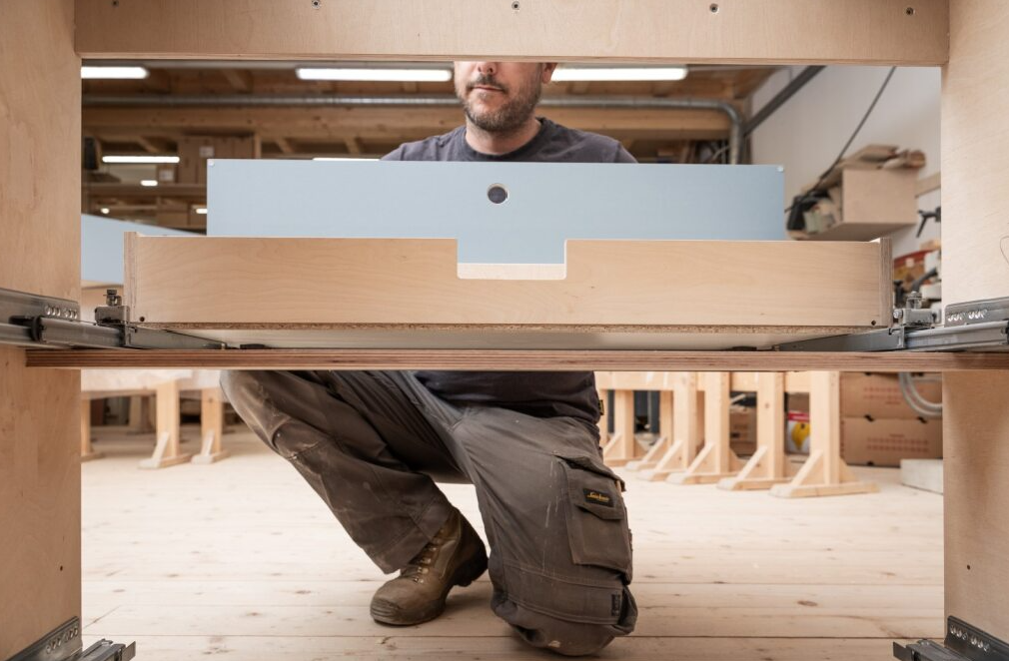
232026_a
It is not only the professionals at the ‘Das ganze Leben’ workshop who benefit from the ease of assembly, but also those who will enjoy the piece of furniture throughout their lives. Photo: Silbersalz / Caroline Renzler

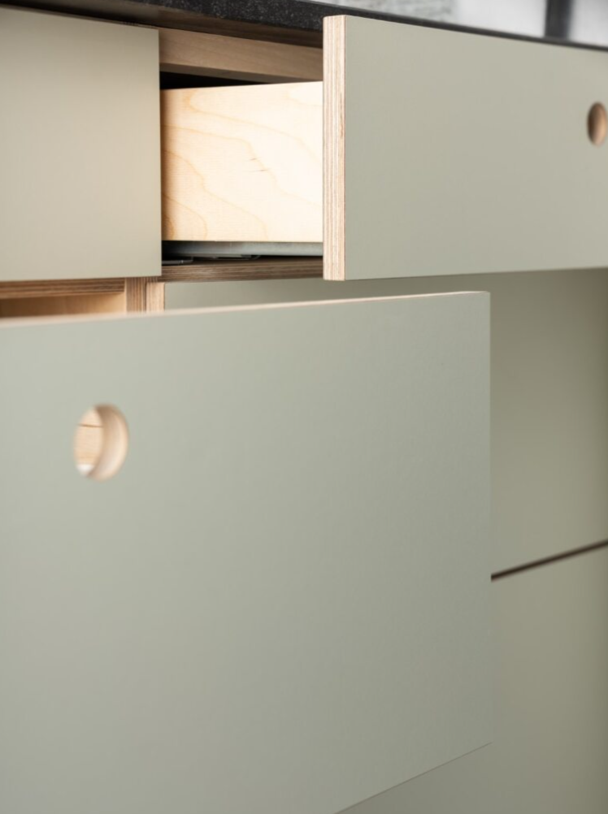
232026_b
Exceptional design, innovative technology: The Actro 5D drawer runner for wooden drawers fits perfectly with the ‘Das ganze Leben’ concept. Photo: Silbersalz / Caroline Renzler

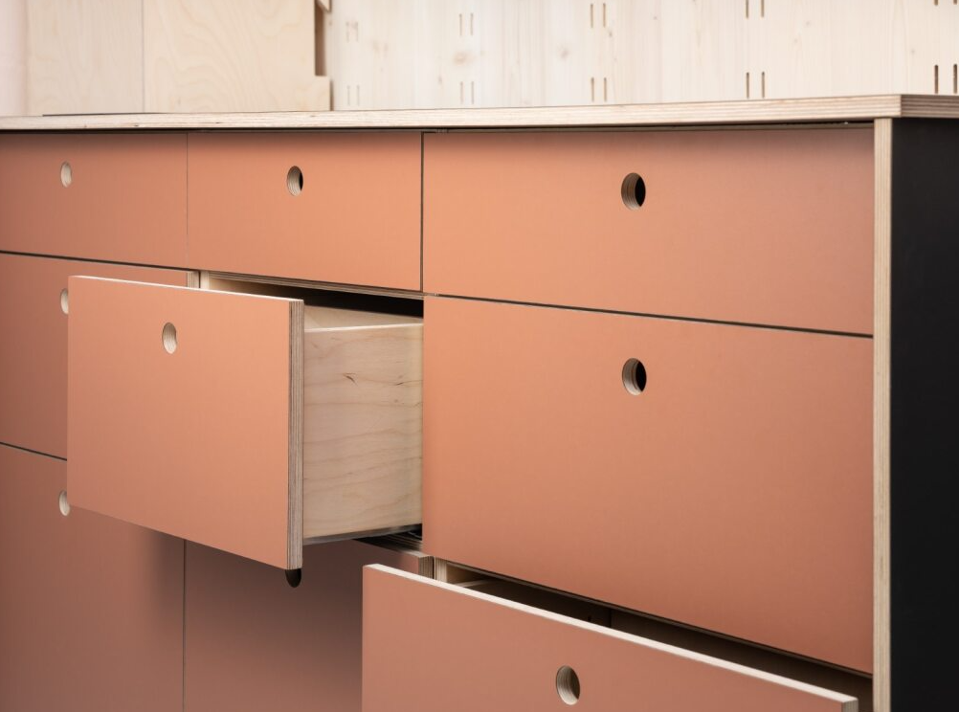
232026_c
It is the combination of delicate reveal alignment, simple design and muted colours that makes EVA kitchens so refreshingly different.
Photo: Silbersalz / Caroline Renzler

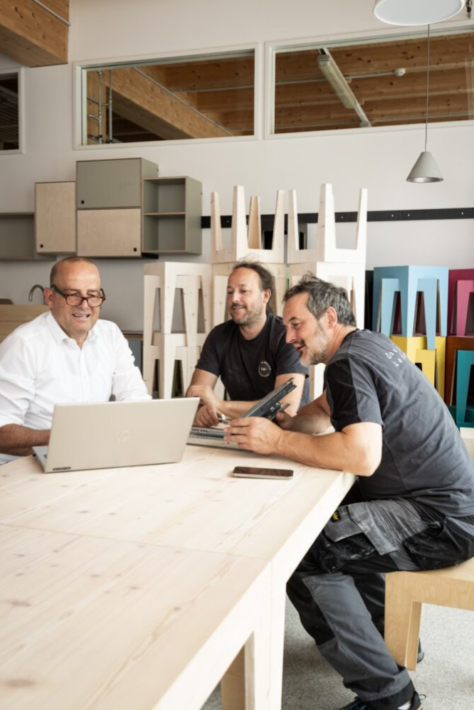
232026_d
Florian Psenner, a sales representative at Hettich, and the two designers behind ‘Das ganze Leben’, Georg Agostini and Lorenz Sternbach (from left), both value this collaborative partnership equally. Photo: Silbersalz / Caroline Renzler

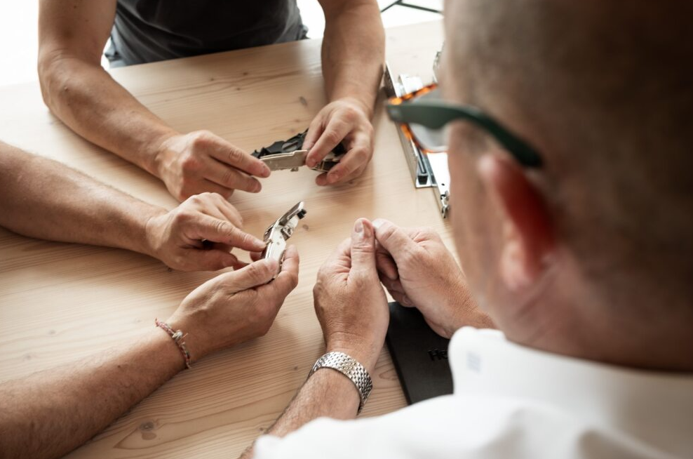
232026_e
Around a table, face to face, in person: in South Tyrol, craftspeople and hardware manufacturers meet on equal terms. Photo: Silbersalz / Caroline Renzler

About Hettich
Founded in 1888, Hettich is one of the world’s largest and most successful manufacturers of furniture fittings. The family-owned company is based in Kirchlengern, in Germany’s East Westphalia furniture production region. Around 8,200 colleagues work together to deliver future-ready solutions in more than 100 countries. Under the brand promise “It’s all in Hettich”, the company provides a comprehensive portfolio of products and services consistently aligned with customer needs worldwide. Responsible, sustainable action — socially, societally and environmentally — has always been a top priority for Hettich. www.hettich.com

