Schwarzwälder Carpentry holds its own thanks to creativity and quality
Hettich supports tradespeople in developing their businesses

100 years of carpentry tradition, looking to the future. Master carpenter Nico Schwarzwälder and his brother Tom are the fifth generation to run the family business. In doing so, they face a number of challenges: a shortage of skilled workers, digitalisation and competition. The Black Forest joinery has always managed to keep up with the times. Hettich’s innovations in fittings have played an important role in this field for four decades.

“As a joiner, you’re always competing with furniture stores or kitchen showrooms,” explains Nico Schwarzwälder. “Our great advantage is that, from a design perspective, almost anything is possible and there are really no limits for us,” the master joiner continued. The Schwarzwälder brothers have set themselves some ambitious goals to continue to win over customers and remain competitive in the future. Ultimately, it is their blend of creativity and quality that wins over their customers. Word is getting round not only amongst private customers; architects are also commissioning the joinery firm to fit out their commercial premises. Nico Schwarzwälder sees great potential in building his own kitchens. Here are the young carpenter brothers in the construction phase. The process of digitalisation is already well advanced. All staff members have tablets on which every process can be viewed in real time. The next step is to digitise the stock control system. These automated processes help the team to focus its resources on the essential tasks: building furniture that is true to size and of high quality.

40 years of partnership with Hettich
Like father, like sons – for 40 years, Schwarzwälder Joinery has relied on Hettich’s fittings and service. For Nico and Tom Schwarzwälder, stylish, comfortable fitting solutions are inextricably linked to the high standards demanded of bespoke, handcrafted furniture. The use of Hettich fittings, such as Sensys with integrated damping or the Actro 5D runner for wooden drawers, is standard at Schwarzwälder. In 2024, Nico Schwarzwälder decided to stop assembling drawers himself and to switch to the AvanTech YOU drawer system. He has not regretted this decision; on the contrary. His conclusion: “The clean-lined, slim drawer design won us over, and the design profiles and the simple lighting solution featuring the LED light profile have given us greater flexibility in our design work. What’s more, we can now produce goods more quickly and more cost-effectively." Customers are also enthusiastic about this.

Interior fittings available only with Hettich fittings
For a private client, the Schwarzwälder joinery workshop designed a floor-to-ceiling built-in wardrobe and a headboard with bedside tables for the double bed, with a chest of drawers attached to the back of the headboard. The commission also included a wardrobe that blends seamlessly into the room’s architecture, as well as the bathroom furniture. The design is minimalist, featuring handleless front panels with milled handle recesses and finishes in fine-grained oak veneer and white. As the customers placed particular importance on full extension runners in all their furniture, they came to the workshop to view samples. The drawers’ convenience and lighting solution made an immediate impression. LED lighting from Halemeier – a company within the Hettich Group – was fitted to provide side lighting in the wardrobe and recessed lighting for the balustrade.

A partnership of equals
When it comes to design-related questions, Nico Schwarzwälder is happy to bring Alex Wiegele from Hettich on board. Nico Schwarzwälder particularly appreciates the speed of response in his collaboration with Hettich: “The support is excellent.” Alex always answers the phone or drops by. When it comes to specific topics, he brings in other members of the Hettich team. "Together, we always find a solution," says the young company director happily. It even happens that Schwarzwälder’s customers are advised jointly. The close personal relationship with craft businesses and bespoke project support are among the factors that make all the difference when working with Hettich.

The following picture material is available for download under the "Press" menu at www.hettich.com:
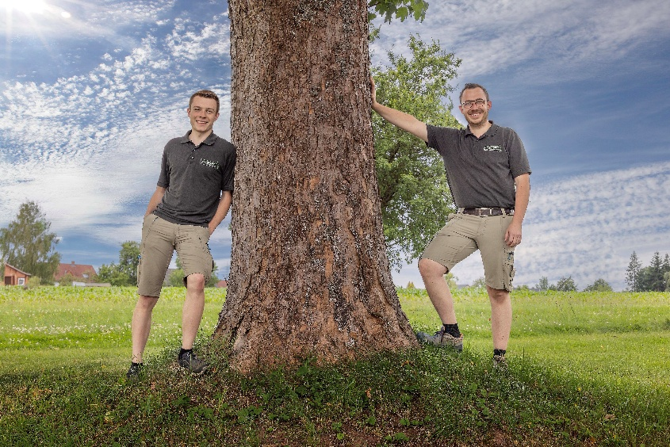
272026_a
A young fifth-generation management team: (from left) Tom and Nico Schwarzwälder are successfully putting their ideas for a sustainable joinery into practice. Photo: Fabian Deberling

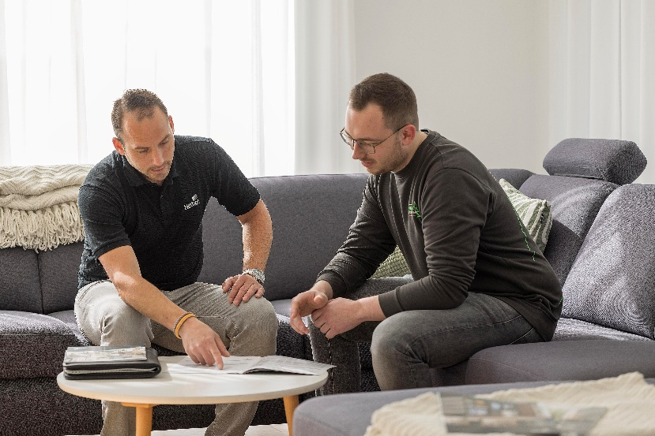
272026_b
(From left) Alex Wiegele from Hettich and Nico Schwarzwälder are a well-established team when it comes to project planning.
Photo: Fabian Deberling

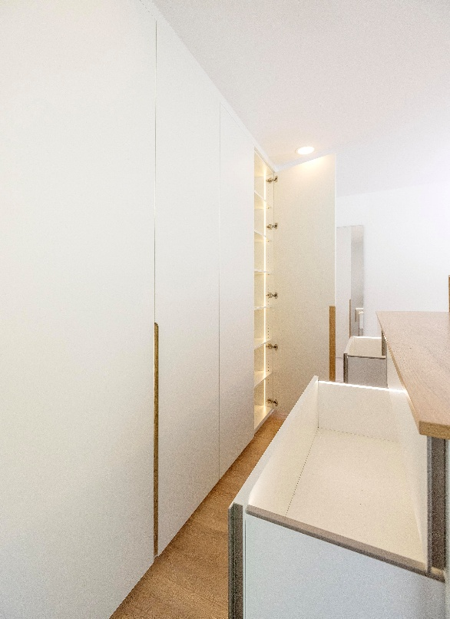
272026_c
A simple design that packs a punch: a floor-to-ceiling wardrobe, a bedhead with bedside tables and a chest of drawers at the back. Everything has been cleverly thought out and equipped with drawers and fittings from Hettich. Photo: Fabian Deberling

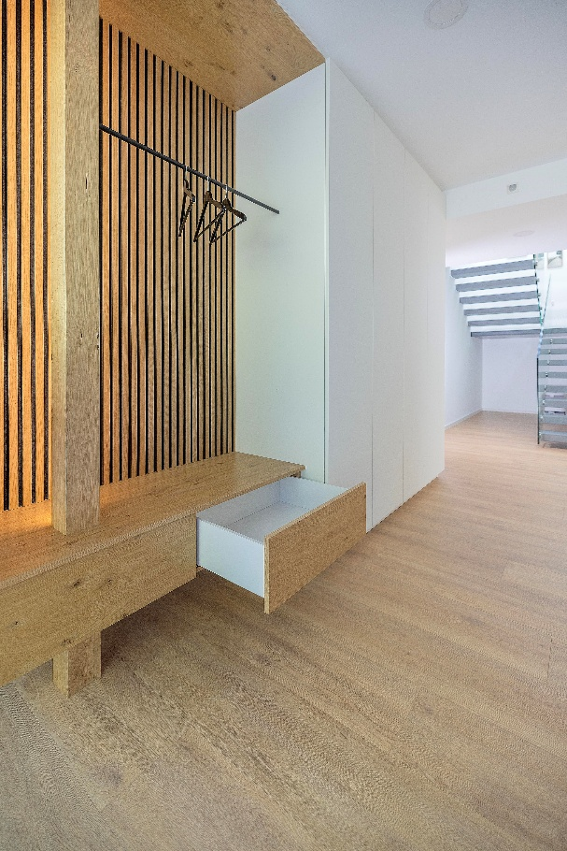
272026_d
The wardrobe blends in with the building’s modern architecture. AvanTech YOU drawers, with their minimalist design, are also featured here. Photo: Fabian Deberling

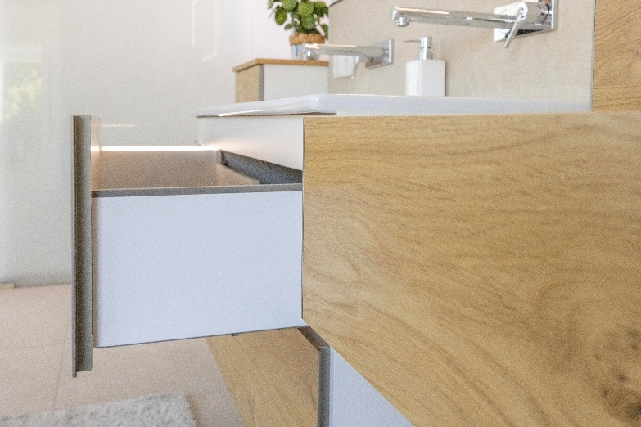
272026_e
Schreiner Schwarzwälder has developed a holistic design concept for all its furniture, featuring handleless front panels and finishes in real wood veneer and white. The lighting in the drawers further enhances the bathroom furniture. Photo: Fabian Deberling

About Hettich
Founded in 1888, Hettich is one of the world’s largest and most successful manufacturers of furniture fittings. The family-owned company is based in Kirchlengern, in Germany’s East Westphalia furniture production region. Around 8,200 colleagues work together to deliver future-ready solutions in more than 100 countries. Under the brand promise “It’s all in Hettich”, the company provides a comprehensive portfolio of products and services consistently aligned with customer needs worldwide. Responsible, sustainable action — socially, societally and environmentally — has always been a top priority for Hettich. www.hettich.com

