Partnerships and products that create freedom
Schrank-direkt focuses on efficiency with AvanTech YOU

Schrank-direkt, the expert in bespoke living space solutions based in the Ingolstadt area, is synonymous with furniture of the very highest quality. To meet this requirement on a long-term basis, the company has been using Hettich’s AvanTech YOU drawer system for the past two years – with tangible benefits for production, staff and customers.

On average, Schrank-direkt’s customers spend between 6,000 and 10,000 euros on a bespoke storage unit. Their expectations regarding quality and processing are correspondingly high. With Hettich components, the company can ensure reliability in meeting this requirement. “Hettich has simply struck the right balance between close partnership, good service and technical quality,” sums up Siegfried Duttler, owner of Schrank-direkt.
“Since we started using AvanTech YOU, our processes have become significantly more efficient, whilst maintaining the same high standard of quality,” Duttler goes on to explain. Previously, Schrank-direkt had been manufacturing the drawers entirely in-house for decades – a labour-intensive process that tied up a lot of staff. As all the drawer components in the AvanTech YOU system are supplied predrilled, this offers cabinet makers a significant advantage in production: the drawer can be fully assembled in just a few simple steps and fitted into the cabinet. This eliminates an entire step in the process.
Well-thought-out solutions, streamlined processes
Thanks to this process optimisation, an average of 1.5 staff members can now be deployed in other areas of the workshop. At a time of skills shortages, this is a major boon for furniture manufacturers. Machine wear and tear and maintenance costs have also been significantly reduced, whilst quality has remained consistently high. “Our customers don’t notice any difference, but behind the scenes everything runs even more precisely and smoothly,” sums up the owner.

Schrank-direkt also received the AvanFit 200 assembly aid via Hettich’s retail partner, Ostermann. This is used to ensure that AvanTech YOU drawers are fitted securely and with a perfect fit. For Siegfried Duttler, this is a clear sign: “It’s things like this that show Hettich knows exactly how we work. Everything is as practical as possible and has been thought through logically."

Service is what makes for a good partnership
But it is not just technology and innovation that make Schrank-direkt stand out. Owner Duttler also values the service and personalised advice provided by Hettich’s sales team: “The service really is exceptional. Even on an ad hoc basis, there’s always someone there for us who really listens and thinks things through with us.” From the design phase through to prototyping and right up to series production, Hettich’s sales team works closely alongside the furniture manufacturer. This includes visits to the workshop as well as a detailed review of plans and processes, and the submission of specific proposals. “This personalised support has been, and continues to be, absolutely crucial for us. We get quick answers to new challenges or questions, which means we can always get on with things straight away. That saves time and provides safety," said Duttler.

Our collaboration with Hettich demonstrates how a genuine partnership between equals works: it is not just a matter of supplying products; the processor is also closely supported and given practical advice and assistance. The result is increased efficiency, less effort and consistently high quality. Quite simply, a partnership that creates the space for what really matters: satisfied customers and furniture that inspires.

The following picture material is available for download under the "Press" menu at www.hettich.com:

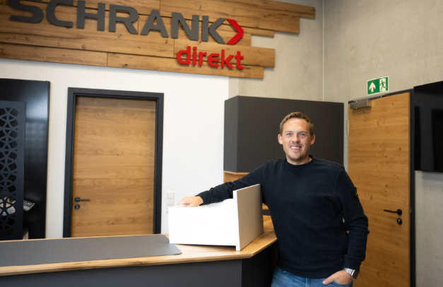
242026_a
Siegfried Duttler, owner of Schrank-direkt, is thoroughly impressed by the partnership with Hettich. Photo: Robert Larsen

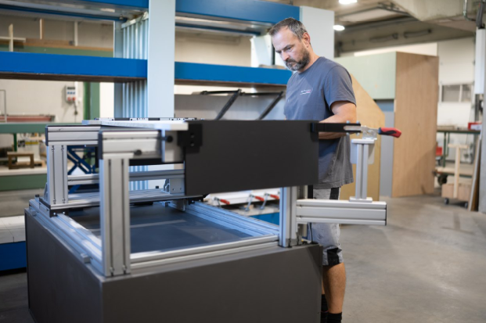
242026_b
The Hettich AvanFit 200 assembly aid enables particularly quick, precise and safe assembly. Photo: Robert Larsen
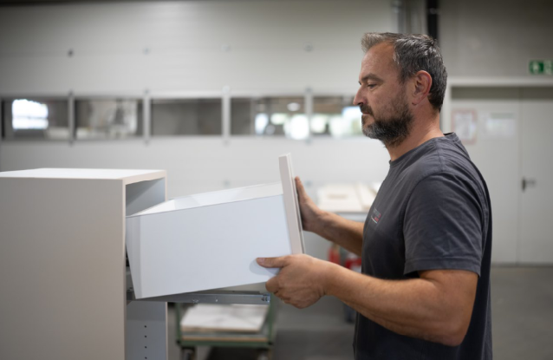
242026_c
AvanTech YOU’s simple adjustment options for height, lateral position and tilt ensure that the joint pattern reveals alignment in no time at all. Photo: Robert Larsen

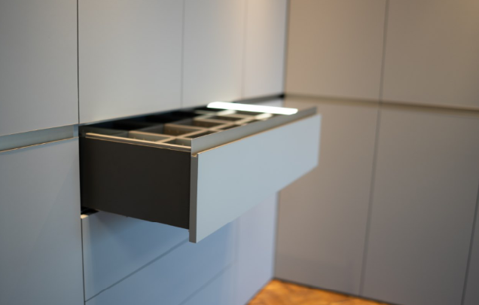
242026_d
Design takes centre stage: the AvanTech YOU drawers, with their drawer side profiles just 13 mm wide, are flawless, with no visible cover caps or holes. The multi-award-winning AvanTech YOU Illumination LED lighting system has also been installed here. Photo: Robert Larsen

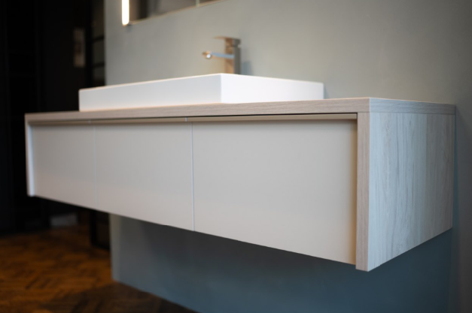
242026_e
The minimalist design of this vanity unit is emphasised by the narrow reveal alignment of the AvanTech YOU drawers. Photo: Robert Larsen

About Hettich
Founded in 1888, Hettich is one of the world’s largest and most successful manufacturers of furniture fittings. The family-owned company is based in Kirchlengern, in Germany’s East Westphalia furniture production region. Around 8,200 colleagues work together to deliver future-ready solutions in more than 100 countries. Under the brand promise “It’s all in Hettich”, the company provides a comprehensive portfolio of products and services consistently aligned with customer needs worldwide. Responsible, sustainable action — socially, societally and environmentally — has always been a top priority for Hettich. www.hettich.com

