Rawert Woodworking: A start-up in the joinery trade
Hettich has been a partner from the very beginning

Marvin Rawert is a master joiner and entrepreneur. He set up his own joinery business when he was just 22. He is therefore a role model for the profession and the best proof that it is possible to be successful by making bespoke furniture. Right from the start, the young entrepreneur has relied on Hettich as his partner for innovative fittings. At the Rawert woodworking workshop, there is no customer request that does not leave the workshop – in the form of a unique piece of furniture – from the idyllic, historic ‘Beller Burg’ in the Eifel.

Marvin Rawert’s philosophy proved successful straight away: the highest standards of craftsmanship and the finest materials form the base for customer satisfaction. Actually, in 2016 he initially only intended to run his own business as a sideline. However, the high demand left him with no other choice, and his self-employment effectively became a runaway success. Yet there is a fairly high concentration of joineries in the region. In his view, however, there is always room for good ideas and first-class work. When, in 2022, a faulty battery set the workshop alight and reduced it to rubble and ashes, the young master craftsman saw the disaster as an opportunity. Within just six months, he assembled the whole business from scratch, whilst at the same time investing in state-of-the-art CNC technology and a paint and drying room. The former farm barn now houses a modern, perfectly organised workshop, where the nine-strong manufacturing team mainly produces high-quality furniture. An exhibition is due to be launched shortly to make it easier to advise private clients. “I can only sell the customer better products if the customer knows what’s available beyond the standard range,” explains Marvin Rawert. He also hopes that the exhibition will attract more walk-in customers, as the woodworking workshop is situated near Lake Laach – a popular tourist destination.

A piece of furniture must be worth the price
Even now, customers are invited to the workshop to give them an impression of the high-quality materials, the sustainability benefits of locally sourced wood and the features of modern fittings. “Hettich has many solutions that others don’t,” says Marvin Rawert, explaining his partnership with the fittings specialist. “The fittings are easy to process and work very well.” The Rawert team are also big fans of the Actro 5D drawer runner for their homemade wooden drawers. “Before we started using Actro 5D, we used to receive complaints quite frequently; fortunately, that is no longer the case.” Marvin Rawert adds: “With Actro 5D, we are much more flexible and can equip drawers to a greater extent, for example with a push-to-open mechanism.” “Retrofitting of the running mechanism is also possible with ease.” A fine example of the sophisticated furniture-making expertise at Holzmanufaktur Rawert is a floor-to-ceiling wardrobe, which was designed to meet the customer’s individual requirements and fitted with Hettich fittings, including Actro 5D.

A customer’s dream: a floor-to-ceiling wardrobe
The wardrobe has turned out absolutely beautifully. There are many details that show just how well thought-out it is. The colour scheme – featuring cabinet bodies in eucalyptus green, front panels in top-matt angora grey and wooden drawers, as well as other elements in solid wood or real wood veneer finished with a raw wood-effect lacquer – is also impressive and has a timelessly modern look. The wardrobe is divided into five sections: on the far left is an open coat rack area with hooks, a shelf and two drawers. These are followed by open shelving units with a garment lift above them. The Amari pull-out shelf from Hettich provides additional storage space when needed, whilst the Sensys hinge with integrated damping in Obsidian Black from Hettich emphasises the high quality of the furniture. With a ceiling height of 2.50 metres, the Lift clothes rail is positioned at a height of 2.30 metres. It can be pulled out or down by 90 degrees, so that shirts and blouses can be hung up easily. In the centre is an area with a built-in recess for a TV. Below, four wooden drawers provide ample storage space, whilst there is further storage space behind the hinged doors at the top. Adjoining this is another cloakroom area with a lift-up clothes rail. The open drawers contain round rails for trousers and tie holders. The right-hand section stands out thanks to its sloping shelves, which are designed specifically for shoes. A vertical compartment is provided for the ironing board. Just like this wardrobe, every piece of furniture produced by the Rawert woodworking workshop is assembled in the workshop once it has been completed, as part of our quality assurance process. The team checks whether everything is working as planned or whether anything might have been overlooked. After all, there must be no hitches whatsoever during the on-site assembly.

Hettich offers advice and practical support
“We really appreciate getting tips from our account manager, Robin Sandmann from Hettich,” explains Marvin Rawert, “because with so many products, we’re not always aware of the finer details of what could perhaps be done better, and we’d end up spending a lot of time searching for answers. We’re in close contact; it’s going really well."

The following picture material is available for download under the "Press" menu at www.hettich.com:

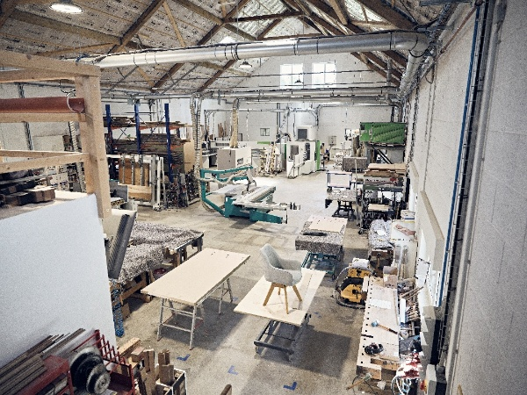
252026_a
This is where the unique pieces of furniture from the Rawert woodworks are crafted. Marvin Rawert has converted a former farm barn into a modern workshop. Photo: Marco Rothbrust

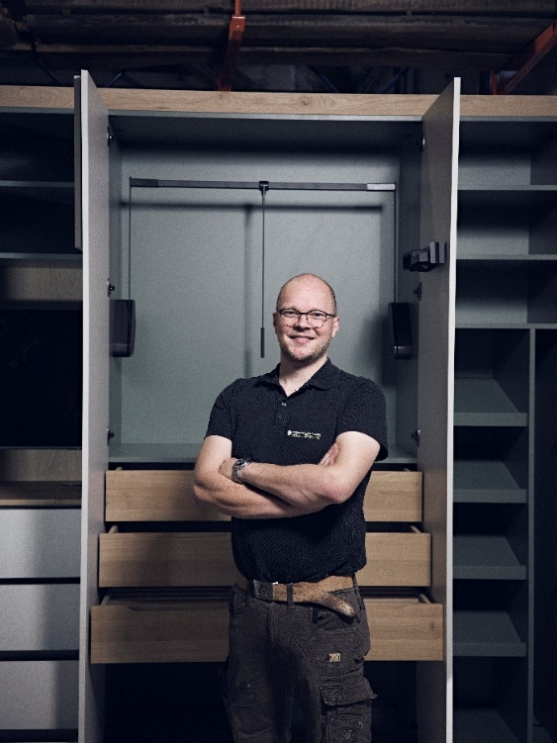
252025_b
Marvin Rawert builds furniture out of a passion for it. He has turned a one-man business into a joinery with eight employees and is making his mark with fresh and innovative ideas. To this end, he is relying on the strong partnership with Hettich. Photo: Marco Rothbrust

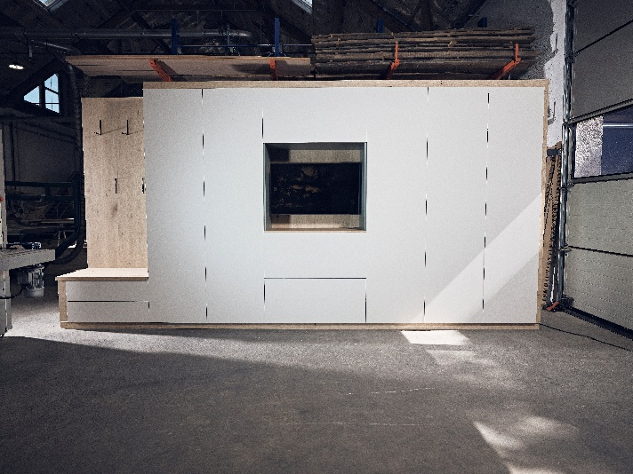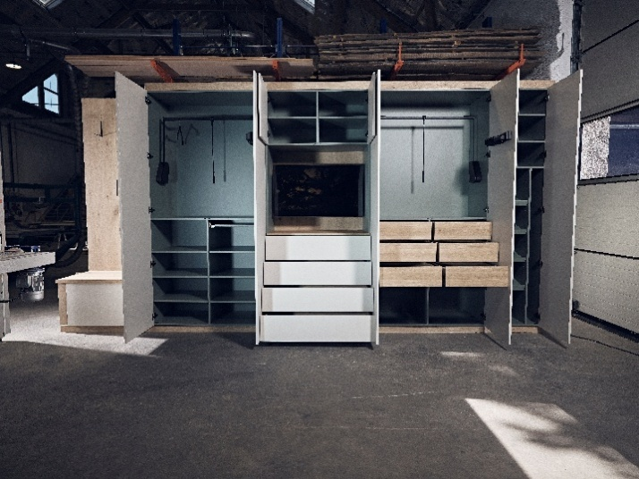
252026_c+d
Impressive both inside and out: a test model of the floor-to-ceiling wardrobe in the Rawert woodworking workshop. Photo: Marco Rothbrust

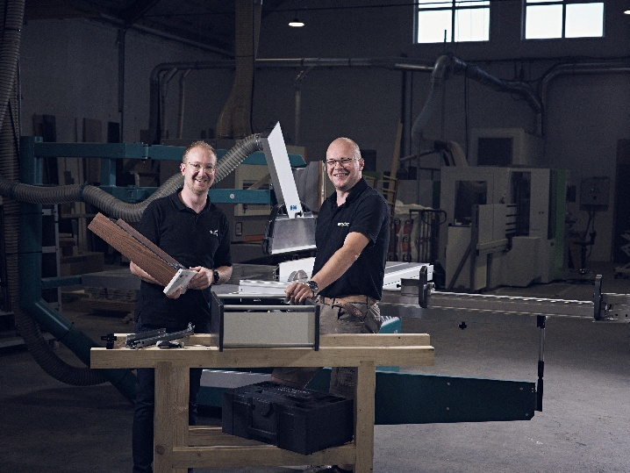
252026_e
Robin Sandmann from Hettich and Marvin Rawert are a well-established team when it comes to finding the ideal fittings for a project. Photo: Marco Rothbrust

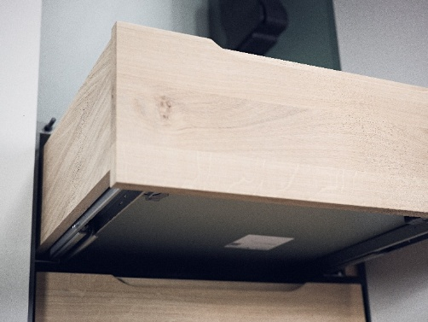
252026_f
The wooden drawers run on Actro 5D runners from Hettich, which are not only particularly sturdy and have smooth-running action, but also ensure that the joints remain perfectly aligned over time. Photo: Marco Rothbrust

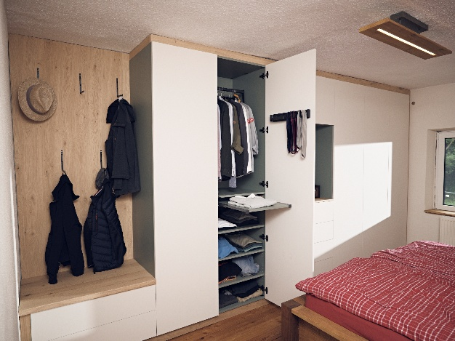
252026_g
The floor-to-ceiling wall cabinet after installation at the customer’s premises. Everything was carried out exactly in accordance with the customer’s wishes and complemented by ideas from the Rawert timber workshop. This includes a telescopic pull-out shelf, which provides additional storage space when needed.
Photo: Marco Rothbrust

About Hettich
Founded in 1888, Hettich is one of the world’s largest and most successful manufacturers of furniture fittings. The family-owned company is based in Kirchlengern, in Germany’s East Westphalia furniture production region. Around 8,200 colleagues work together to deliver future-ready solutions in more than 100 countries. Under the brand promise “It’s all in Hettich”, the company provides a comprehensive portfolio of products and services consistently aligned with customer needs worldwide. Responsible, sustainable action — socially, societally and environmentally — has always been a top priority for Hettich. www.hettich.com

