Hettich DIY at the International Hardware Fair 2026 – Innovations for creative do-it-yourselfers
Product premieres at the International Hardware Fair 2026

Building your own furniture and furnishings is a growth market. Creativity, self-fulfilment and cost savings are making DIY an attractive option for more and more people, and they’re constantly looking for inspiration and new products. Whether in DIY stores, online shops or social media channels, what’s needed are functional, easy-to-use fitting solutions that deliver results to be proud of. Hettich Do-It-Yourself will be showcasing a host of these at the International Hardware Fair from 03 - 06 March 2026 in Cologne.

Hettich DIY is an innovative player in the DIY trend market. Fitting solutions developed within the international Hettich Group for industry and trade are a constant source of products for the DIY segment. With EasySpin, Hettich is presenting a top innovation for do-it-yourselfers, alongside many other exciting new products.

EasySpin brings rotation to furniture
EasySpin opens up a new dimension of furniture function: with EasySpin, furniture can rotate to reveal two independently customisable sides in a single product. The innovative mechanism delivers surprising design freedom, makes optimal use of space and helps even small floor plans feel bigger. Each side can look different, be used differently or staged differently, functional front and decorative back, or open and closed. EasySpin is a square, wheeled platform onto which the furniture is mounted. It combines comfort, creativity and flexibility, making it a must-have for design-oriented DIY enthusiasts.

TL corner bracket - industrial chic for workshop and living
Building your own workbench? No problem with the new TL corner brackets from Hettich DIY. The L-shaped T-construction made of 2.5 mm high-quality steel with eight-point fixing gives solid, heavy furniture constructions the stability they need, no more wobbling or tilting. The striking black TL brackets fit perfectly with the industrial style. Whether shelves, tables and benches, machine bases or pergolas, TL brackets offer a wide range of applications.

DIY drawer pull-outs - an end to cabinet clutter
With adjustable telescopic pull-outs, organising cabinet contents has never been easier. The drawers can be continuously adjusted in width from 32 to 68 cm; depths of 42 or 52 cm and a height of 7 cm make full use of every centimetre. Poorly organised cabinets become clearly structured, easily accessible storage. Tool-free assembly is simplicity itself. Thanks to innovative nano-adhesive technology, durable, damage-free fixing on metal, wood or plastic surfaces is no problem. Robust ball-bearing runners glide quietly and smoothly, even under heavy loads — a real boost in convenience for furniture in the kitchen, utility room, bathroom or office.

Click & Hang – the magnetic organisation system
Fix with magnets instead of drilling or gluing. The ingenious Click & Hang range from Hettich DIY includes 19 different organisational helpers specially developed for storing utensils on the washing machine or refrigerator. Everything has its place and is always within easy reach. Click & Hang works on all metallic surfaces and can be attached and removed with ease. Self-adhesive metal strips are also available as accessories, allowing Click & Hang to be used on virtually any other surface.

Hettich DIY - trendsetter in the DIY segment
Current home-living trends are reflected not only in the colourways of Hettich DIY’s decorative fittings. Furniture feet come in on-trend colours, from natural tones and pastels to statement shades such as cornflower blue. Door hooks and metal coat racks stand out in sage and coral. There’s a wide choice of modern designs and new materials for handles and furniture knobs, including faux leather, stone and jute. Another highlight is a range of exclusive occasional tables made of high-quality magnesium oxide in various designs — eye-catchers indoors or outdoors.

Hettich DIY will present its new products in the shelving on the Trade Fair Boulevard. There’s space and time for conversations at Exhibition stand K010, K011 in Hall 11.1.

The following image material is available for download under the "Press" menu at www.hettich.com:

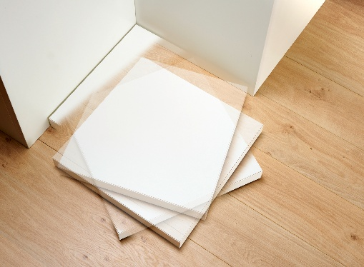
042026_a
EasySpin from Hettich DIY brings rotation to furniture. Simply mount the furniture on the square platform. Photo: Hettich

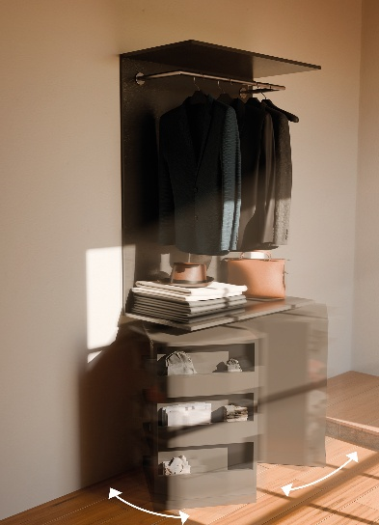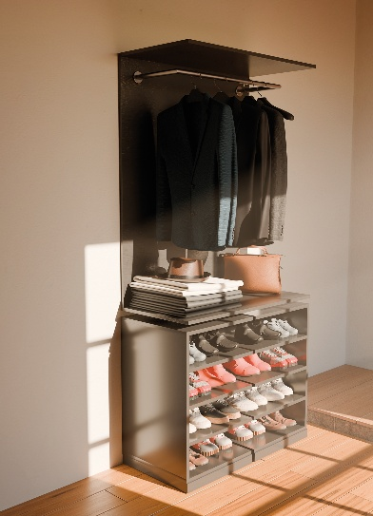
042026_b+c
EasySpin combines practical use of storage space with dynamic furniture design. With a single turn, the shoe cabinet opens and closes — and presents two different views at the same time. Photo: Hettich

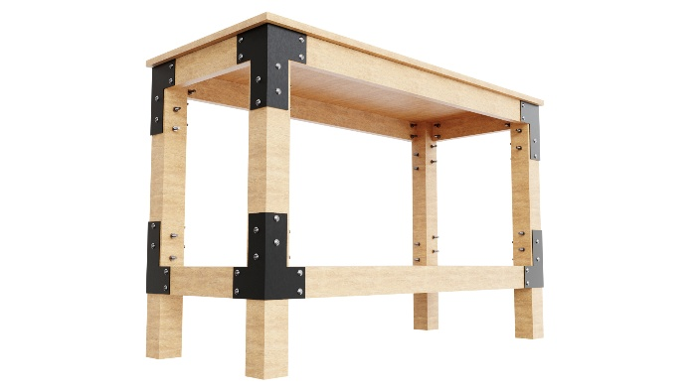
042026_d
The new TL corner bracket from Hettich DIY gives heavy furniture constructions the necessary stability and sets strong design accents. Photo: Hettich

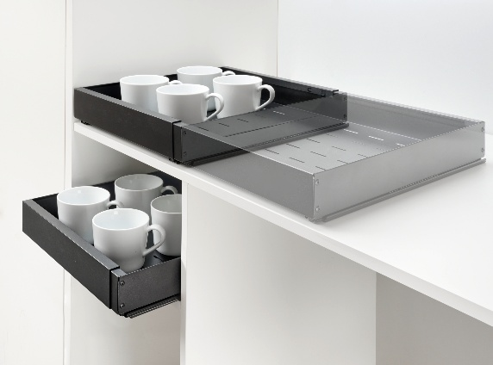
042026_e
Telescopic pull-outs from Hettich DIY make storage space flexible and easy to use. Infinitely adjustable in width to fit the exact space available in the cabinet. Photo: Hettich

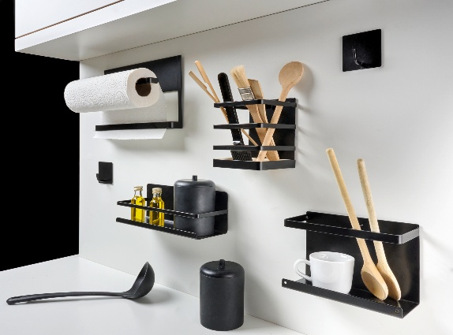
042026_f
The Click & Hang magnetic organiser system can be fixed anywhere on metallic surfaces and offers a wide range of practical organisational helpers. Photo: Hettich

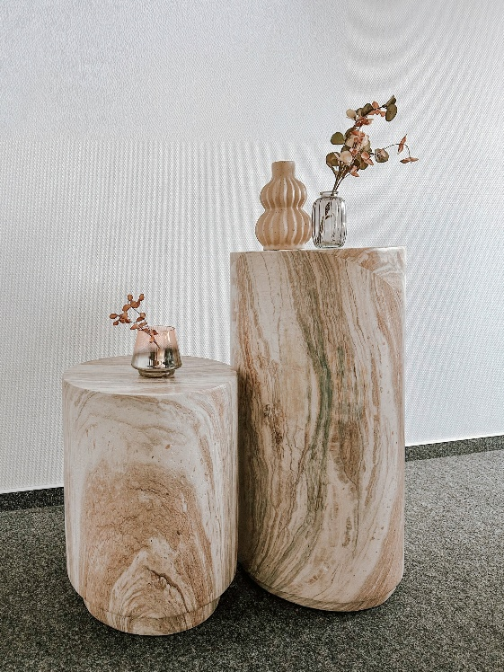
042026_g
Each magnesium-oxide occasional table is one of a kind — a high-quality add-on product from Hettich DIY that sets exclusive accents. Photo: Hettich

About Hettich
Founded in 1888, Hettich is one of the world’s largest and most successful manufacturers of furniture fittings. The family-owned company is based in Kirchlengern, in Germany’s East Westphalia furniture production region. Around 8,400 colleagues work together to deliver future-ready solutions in more than 100 countries. Under its brand promise “It’s all in Hettich”, the company offers a comprehensive portfolio of services consistently aligned to customer needs worldwide. For Hettich, sustainable action — socially, societally and environmentally — has always been a top priority. www.hettich.com

