“One Hettich Germany”: Hettich pools its strengths to achieve even greater speed and customer value
Shorter decision-making channels & streamlined structures: the family-run enterprise is streamlining its organisation, thereby strengthening collaborative partnerships with its customers.
To be an even stronger partner for its customers, to simplify collaboration, and to combine expertise even more effectively, Hettich – under the motto “One Hettich Germany” – is systematically realigning itself to be more customer focused in Germany. Established structures are being streamlined, and corporate boundaries are being dissolved in favour of greater transparency and speed. The family-owned company aims to take this formal step at the turn of the year 2027/2028.

A customer-focused, collaborative spirit prevails throughout the global Hettich network. Through global, cross-brand network structures and end-to-end processes – linked by a vibrant many-to-many culture – colleagues are already working closely together across company, division, and geographical boundaries. The consistent path toward “One Hettich Germany” builds on this strong sense of collaboration and continues to develop cooperation systematically.

Greater transparency and speed for customers
Working with Hettich will become even easier as Hettich streamlines its structures – both internally and, in particular, for Hettich’s customers and partners. Better-connected expertise and evolved business processes that transcend corporate boundaries will help Hettich address customer needs across the board and deliver solutions even faster. Hettich will concentrate its resources where they create the greatest value: in the customer experience.

Michael Lehmkuhl, Managing Director at Hettich:
“Our customers value us as a strong, reliable and straightforward partner. We’ll continue to develop that. With ‘One Hettich Germany’, we are pooling our strengths, speeding up decision-making and streamlining collaboration. "This is how we create greater value for our customers and design the future of the industry together."

Networking as a foundation
Hettich’s continued development in Germany is based on a way of working that has defined Hettich for years. This networked approach is already evident in the company’s day-to-day work: expertise, responsibility, and decision-making come together in cross-functional networks. Consistent end-to-end processes and a “many-to-many” culture make it possible to advance initiatives collaboratively across corporate and organisational boundaries.

The goal is not to reinvent what has worked well, but to build on existing networks consistently. As a family-owned company, Hettich focuses on the long term: simpler structures and even closer collaboration create additional opportunities for customers, markets, innovation, and sustainable growth.

The following image is available for download in the "Press" section at www.hettich.com:
Illustration
Caption

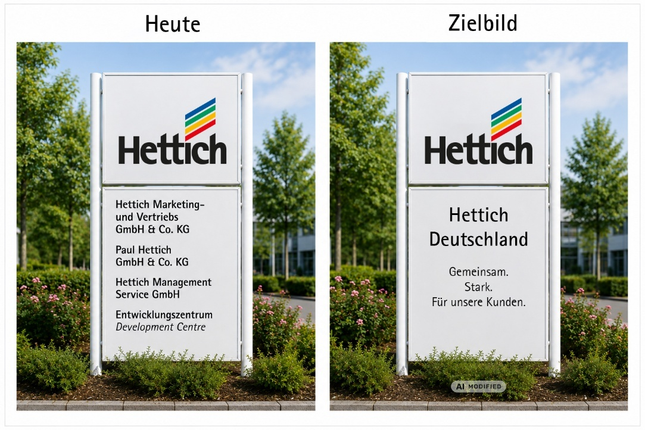
352026_a
“One Hettich Germany”: The concept brings together the collaborative working practices that are already in place today. Illustrative visualisation: Hettich (AI-generated)

About Hettich
Founded in 1888, Hettich is one of the world’s largest and most successful manufacturers of furniture fittings. The family-owned company is based in Kirchlengern, in Germany’s East Westphalia furniture production region. Around 8,200 colleagues work together to deliver future ready solutions in more than 100 countries. Under the brand promise “It’s all in Hettich”, the company provides a comprehensive portfolio of products and services consistently aligned with customer needs worldwide. Responsible, sustainable action – socially, societally and environmentally – has always been a top priority for Hettich. www.hettich.com

