DEMMELHUBER switches to AvanTech YOU drawer system
Reliability and more variability

Demmelhuber Holz und Raum GmbH operates throughout Europe as a full-service provider for customised interior designers and furniture construction in the shopfitting sector. Architects and building owners place high demands on interior design, as shopfitting furniture has to be able to withstand high loading capacities. Quality and long-lasting durability are just as important here as a clear design language. Last year, Demmelhuber decided to switch its drawer systems to AvanTech YOU from Hettich. For Demmelhuber, this is a calculated step towards greater efficiency and customer-orientation.

Whether new workspaces for law firms and company headquarters, the interior design of the 5,000 square metre Linden Palais office complex in Berlin or the headquarters of a Bundesliga football club - Demmelhuber Holz und Raum realises the most diverse and demanding interior design projects at its Hainichen site in Saxony with its team of around 30 designers, technicians and joiners.
Advice, planning, production, assembly - all under one roof and from a single source. For Demmelhuber, this is the base for fulfilling its own quality standards and meeting deadlines, which is highly valued by customers. The prerequisite for this is that all processes interlock perfectly and that both material quality and availability are right. "We can only complete these challenging projects because we can rely on our business partners and suppliers," explains Maik Fritzsche, the design engineer responsible for technical project management at Demmelhuber Holz und Raum.

The changeover has paid off: AvanTech YOU drawer system
Demmelhuber does not want to and cannot afford to compromise. When availability problems arose with the drawer system previously used, the management decided without further ado to switch to AvanTech YOU from Hettich. "We were particularly impressed by the chic, slim design, which perfectly matches our carcase material and the architects' ideas. It was also important for us to be able to choose from a wide product range in terms of sizes, designs and colours. Overall, the price-performance ratio was absolutely right for us," says Maik Fritzsche. In order to test the new drawer system, various sample assemblies were made together with Hettich customer advisor Jörg Feige and the AvanFit assembly aids for easy completion of the drawers were also tested. At the same time, the appropriate basic range was defined so that customised pull-outs could also be built.
Today, White and anthracite-coloured AvanTech YOU drawer fittings in standard lengths are available in bulk packs ready to hand in the bearing at any time. As a reliable partner, IuG Baufachhandel in Chemnitz ensures rapid availability - both of bulk packs and order-related orders in other colours.

Perfect process integration
At Demmelhuber Holz und Raum, planning is largely based on the architects' designs and drafts. Maik Fritzsche and his team then present the best possible solutions in the factory planning. The right fittings are selected for the respective project on this basis. "We use the Actro YOU drawer runners not only for steel drawer sides, but also for our wooden drawers. This means we only need one system for all our drawers," says the designer, describing another advantage.
The CAD data from Hettich is transferred to the design software, further processed for cutting and CNC production and integrated into the manufacturing process. Demmelhuber uses different heights for the AvanTech YOU drawers: low for cutlery drawers and higher for other accessories. Each piece of furniture is completely assembled once in the workshop to ensure that nothing is missing. At the same time, this ensures high quality and fast work processes on the construction site. The AvanTech YOU drawers are assembled efficiently using knock-in screws.

Demmelhuber Holz und Raum's conclusion after the changeover is consistently positive: "With AvanTech YOU, we have gained versatility, quality and reliability and with Hettich we have a partner at our side who is always there for us," summarises Maik Fritzsche.

The following image material is available for download in the menu "Press" at www.hettich.com:

Images
Captions

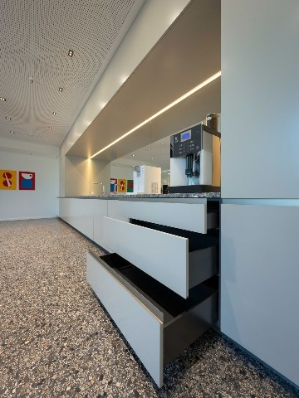
132026_a
Demmelhuber Holz und Raum built this XXL kitchen unit in a class of its own for a company headquarters in Berlin: the narrow drawer side profile of the AvanTech YOU drawer systems fits perfectly with the contemporary design. Photo: Sebastian Weingart

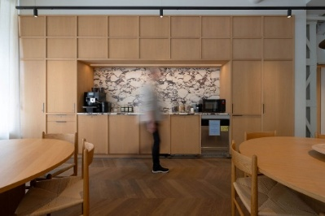
132026_b
Modern and cosy: this is the look of the Kitchens for employees in the new Linden Palais office complex in Berlin, which Demmelhuber Holz und Raum built using the AvanTech YOU drawer system from Hettich. Photo: Sebastian Weingart

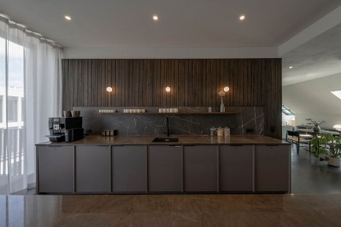
132026_c
Demmelhuber Holz und Raum knows what it takes to effectively showcase furniture - as this Kitchens in the Linden Palais office complex shows. High quality across the board: design concept, materials, finish. Photo: Sebastian Weingart

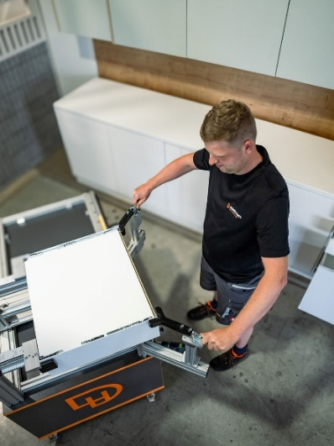
132026_d
The AvanFit assembly aids are mounted on a mobile workshop trolley at Demmelhuber. This allows journeyman carpenter Pascal Seidel to quickly and easily assemble and install the AvanTech YOU drawers directly on the furniture. Photo: Sebastian Weingart

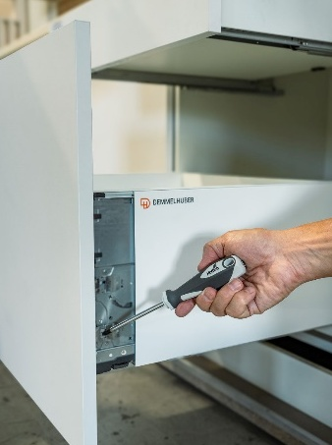
132026_e
The aperture alignment can be conveniently adjusted on the AvanTech YOU drawer side profile. You can't see any of the technology on the finished drawer, just pure design. Photo: Sebastian Weingart

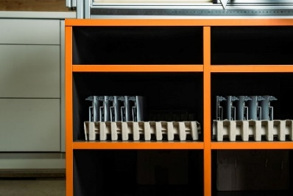
132026_f
Hettich supplies the Demmelhuber Holz und Raum dealer with bulk packs. This means that all AvanTech YOU components are at the furniture maker's fingertips. Photo: Sebastian Weingart

About Hettich
Founded in 1888, Hettich is one of the world’s largest and most successful manufacturers of furniture fittings. The family-owned company is based in Kirchlengern, in Germany’s East Westphalia furniture production region. Around 8,200 colleagues work together to deliver future ready solutions in more than 100 countries. Under the brand promise “It’s all in Hettich”, the company provides a comprehensive portfolio of products and services consistently aligned with customer needs worldwide. Responsible, sustainable action — socially, societally and environmentally — has always been a top priority for Hettich. www.hettich.com

