Hettich Group demonstrates stability and looks to the future
€1.4 billion turnover in the 2025 financial year

The Hettich Group, one of the world’s leading manufacturers of furniture fittings and headquartered in Kirchlengern, has published its results for the 2025 financial year. In a market environment that remained challenging throughout the year, the family-owned company achieved sales of €1.4 billion, thereby maintaining overall stability.

Compared to 2024, this represents a nominal decline of 2 per cent. Adjusted for currency effects, turnover remained at the previous year’s level.

International business accounted for around 79 per cent of total sales. At the end of 2025, the Hettich Group employed approximately 8,200 colleagues worldwide, including around 3,900 in Germany.

“2025 has shown how important clear priorities and flexible structures are,” says Managing Director Michael Lehmkuhl. “We analysed market developments in a highly differentiated way and made conscious decisions about where we want to actively shape the market. Our international positioning and innovative strength provide both stability and room for manoeuvre.”

Investments with a Clear Focus

In 2025, the Group invested €87 million. These funds were directed into innovations, production and logistics structures, as well as the targeted expansion of regional market presence worldwide.

“We invest where we see long-term prospects,” explains Managing Director Timo Pieper. “Our aim is to concentrate on growth markets and future fields in order to strengthen our position sustainably.”

Press tour instead of classic presentation

The 2026 annual results press conference once again took place in a special format at the Hettich Forum in Kirchlengern. Rather than a traditional presentation, the company organised a press tour with multiple themed stations, making strategic topics tangible on site.

Innovation projects such as the SpinLines product family — featuring ComfortSpin, FurnSpin and RoomSpin — took centre stage. These turning and swivelling systems exemplify the guiding principle “Transforming Spaces with Innovative Motion”, illustrating how societal developments can be translated into product solutions that make spaces flexibly adaptable.

The company also presented its international multi-brand strategy. With Hettich and FGV, the Group deliberately serves different market segments and clearly differentiated customer needs. Both brands have their own independent identity, making Hettich the only company in the industry able to cover the entire value spectrum — from the entry-level segment to the premium sector.

Another key focus was the expansion of regional market presence. With the founding of Hettich Central Asia in Kazakhstan, the Group is strengthening its position in Central Asia’s growing markets.

Conscious decisions with a future-oriented approach

In addition to market and product perspectives, organisational developments were also addressed as part of the tour.

“Our goal is to ensure that Hettich remains competitive and flexible in the long term,” says Managing Director Jana Schönfeld. “This includes realistically assessing external framework conditions while taking responsibility for our own strategic direction. Strong collaboration and international teamwork are key success factors.”

Outlook for 2026

The Hettich Group does not expect a rapid, broad-based recovery of the market in 2026. At the same time, long-term growth prospects continue to exist — particularly in selected international regions and in the area of smart, modular solutions.

With a clear strategic focus, strong regional proximity to markets and its distinctive multi-brand strategy, the Group sees itself well positioned to actively leverage opportunities and further expand its international competitiveness.

The following images are available for download at www.hettich.com :

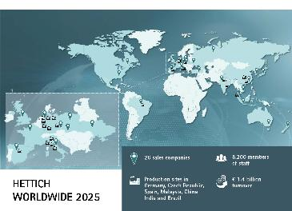
102026_a

The Hettich Group takes stock of 2025. Photo: Hettich

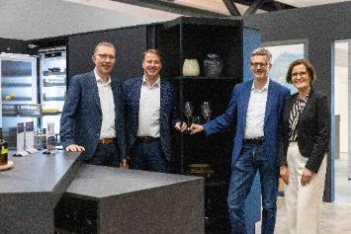
102026_b

The Hettich Group takes stock for the year 2025: Timo Pieper, Michael Lehmkuhl, Dr Andreas Hettich and Jana Schönfeld. Photo: Hettich

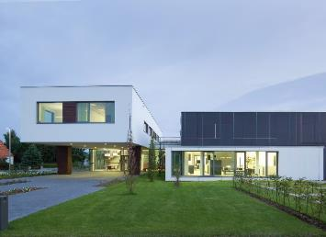
102026_c

Hettich Forum at the headquarters in Kirchlengern, Germany. Photo: Hettich

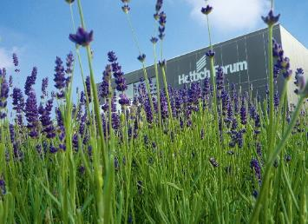
102026_d

Hettich Forum at the headquarters in Kirchlengern, Germany. Photo: Hettich

About Hettich
Founded in 1888, Hettich is one of the world’s largest and most successful manufacturers of furniture fittings. The family-owned company is based in Kirchlengern, in Germany’s East Westphalia furniture-production region. Around 8,200 colleagues work together to deliver future ready solutions in more than 100 countries. Under the brand promise “It’s all in Hettich”, the company provides a comprehensive portfolio of products and services consistently aligned with customer needs worldwide. Responsible, sustainable action — socially, societally and environmentally — has always been a top priority for Hettich. www.hettich.com

